Application to make the gas filling station easy using CRM

## NAAN MUDHALVAN PROJECT REPORT

Submitted by

## MURUGADASS B (au620120104067)

**SELVARAJA S (au620120104086) MANIBHARATHI G (au620120104058)**

## SATHISH KUMAR S

**(au620120104085)**

*In partial fulfillment of the award of the degree* of

## BACHELOR OF ENGINEERING

*in*

## COMPUTER SCIENCE AND ENGINEERING

**AVS ENGINEERING COLLEGE AMMAPET, SALEM- 636 003**

**ANNA UNIVERSITY :: CHENNAI 600 025**

# BONAFIDE CERTIFICATE

Certified that this project report **“Application to make the gas filling station**

## easy using CRM” is the bonafide work of “MURUGADASS B (au620120104067), SELVARAJA S (au620120104086), MANIBHARATHI G (au620120104058), SATHISH KUMAR S (au620120104085)” who carried out the project work under my supervision.

## SIGNATURE SIGNATURE

**HEAD OF THE DEPARTMENT**

## Prof. V. Meena, M.E.,

**PROJECT SUPERVISOR**

## Mr. S. Dhamodharan, M.E.,

Assistant Professor, Department of CSE,

AVS Engineering College, Salem- 636003.

Assistant Professor, Department of CSE,

AVS Engineering College, Salem- 636003.

**SPOC HEAD OF THE DEPARTMENT**

# ACKNOWLEDGEMENT

We would like to express our gratitude and appreciation to all those who gave us the possibility to complete this report. We would like to acknowledge with much appreciation to our honorable Chairman, **Shri.K.KAILASAM**, Secretary, **Shri.K.RAJAVINAYAKAM, MBA.,** and also to our Correspondent, **Shri.K.SENTHILKUMAR, B.Tech.,** for providing all necessary facilities for the successful completion of the project.

We have immense pleasure in expressing our gratitude to our beloved Principal, **Dr.J.SUNDARARAJAN, M.E,Ph.D.,** for allowing us to have extensive use of our college facilities to do this project. It gives us a great sense of pleasure in expressing our gratefulness to our beloved Vice Principal’s, **Dr.R.VISWANATHAN, M.E.,Ph.D.,** and **Dr.D.R.JOSHUA, M.E.,Ph.D.,** for

their professional guidance in scheduling the project work to complete on time.

We express our heartiest gratitude to **Dr.M.VILASINI, M.E.,Ph.D.,** Dean R&D and Head of the Department **Prof.V.MEENA, M.E.,** Department of Computer Science and Engineering for her guidance and encouragement throughout the Project Period. We are indebted to our project coordinator **Prof. S. DHAMODHARAN, M.E.,** Assistant Professor for their constant help and excellent direction.

We specially thank all our Teaching and Non-Teaching Staff Members and Lab Technicians of the **Computer Science and Engineering** for their consistent encouragement to do the project work with full interest and zeal. We pay our profound gratitude to the Almighty God for his invisible vigilance and would like to thank our Parents for giving us support, encouragement and guidance throughout the course of our work.

# TABLE OF CONTENTS

## Chapter No

**LIST OF FIGURES**

## Title Page No

**5**

1. PROJECT SPECIFICATION 6
   1. Project Goal 6
   2. Project Scope 7
   3. Problem Statement Definition 8
   4. Empathy Map Canvas 8
   5. Proposed Solution 10
   6. Functional & Technical Requirements 11
   7. Project Road Map 13
2. PREPARATION DATA MODELING 15
   1. Salesforce Developer Org 15
   2. Object Creation 18
   3. Tabs 20
   4. The Lightning App 22
   5. Fields and Relationship 25
   6. Page Layouts 40
3. USERS & DATA SECURITY 43
   1. Profile 43
   2. Setup Roles 49
   3. Users 53
   4. Permission Set 55
   5. Setup for OWD 60

3.4 User Adoption 62

1. AUTOMATION 67
   1. Flow 67
   2. Apex Trigger 72
2. REPORTS & DASHBOARD 76
   1. Reports 76
   2. Dashboard 82
3. **CONCLUSION 87**
4. **Project Demonstration 88**

GitHub & Project Video Demo Link

## LIST OF FIGURES

|  |  |  |
| --- | --- | --- |
| **Figure No** | **Name of Figure** | **Page No** |
| 1.7.1 | Data Flow Diagram | 13 |
| 1.7.2 | Technical Architecture | 14 |

## Project Goal

# CHAPTER-1 PROJECT SPECIFICATION

The primary aim is to provide gas station owners with a comprehensive CRM solution that enhances customer service, streamlines operations, and drives business growth while ensuring a convenient and efficient experience for customers.

* + - **Efficient Customer Management:** Implement a CRM system to effectively manage customer information and interactions, allowing for personalized service and targeted marketing efforts.
    - **Optimized Inventory Control:** Utilize CRM tools to track and manage inventory levels of fuel and other products, ensuring efficient stock management and replenishment.
    - **Automated Order Processing:** Automate the ordering process for fuel and related products, simplifying the purchase and delivery procedures for both customers and suppliers.
    - **Improved Customer Service:** Enhance customer service and support by providing real-time information on fuel prices, availability, and promotions, and by enabling quick issue resolution.
    - **Data Analytics:** Leverage CRM data and reporting capabilities to gain insights into customer behavior, preferences, and trends, allowing for data- driven decision-making.
    - **Sales and Marketing:** Utilize CRM to create targeted marketing campaigns, track leads, and convert them into customers while increasing sales and revenue.

## Project Scope

This project encompasses a comprehensive range of activities. It includes the assessment of our current operational challenges and customer service deficiencies. We will explore and evaluate various CRM solutions to select the one best suited to our gas station's unique requirements and budget. The selected CRM will be customized to meet our specific needs, encompassing data fields, workflows, and reporting capabilities:

* **Needs Assessment:** Identifying and documenting current operational challenges and customer service deficiencies.
* **CRM Selection:** Thoroughly researching and evaluating CRM solutions to find the best fit for our station's needs and budget.
* **Customization:** Configuring the selected CRM system to meet the specific requirements of our gas filling station, including data fields, workflows, and reporting.
* **Data Migration:** Migrating existing customer data into the CRM system and ensuring data accuracy.
* **Staff Training:** Providing comprehensive training to station staff to ensure they are proficient in using the CRM system.
* **Change Management:** Developing a change management plan to address any potential resistance to the new system and to promote user adoption.
* **Ongoing Support and Maintenance:** Implementing a plan for continuous support, system maintenance, and potential future enhancements.

## Problem Statement Definition

|  |  |  |  |
| --- | --- | --- | --- |
| **Problem for** | **Trying to** | **But** | **Which makes** |
| **Employee** | I'm an employee at our gas filling station, and I'm striving to effectively manage customer records, streamline fuel orders, and implement loyalty programs for our diverse customer base. | However, the manual and time- intensive nature of these tasks, coupled with the potential for errors, has created operational challenges. | This inefficiency not only makes our tasks overwhelming but also hinders our ability to provide a seamless and efficient customer experience at the station. |

## Empathy Map Canvas

An empathy map is a simple, easy-to-digest visual that captures knowledge about a user’s behavior and attitudes.

It is a useful tool to helps teams better understand their users. Creating an effective solution requires understanding the true problem and the person who is experiencing it.

The exercise of creating the map helps participants consider things from the user’s perspective along with his or her goals and challenges.

Continuing from the previous section, the empathy map canvas will provide a more comprehensive insight into the needs, emotions, pain points, and goals of customers, employees, and stakeholders. It will also explore potential solutions to address their concerns effectively.

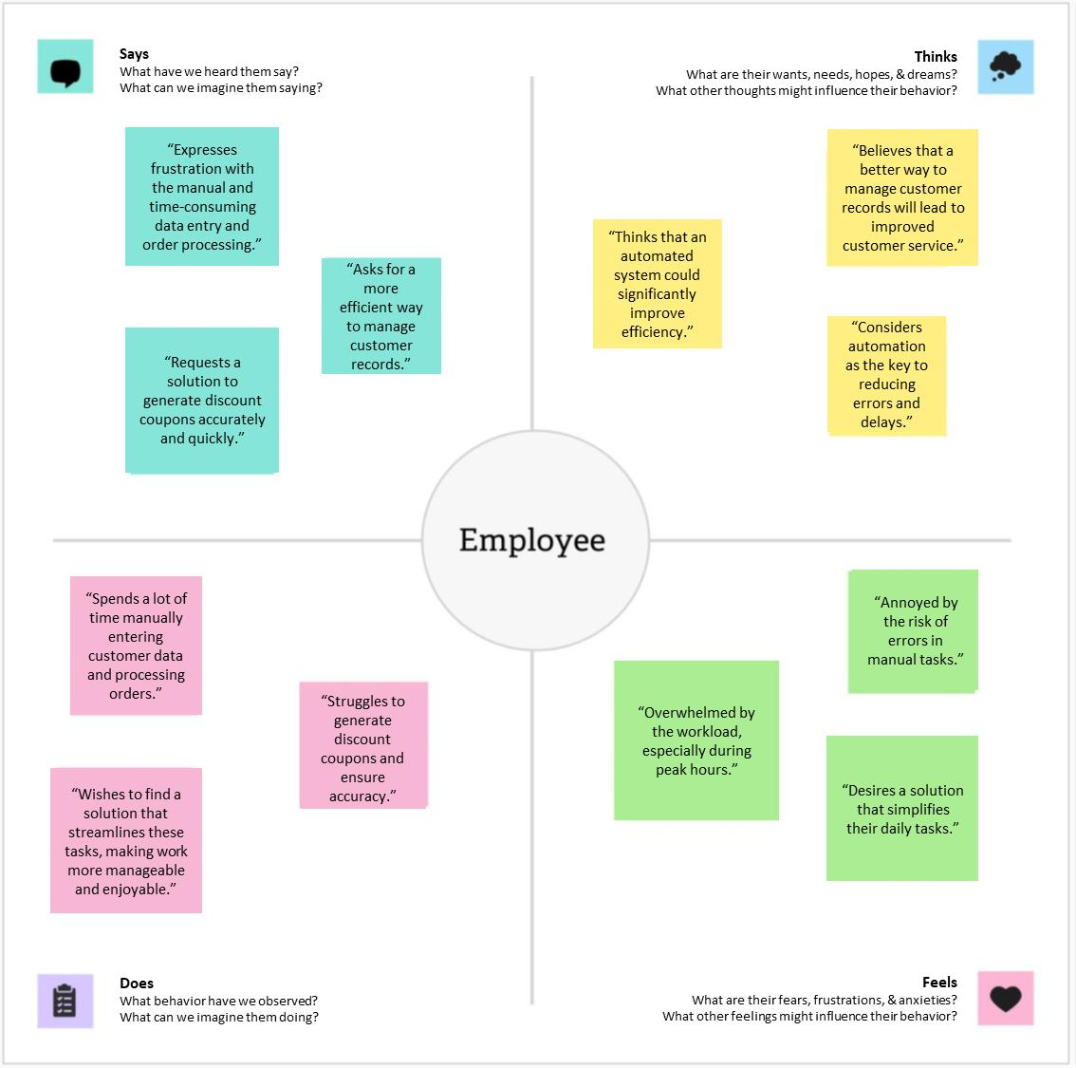

They are motivated to improve customer service and efficiency.

Current actions are time-consuming and error-prone.

Staff feels the current processes are overwhelming.

They use paper records for sales processes.

Staff manually manage customer data and inventory.

They are frustrated with manual tasks and errors.

They suggest that automation can improve sales processes.

They anticipate that automated processes will reduce errors and save time.

Staff thinks that a CRM system will help streamline operation

Employees express the need for better customer data management.

They say that inventory management could be more efficient.

They believe that centralized customer data will enhance customer service.

## Proposed Solution

|  |  |  |  |  |  |
| --- | --- | --- | --- | --- | --- |
| **S. No** | **Parameter** | | | | **Description** |
| 1. | **Says** | | | | In this section, you document what the stakeholder says. This includes their statements, comments, and feedback related to the project. It helps you understand their verbal expressions and  concerns. |
| 2. |  | | | | Here, you explore what the stakeholder might be thinking. This includes their thoughts, concerns, or goals that may not be openly expressed. It helps uncover their underlying motivations. |
| **Th** | **inks** | |  |
| 3. |  | **Pains** |  | | Document the pain points or challenges that the stakeholder experiences. This could include frustrations, obstacles, or difficulties they encounter in the context  of the project. |
|  | | | |
| 4. |  | **Gains** |  | | This aspect highlights the potential benefits, desires, and goals that individuals or groups hope to achieve or experience as a result of the situation or  project. |
|  | | | |
| 5.. | **Feels** | | | | This parameter addresses the stakeholder's emotional state. It helps you identify their emotions, such as joy, frustration, or  anxiety, related to the project or situation. |
| 6. |  | | | | This section describes the actions or behaviors of the stakeholder. It helps you understand their practical actions, routines, or interactions related to the project. |
|  | **Does** |  | |

## Functional & Technical Requirements

* + 1. Functional Requirements

|  |  |  |  |
| --- | --- | --- | --- |
| **Requirement** | | | **Description** |
| **Customer Data Management** | | | The CRM system should allow for the centralized management of customer information, including contact details,  purchase history, and preferences. |
| **Personalized Customer Service** | | | The system should support the ability to create and manage customer profiles, enabling us to provide personalized services, special  promotions, and targeted offers. |
| **Inventory Management** | | | Real-time inventory tracking and automated restocking processes should be integrated to optimize inventory management. This should prevent shortages, reduce operational  disruptions, and control inventory costs.. |
| **Automated Sales Processes** | | | The CRM system should facilitate automated sales processes, including order processing and payment, to ensure a smooth and error-  free customer experience. |
| **Reporting and Analytics:** | | | Comprehensive reporting and data analytics features should be available to provide insights into customer behavior, sales trends, and inventory management. This will support  data-driven decision-making. |
|  | **Integration Capabilities** |  | The CRM system should offer integration options with other systems used at the gas filling station, including accounting and financial software. Seamless integration will  ensure a cohesive operational environment. |
|  | | |

* + 1. Technical Requirements

|  |  |  |  |  |  |  |  |
| --- | --- | --- | --- | --- | --- | --- | --- |
| **Requirement** | | | | | | | **Description** |
|  | | | **Scalability:** |  | | | The CRM system should be scalable to accommodate the potential growth of our business. It should handle an increasing volume of customer data and transactions  without performance degradation. |
|  | | | | | | |
| **Data Security** | | | | | | | Robust data security measures, such as encryption and access controls, should be in place to protect sensitive customer  information and transaction data. |
|  | | **Data Backup and Recovery** | | |  | | The CRM system should have a reliable data backup and recovery mechanism to safeguard against data loss in case of  system failures or errors. |
|  | | | | | | |
| **Cloud-Based or On-Premises** | | | | | | | The choice between a cloud-based or on- premises CRM system should be evaluated based on our specific infrastructure and data management  requirements. |
| **User-Friendly Interface** | | | | | | | The system should feature a user-friendly interface to ensure ease of use and rapid  adoption by our staff.. |
|  | **Technical Support and Updates** | | | | |  | Ongoing technical support, system maintenance, and regular updates should be provided to keep the CRM system up  to date and secure. |
|  | | | | | | |

## Project Road Map

* + 1. Data Flow Diagram

A Data Flow Diagram (DFD) is a traditional visual representation of the information flows within a system. A neat and clear DFD can depict the right amount of the system requirement graphically. It shows how data enters and leaves the system, what changes the information, and where data is stored.

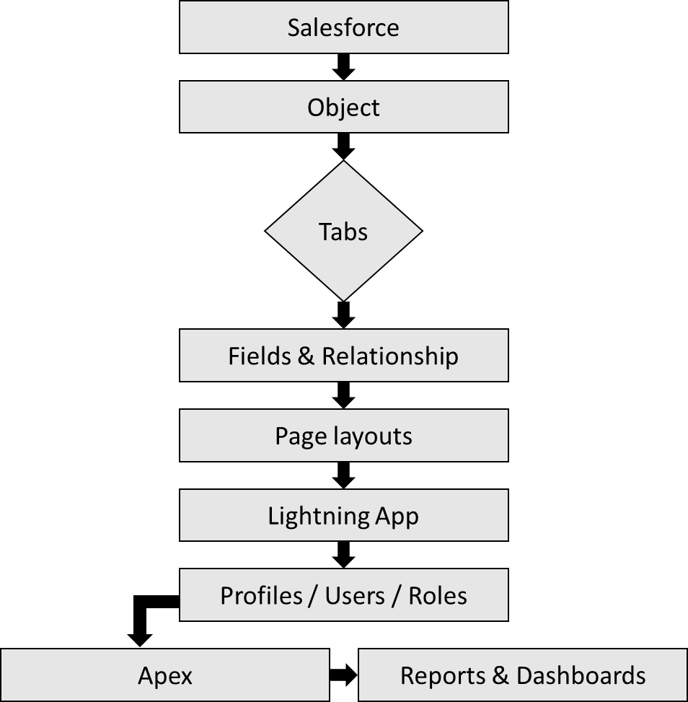

* + 1. Technical Architecture

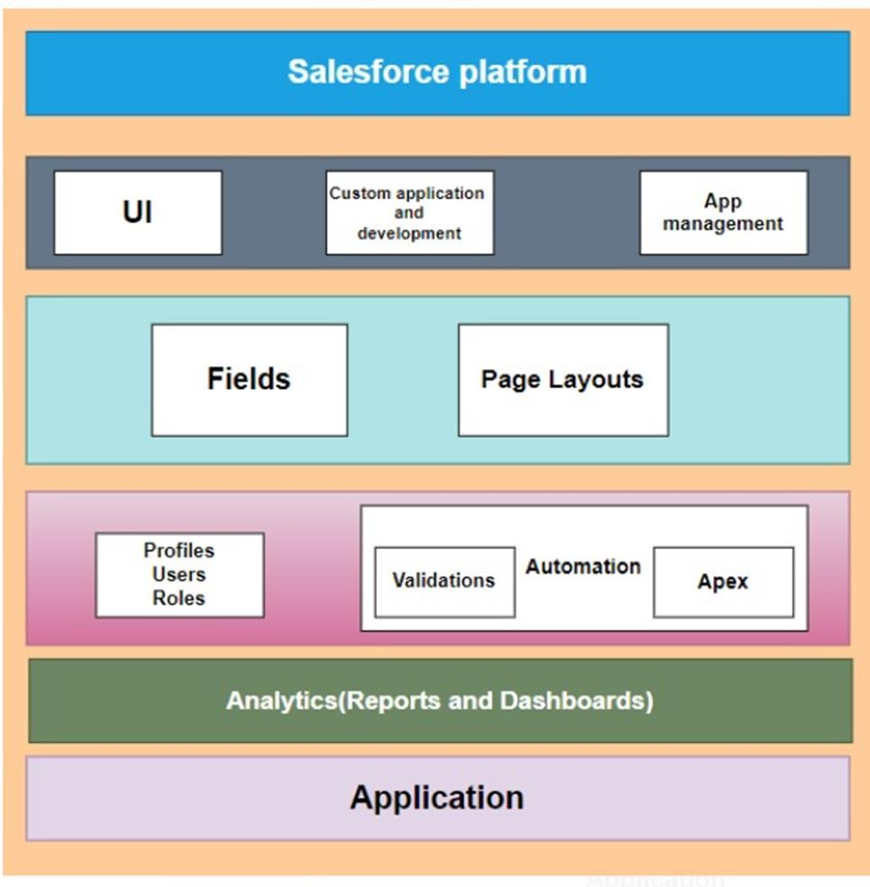

# CHAPTER-2 PREPARATION DATA MODELING

## Salesforce Developer Org

In Salesforce, a Developer Sign Up or Developer Edition is a special type of Salesforce environment that is primarily used for development, testing, and learning purposes.

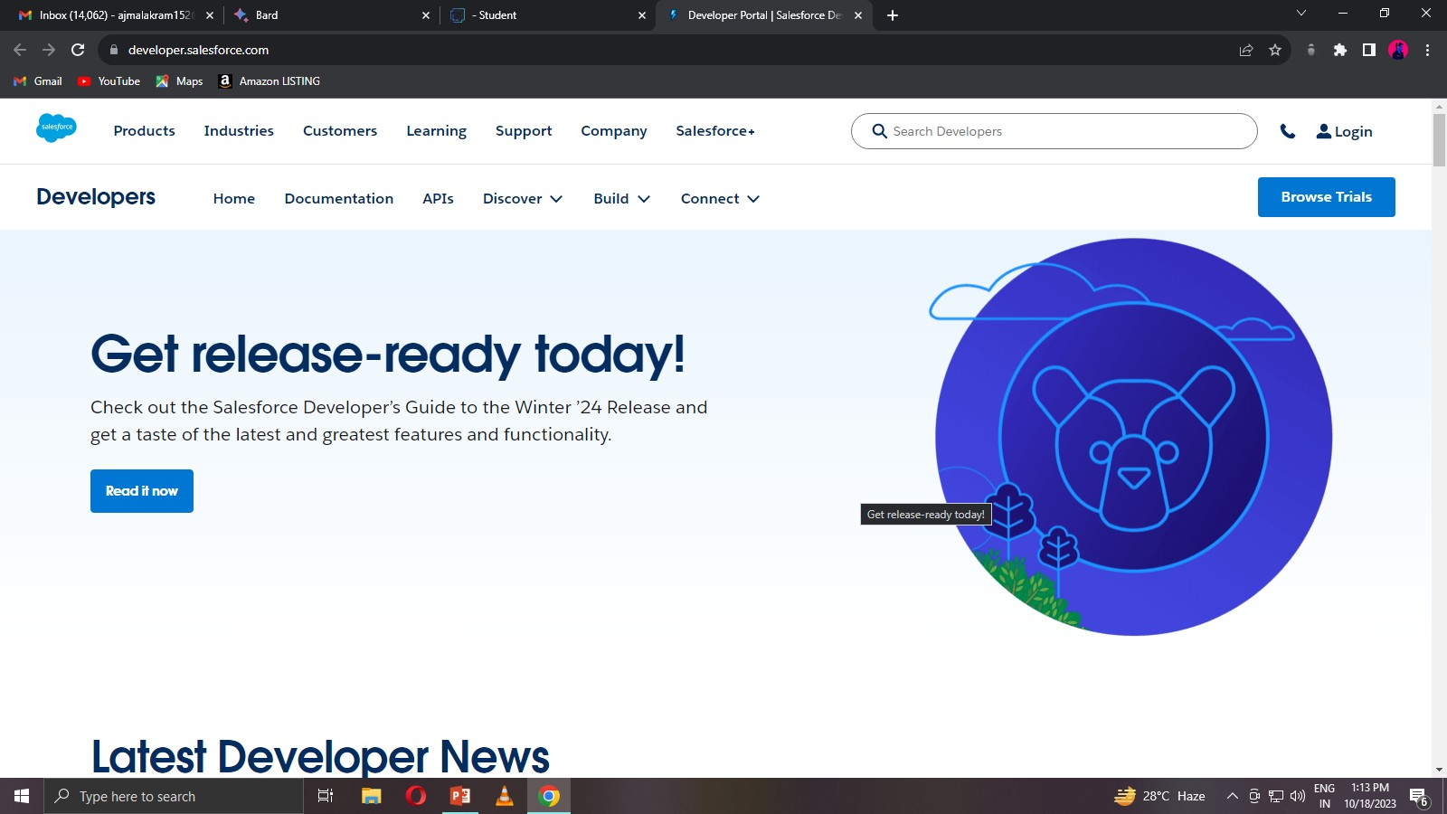

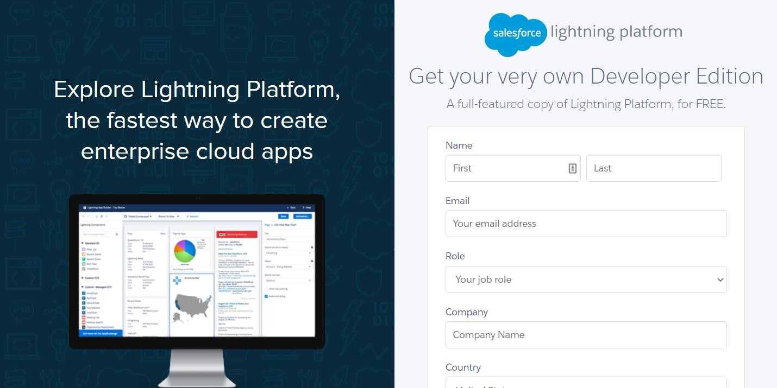

## Account Activation

Activation tracks information about devices from which users have verified their identity.

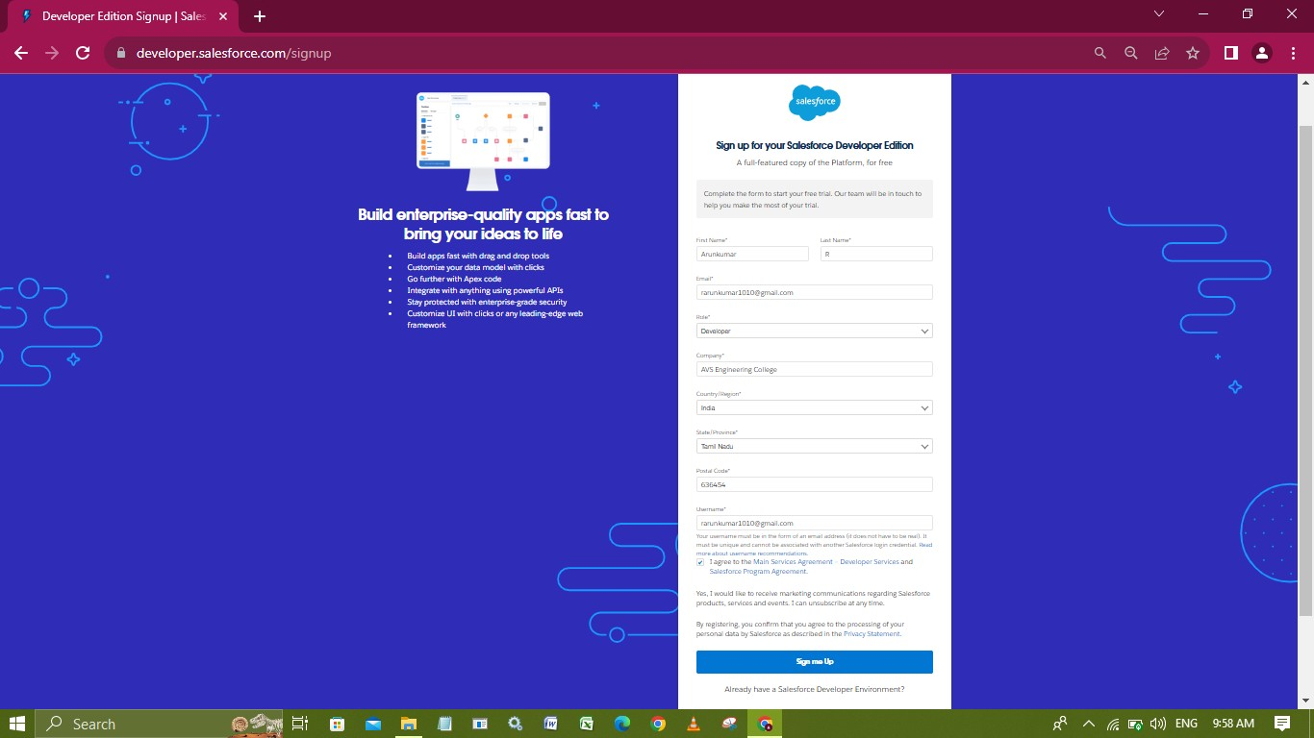

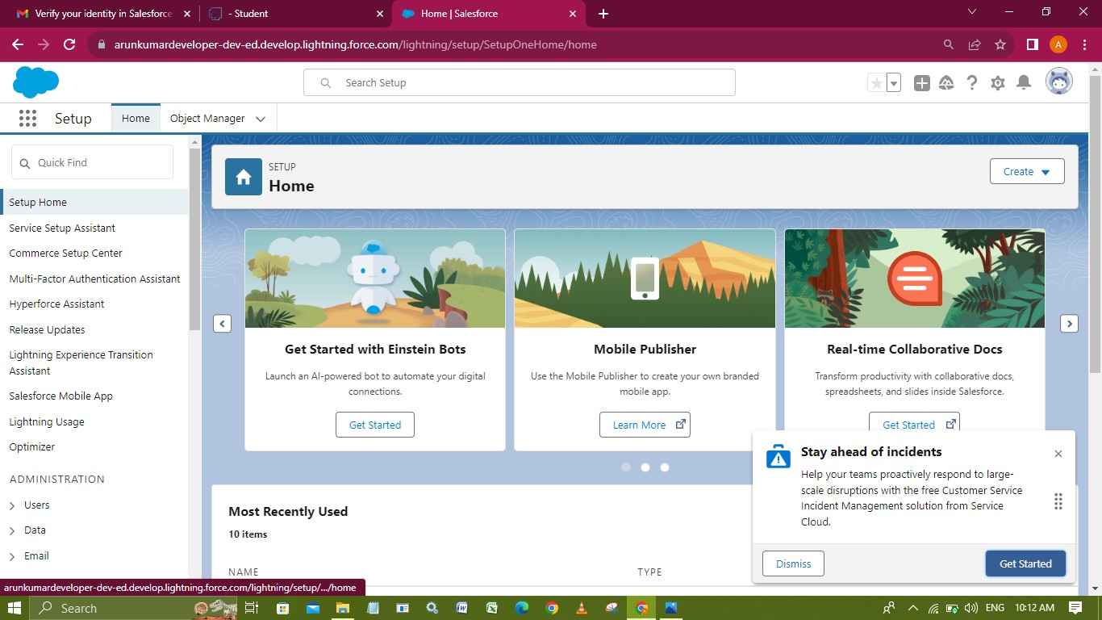

## Object Creation

Salesforce objects are database tables that permit you to store data that is specific to an organization. Salesforce objects are of two types: Standard Objects: Standard objects are the kind of objects that are provided by salesforce.com such as users, contracts, reports, dashboards, etc. Custom objects: Gas Station, Supplier,Buyer, Fuel Details.

## Create the Gas Station Object

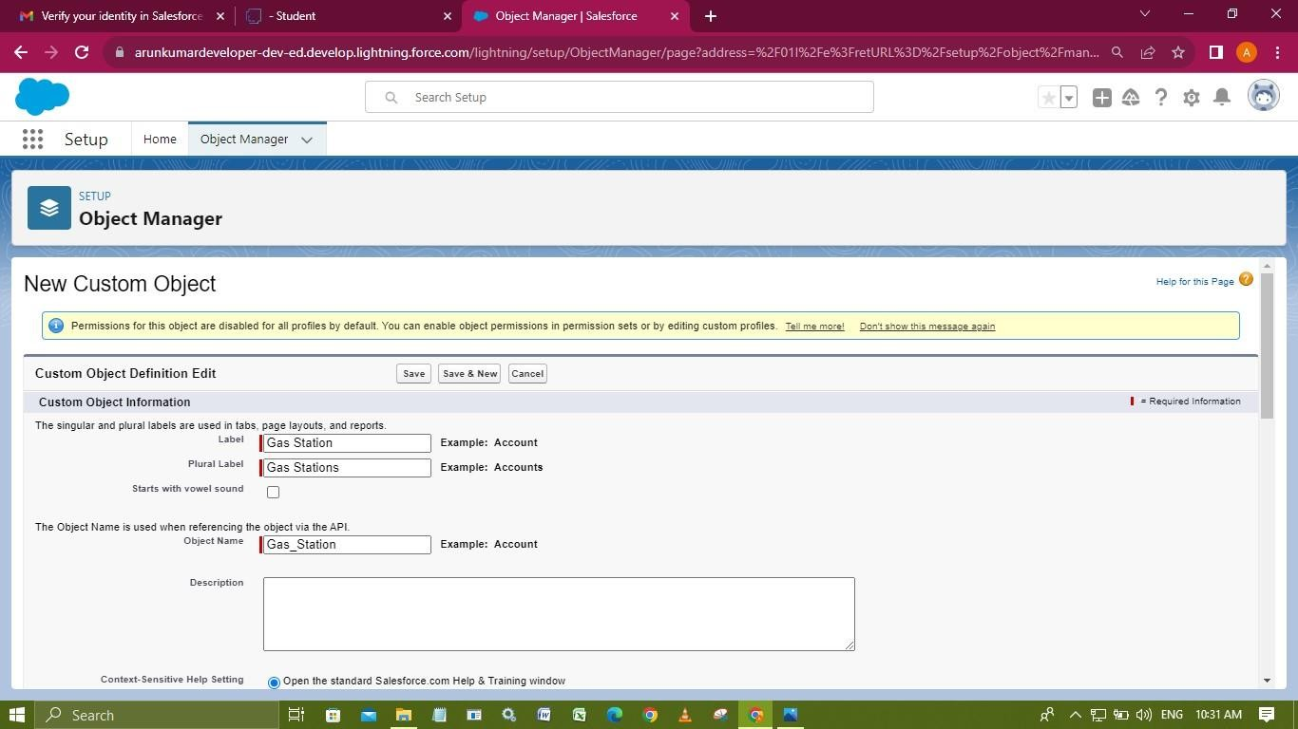

**Create the Supplier Object**

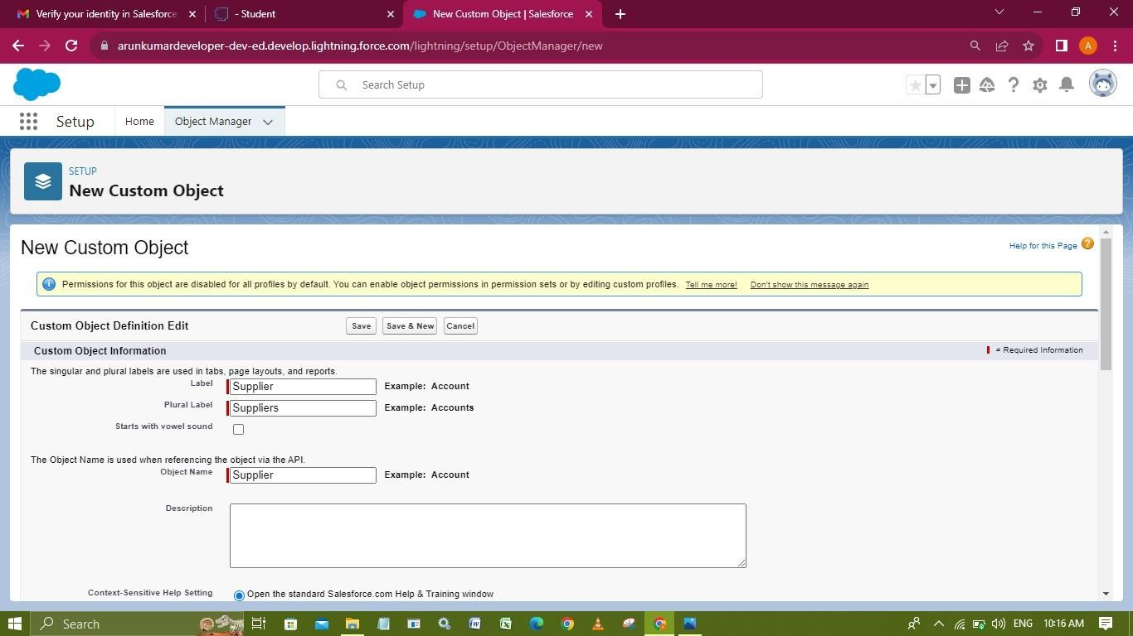

## Create the Buyer Object

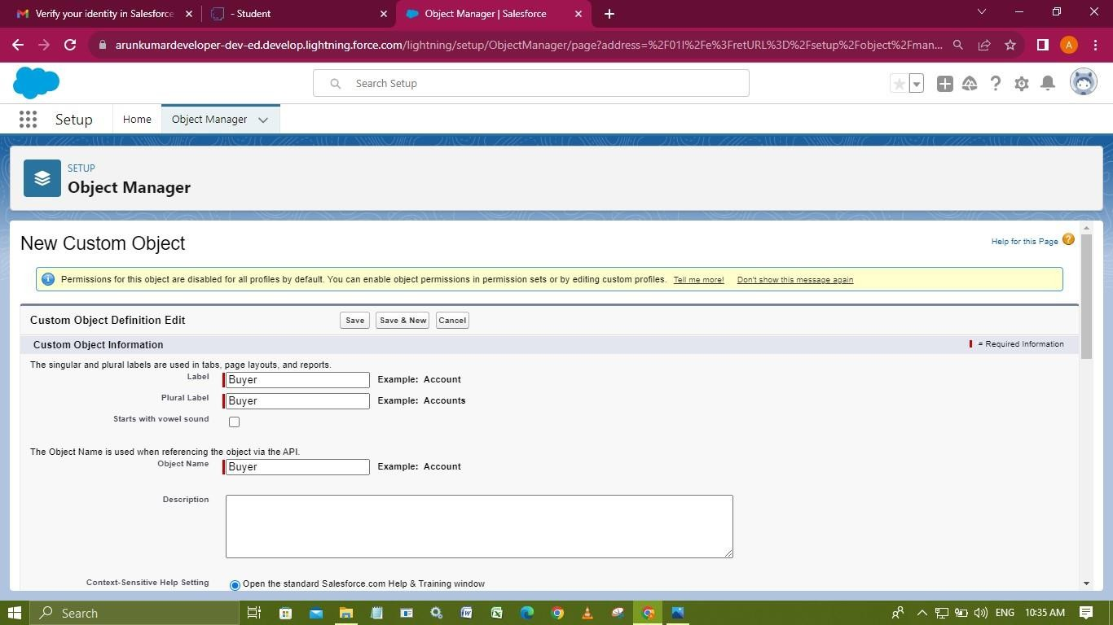

**Create the Fuel Details object**

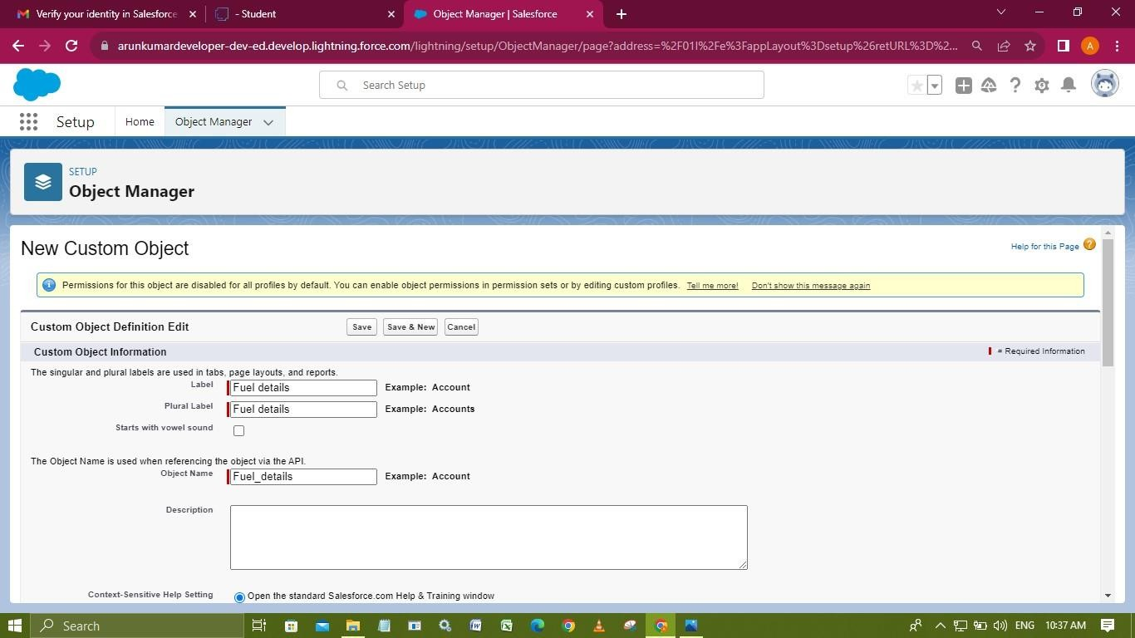

## Tabs

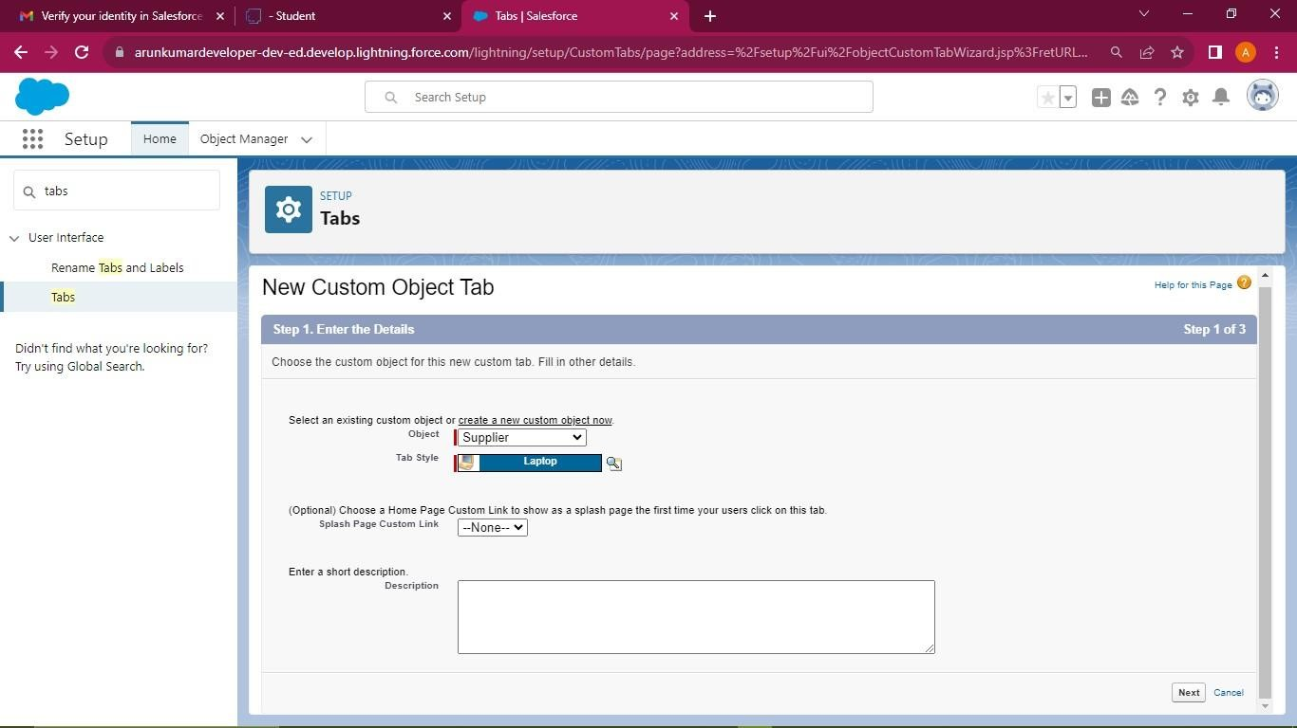

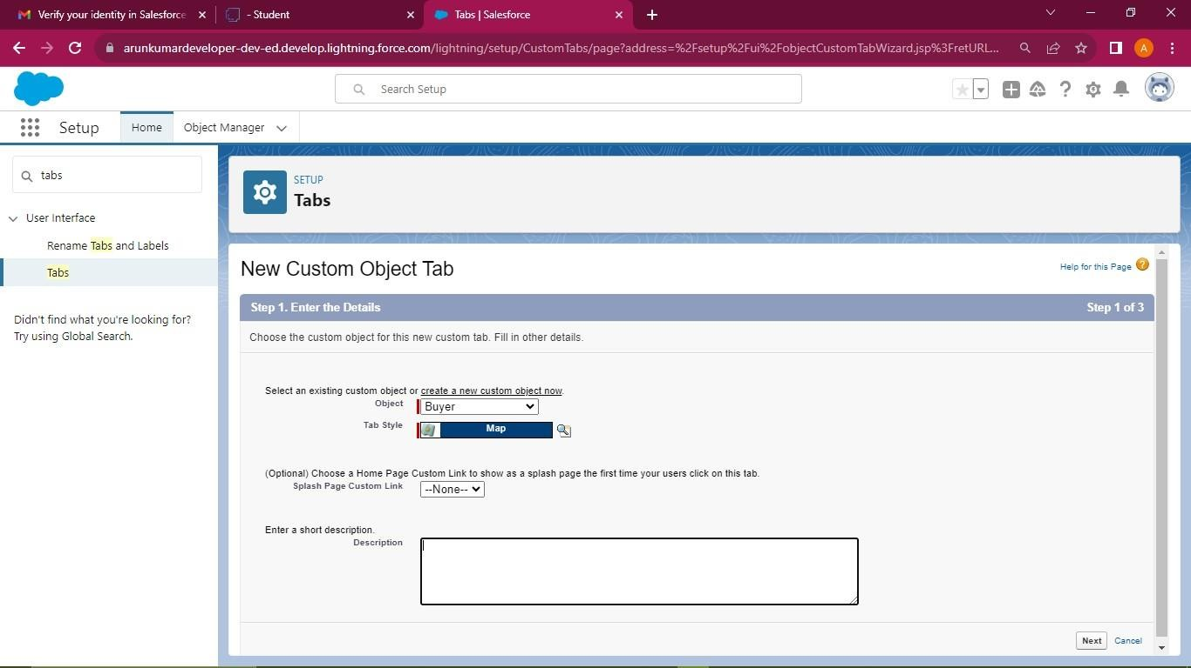

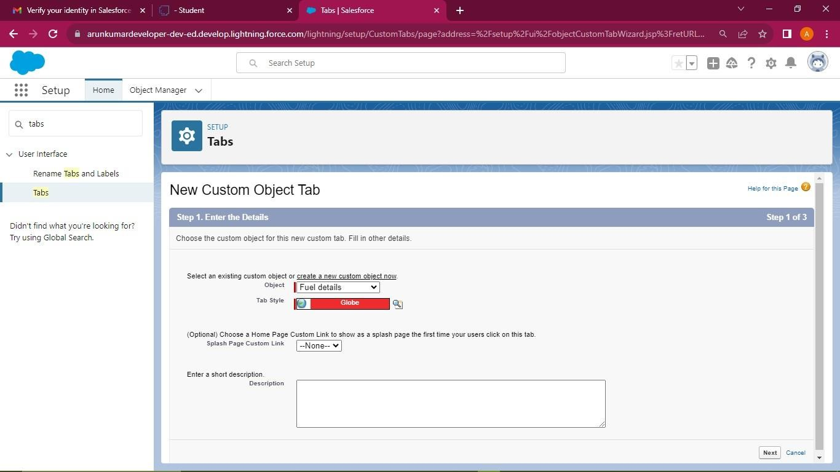

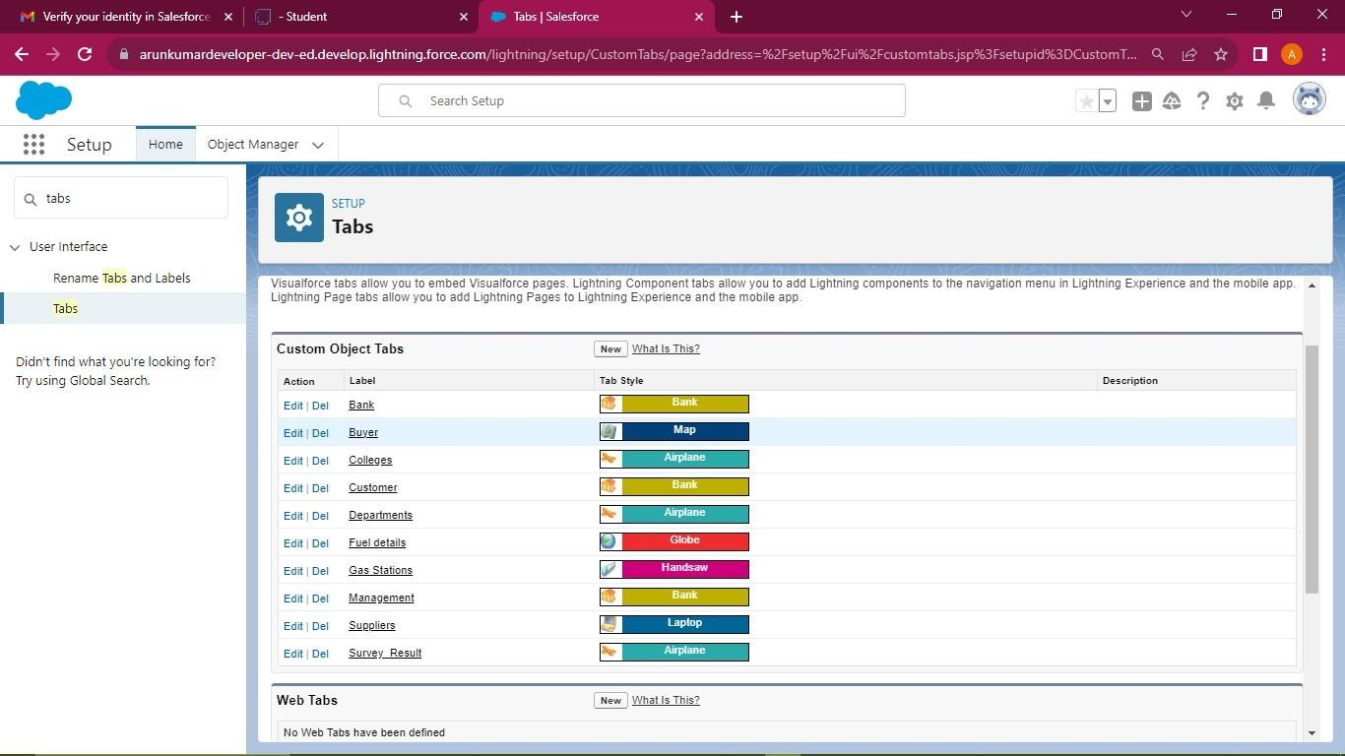

## The Lightning App

An app is a collection of items that work together to serve a particular function. In Lightning Experience, Lightning apps give your users access to sets of objects, tabs, and other items all in one convenient bundle in the navigation bar.

Lightning apps let you brand your apps with a custom color and logo. You can even include a utility bar and Lightning page tabs in your Lightning app. Members of your org can work more efficiently by easily switching between apps.

## Create a Lightning App

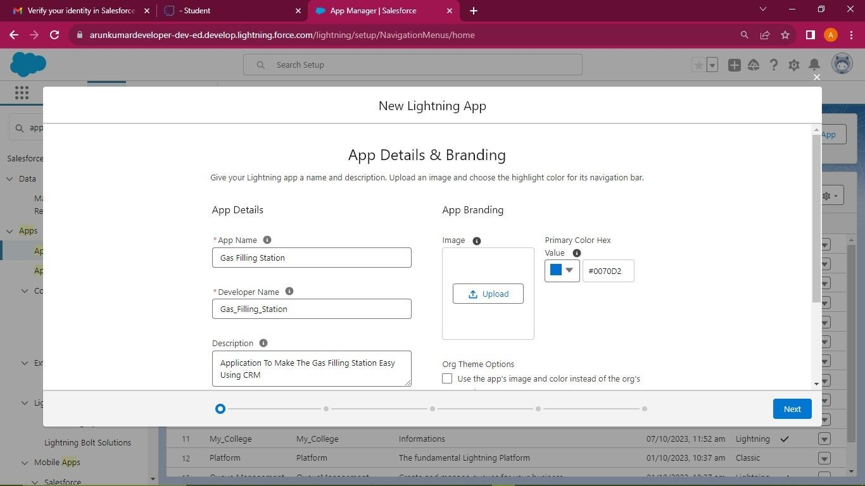

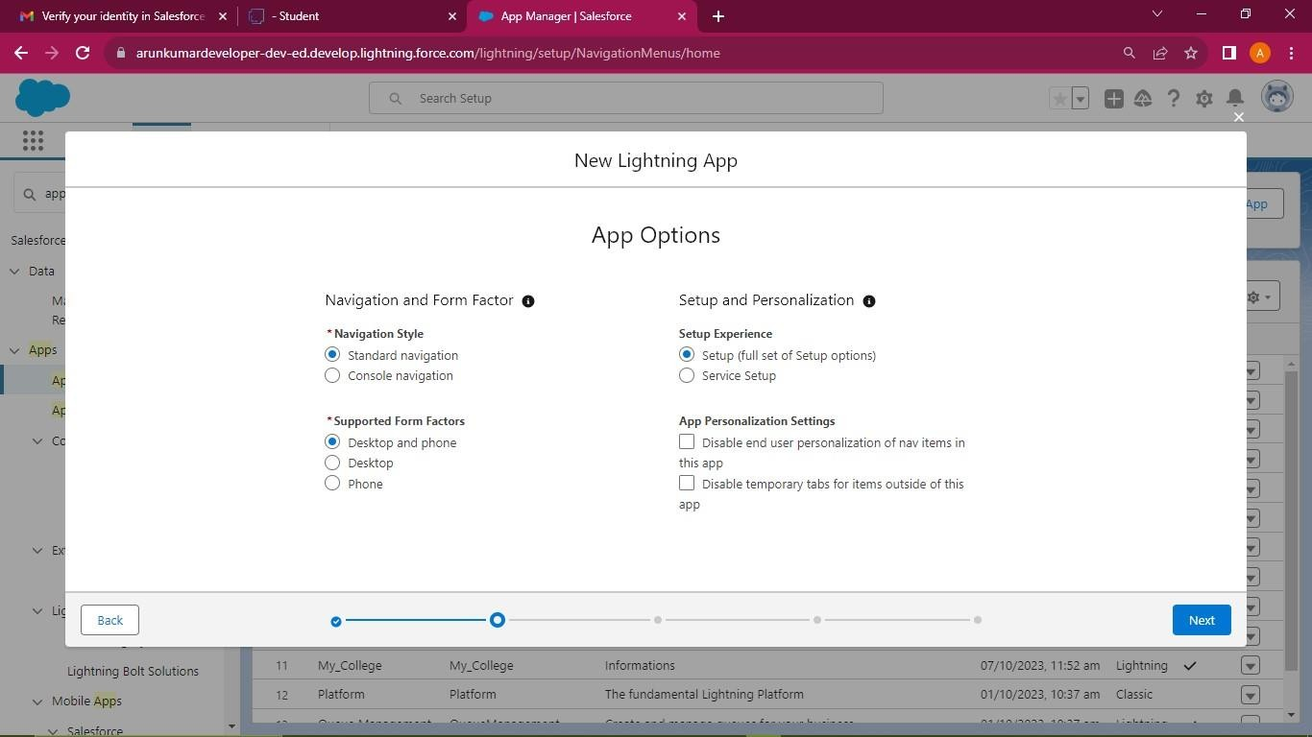

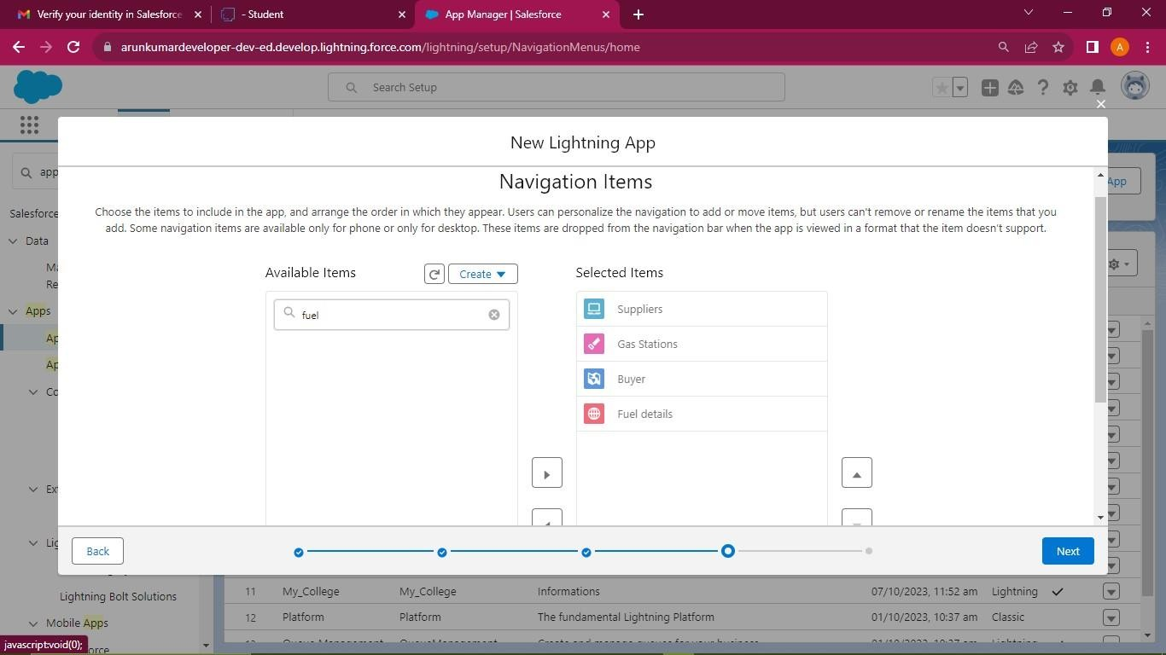

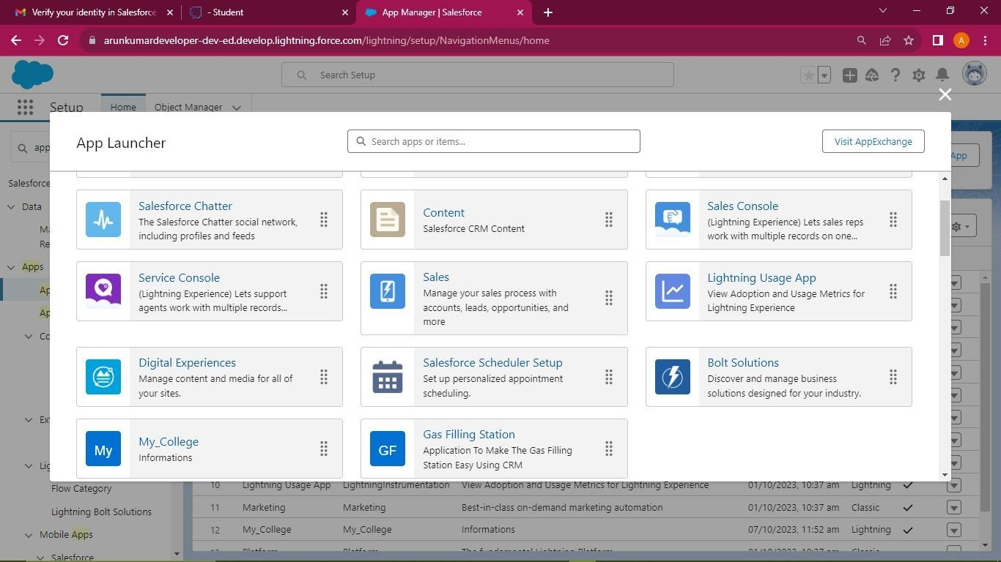

## Fields and Relationship

An object relationship in Salesforce is a two-way association between two objects. Relationships are created by creating custom relationship fields on an object. This is done so that when users view records, they can also see and access related data.

## Fields in Supplier Objects

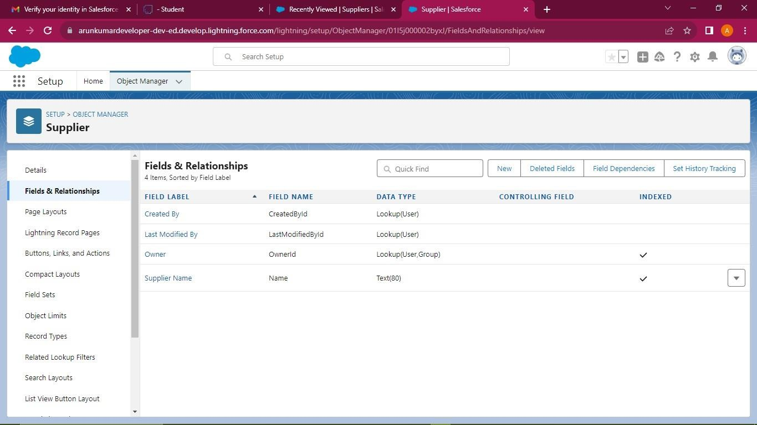

**Fields in Fuel Details Objects**

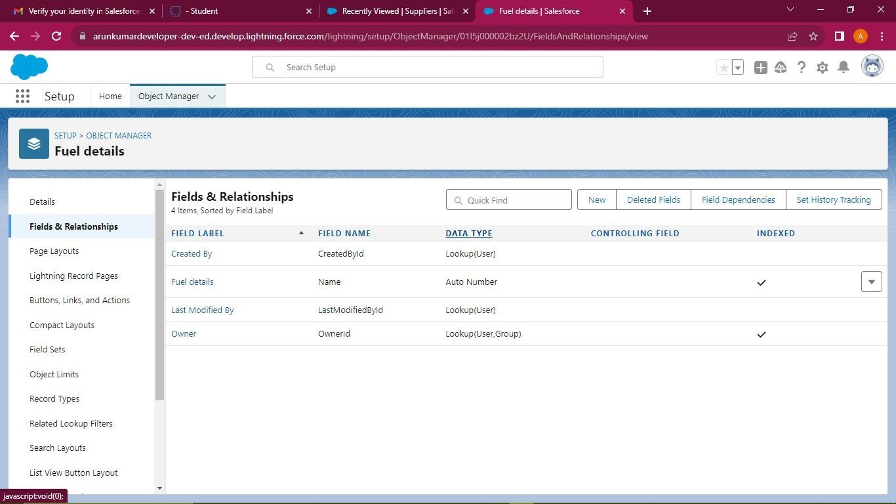

## Creating a Master-Detail relationship

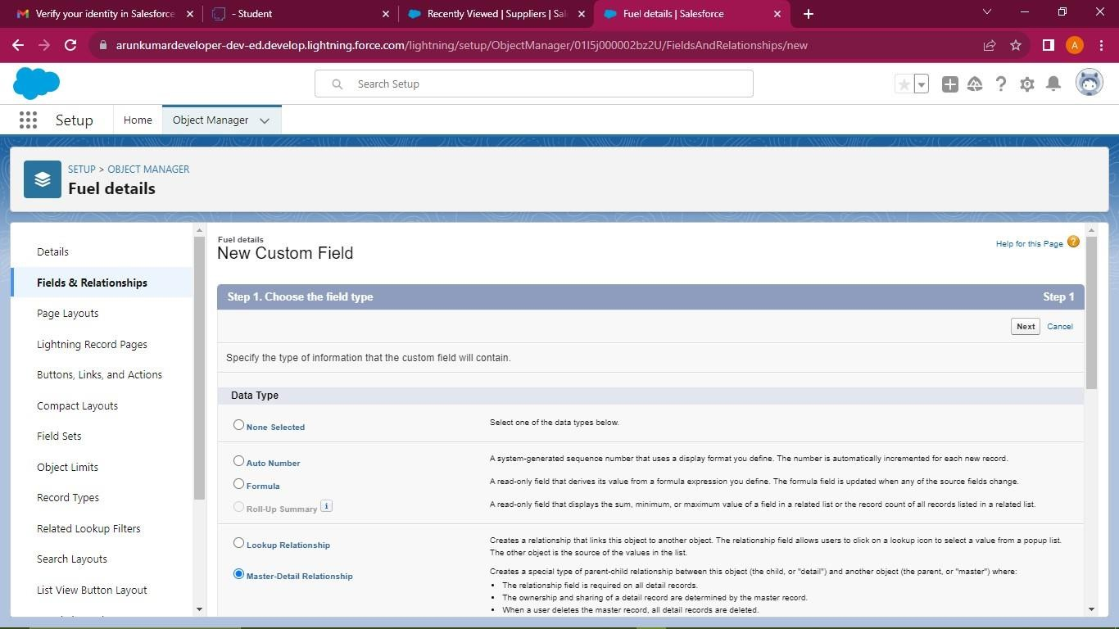

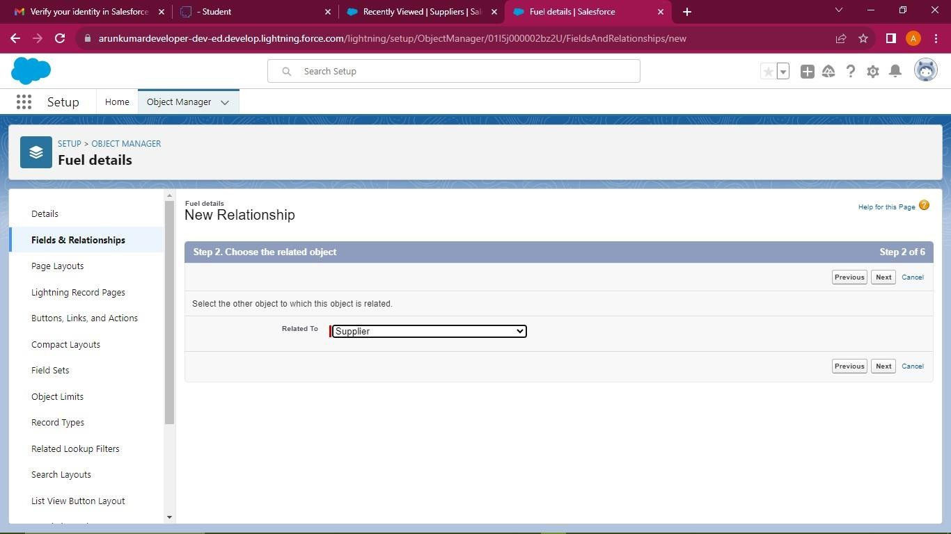

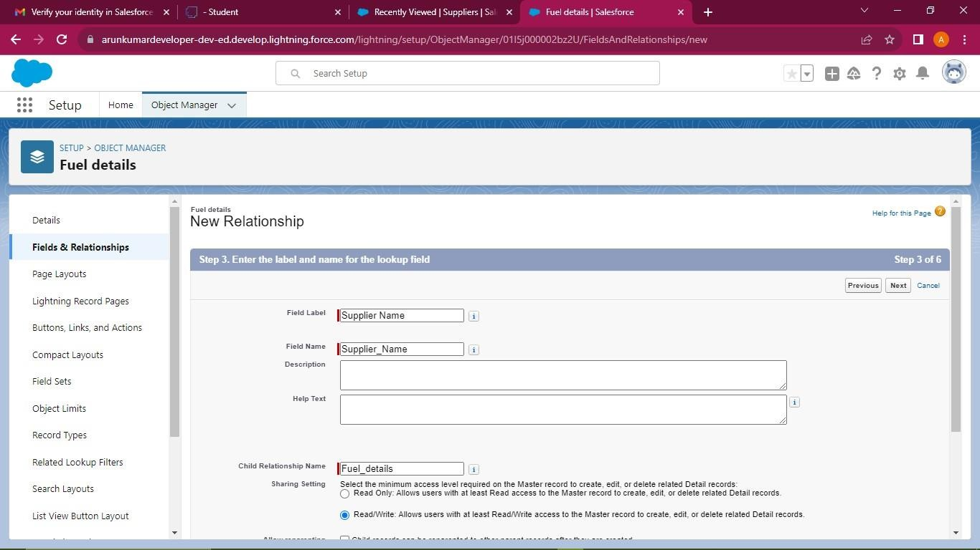

**Creating the number field**

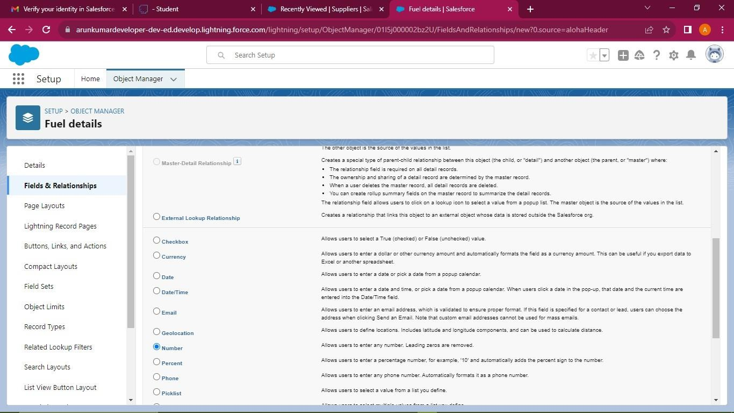

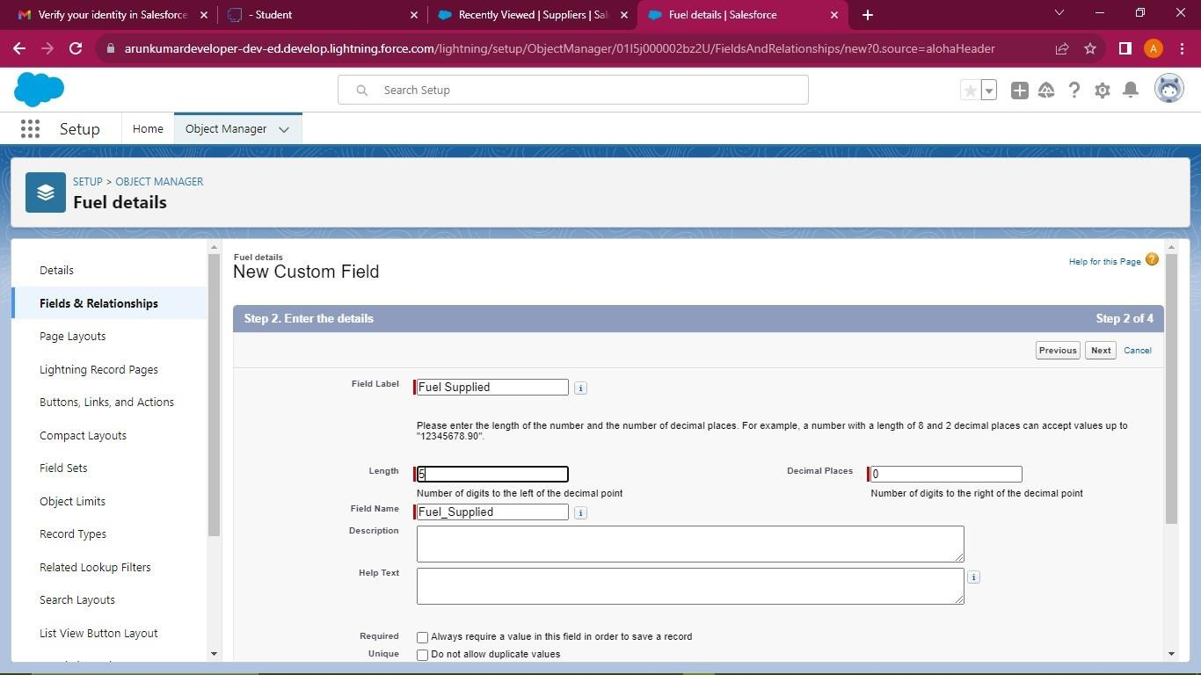

## Fields in Buyer Objects

**Creating a Master_Detail Relationship**

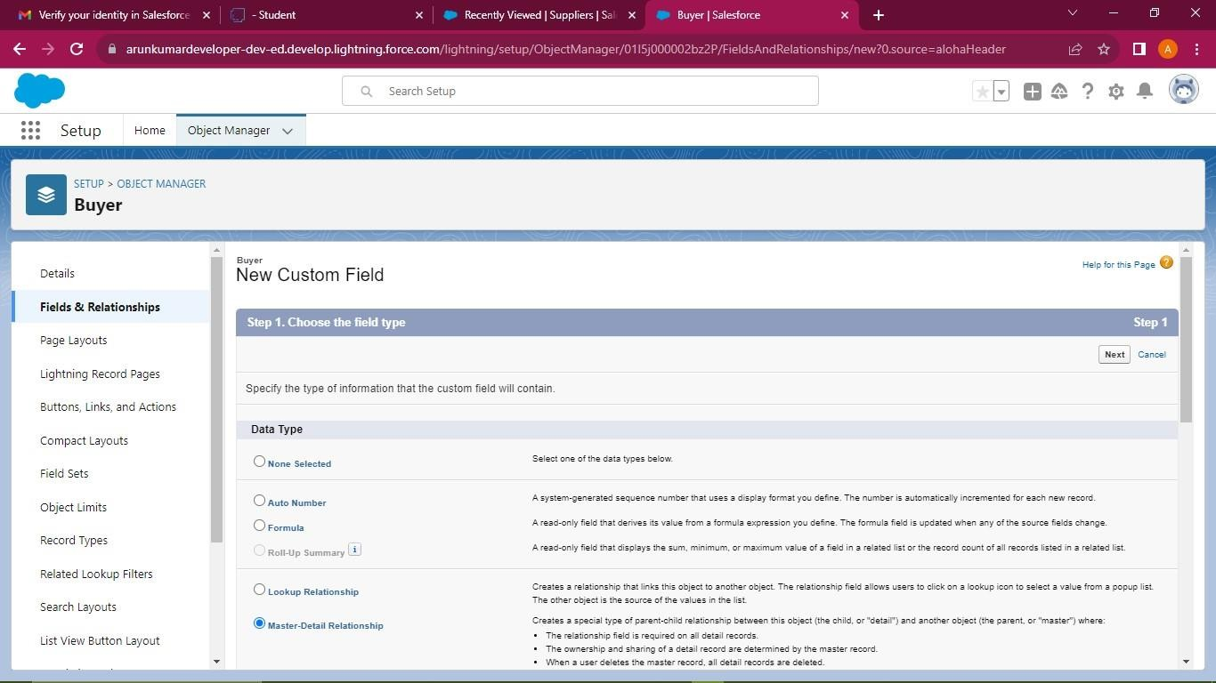

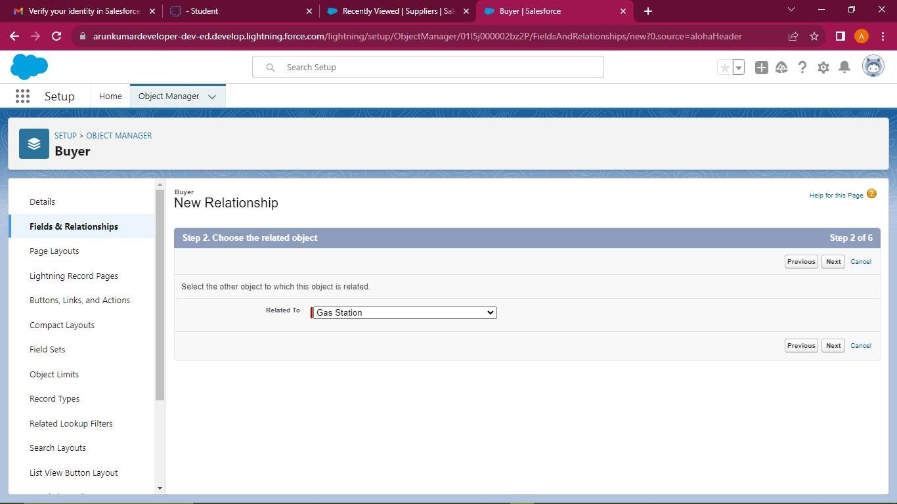

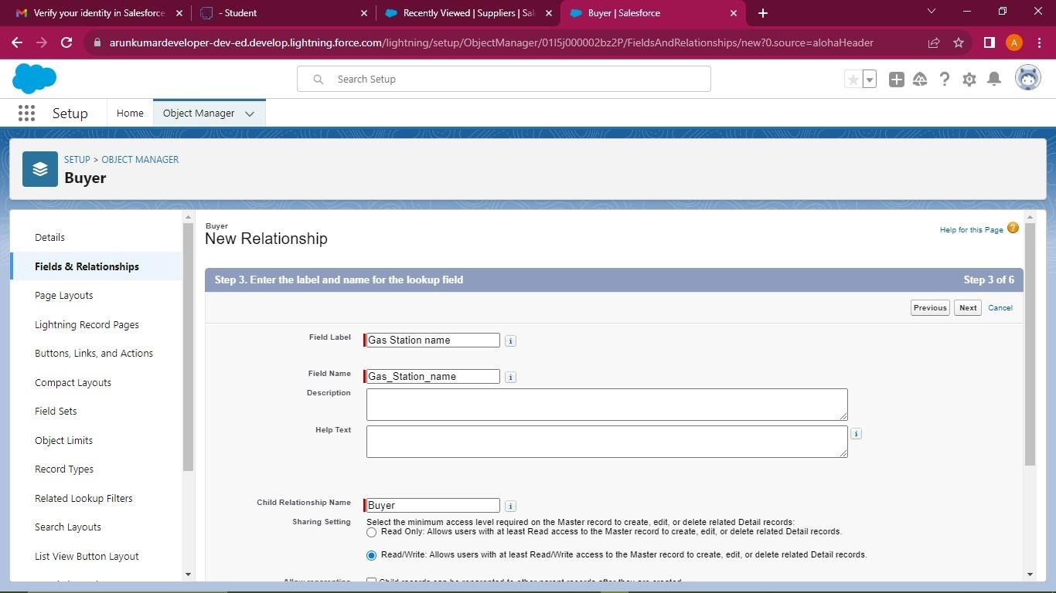

## Creating the number field

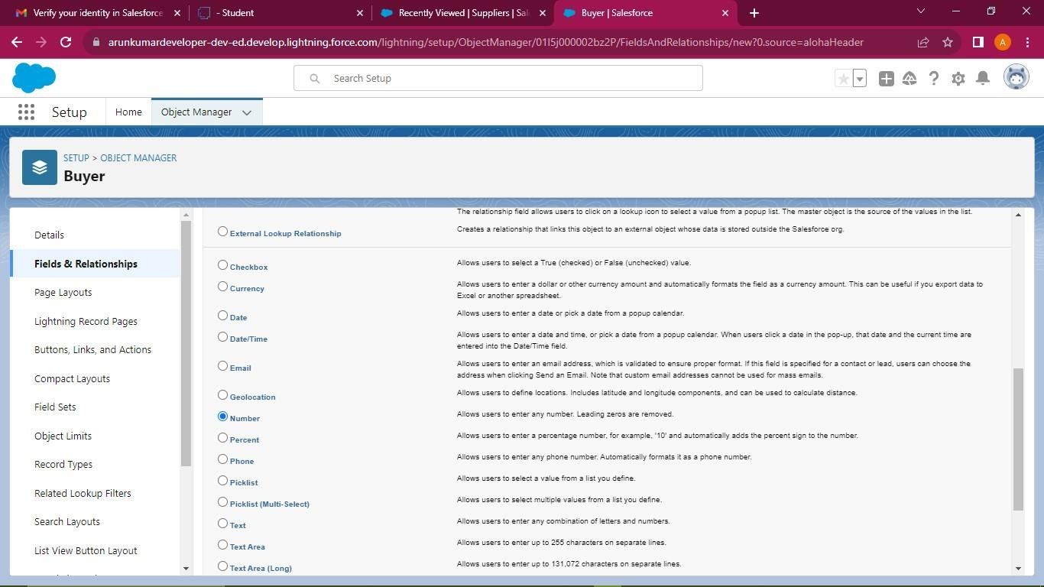

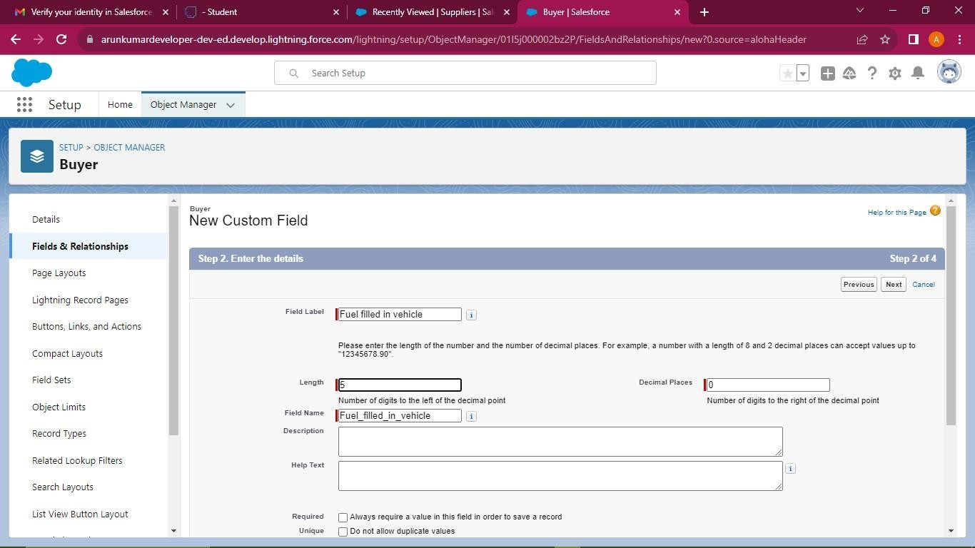

**Creating the formula field**

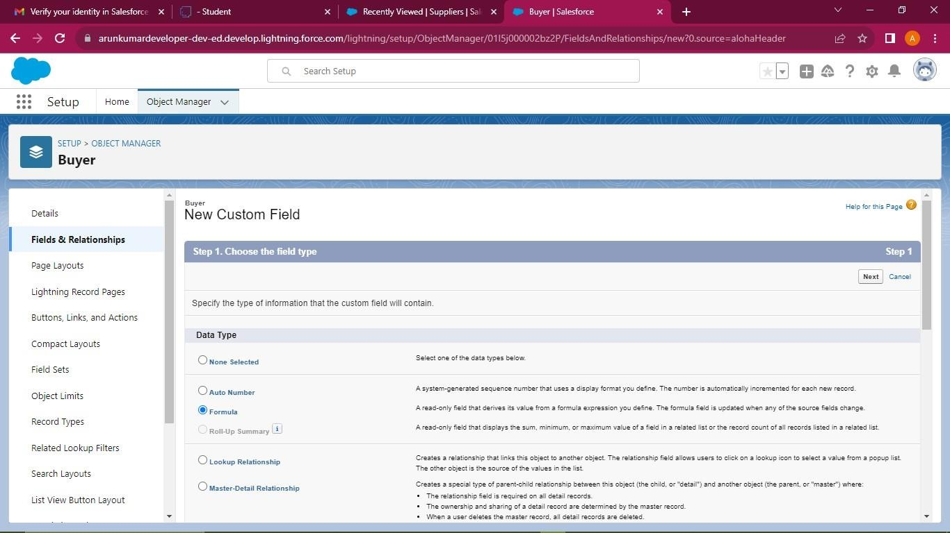

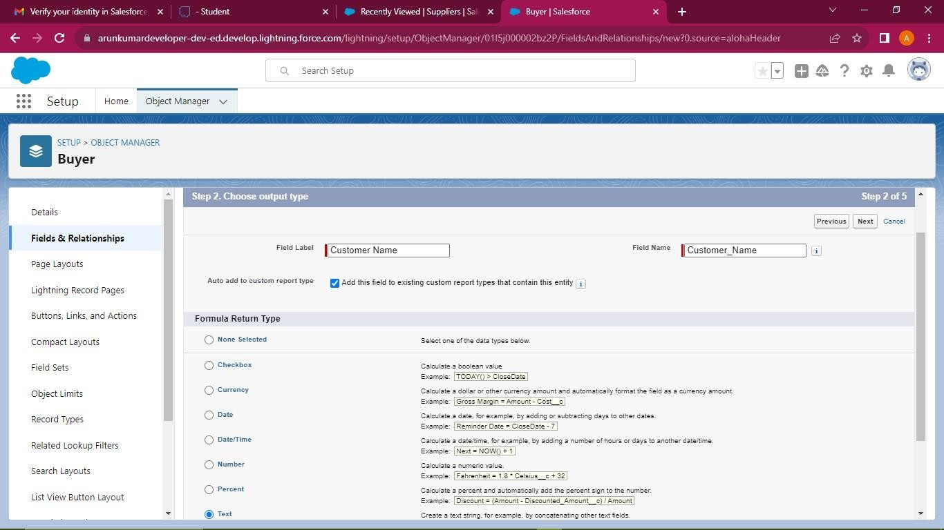

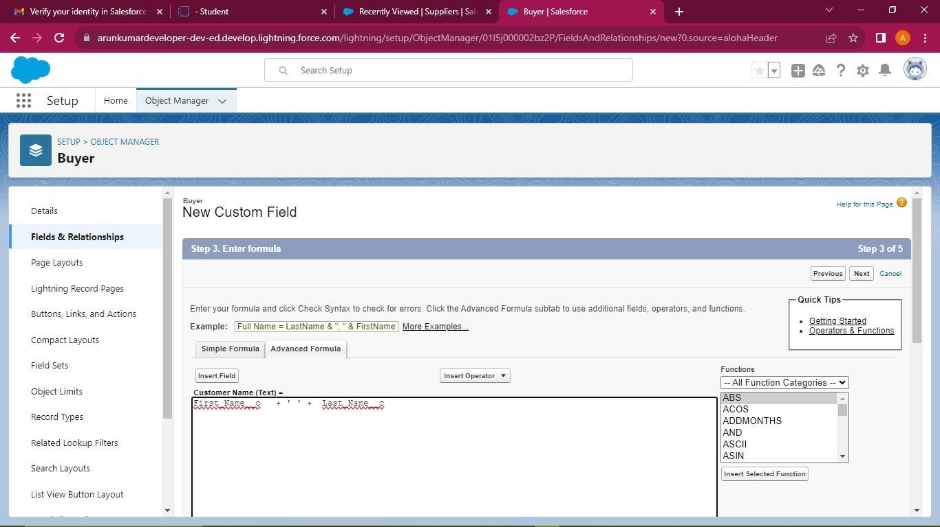

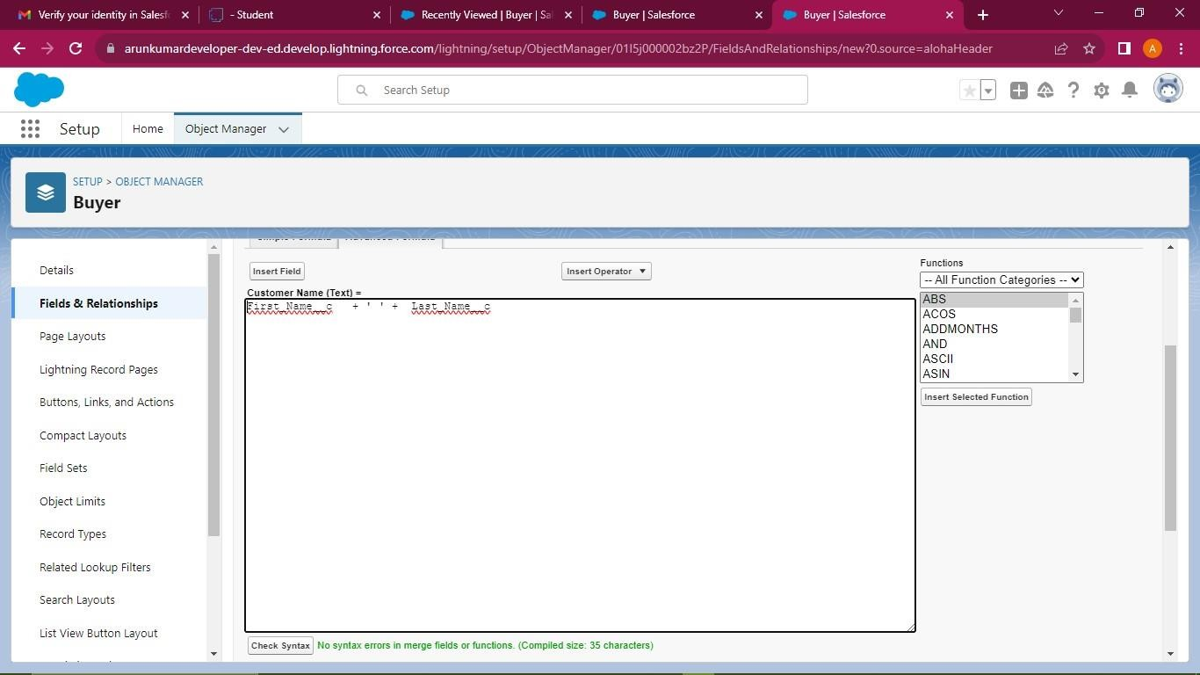

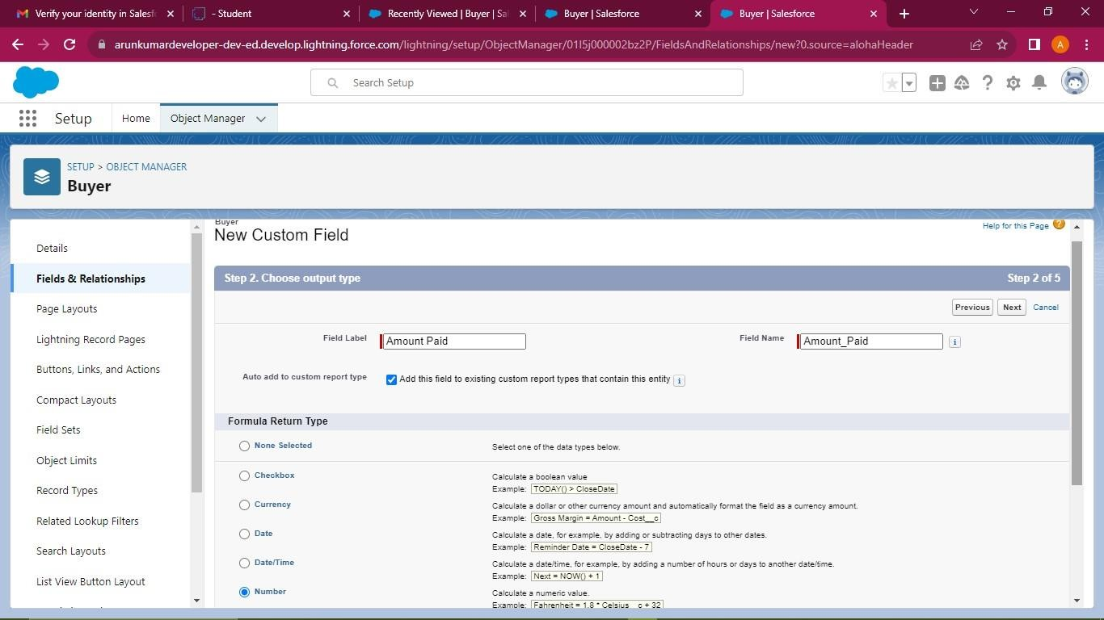

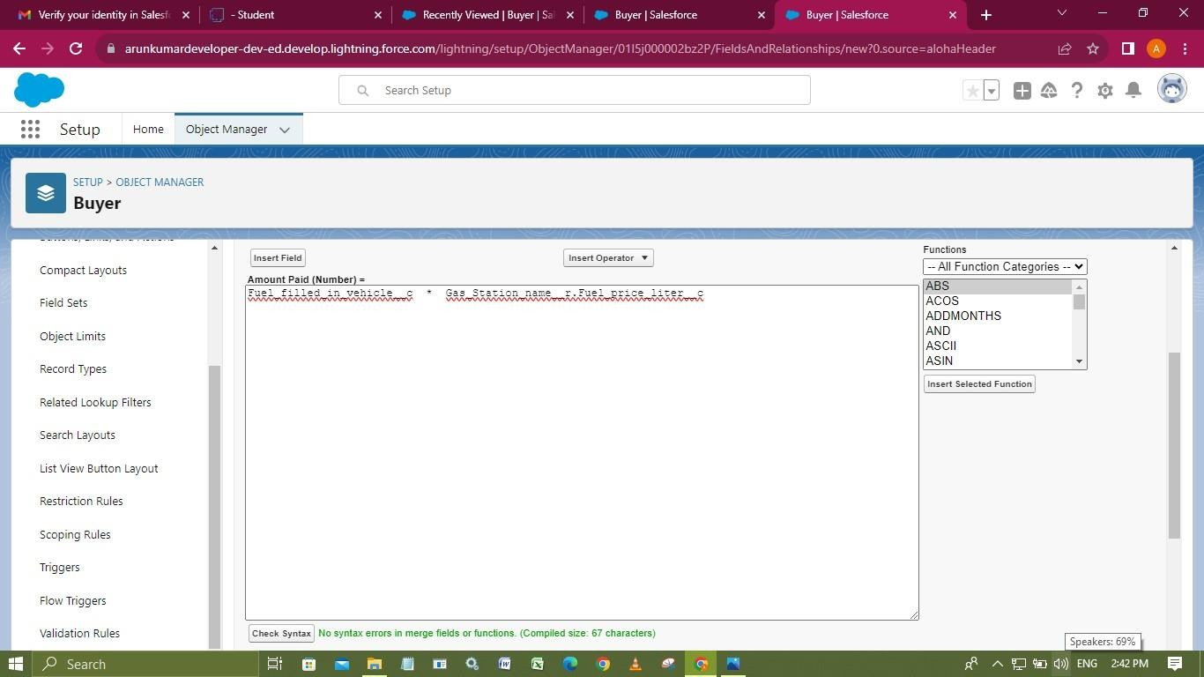

## Creating the picklist field

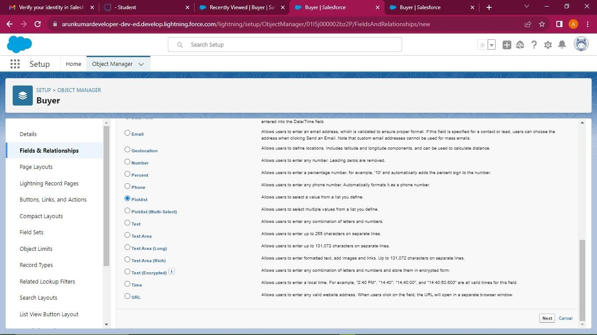

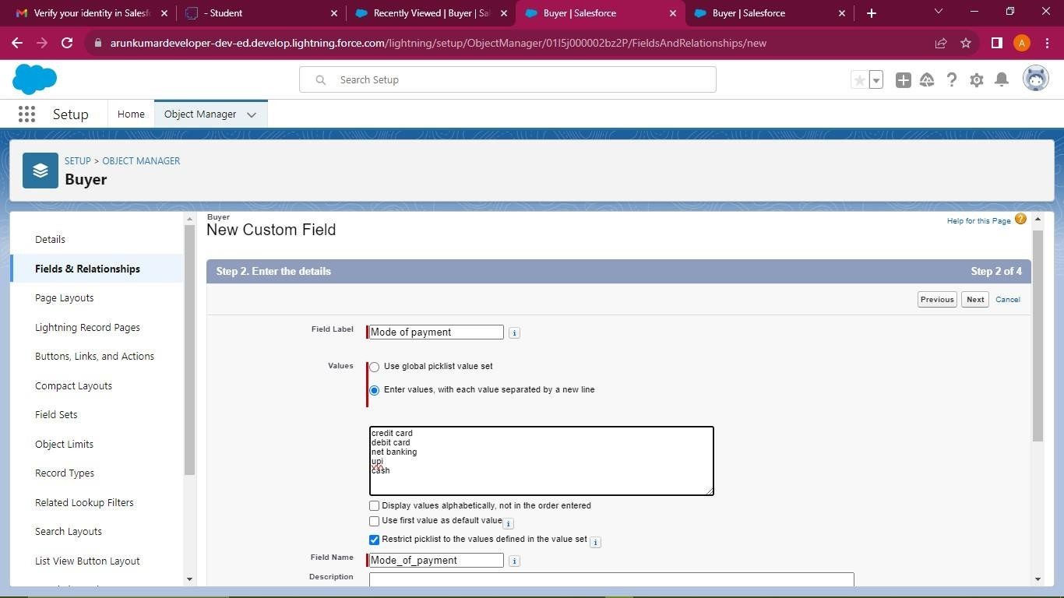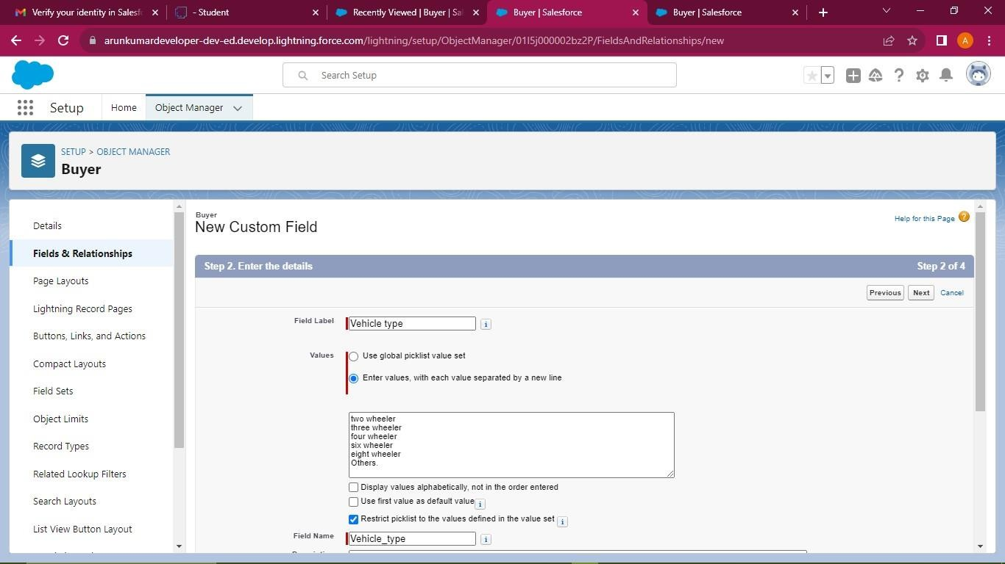

**Fields in Supplier Objects Creating a roll-up summary**

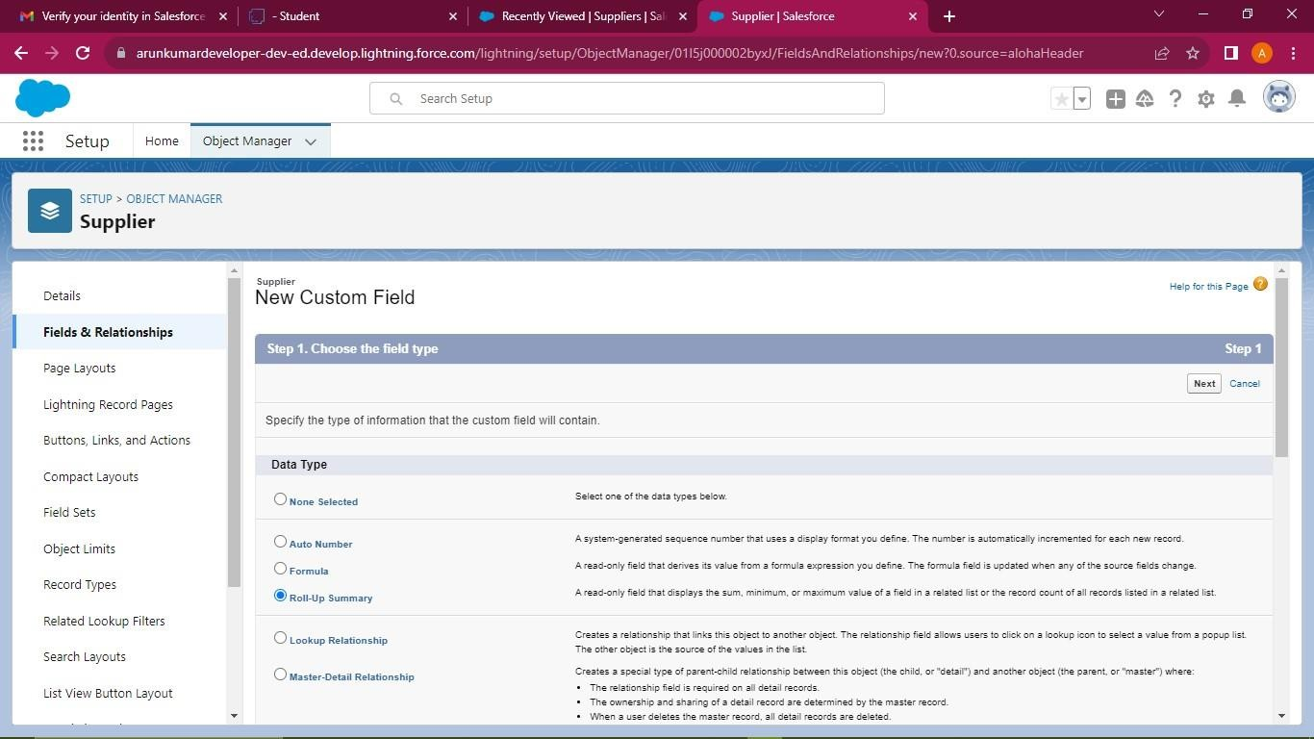

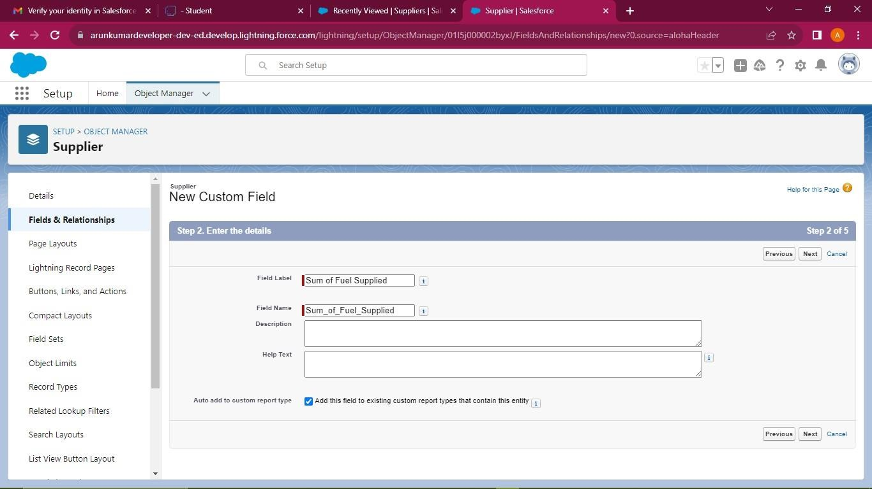

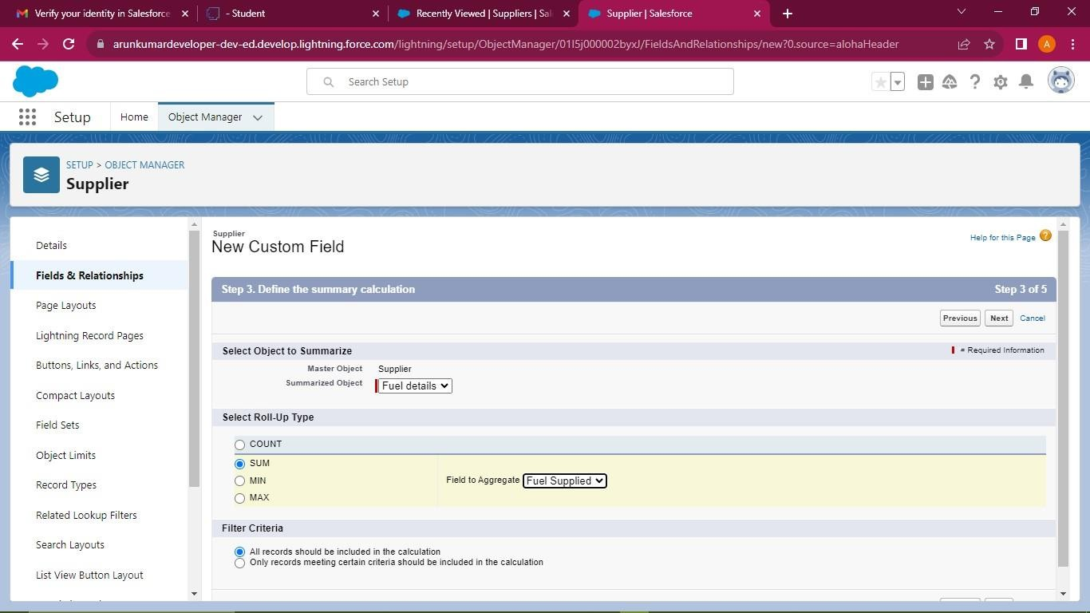

## Fields in Gas Station Objects Creating a roll-up summary

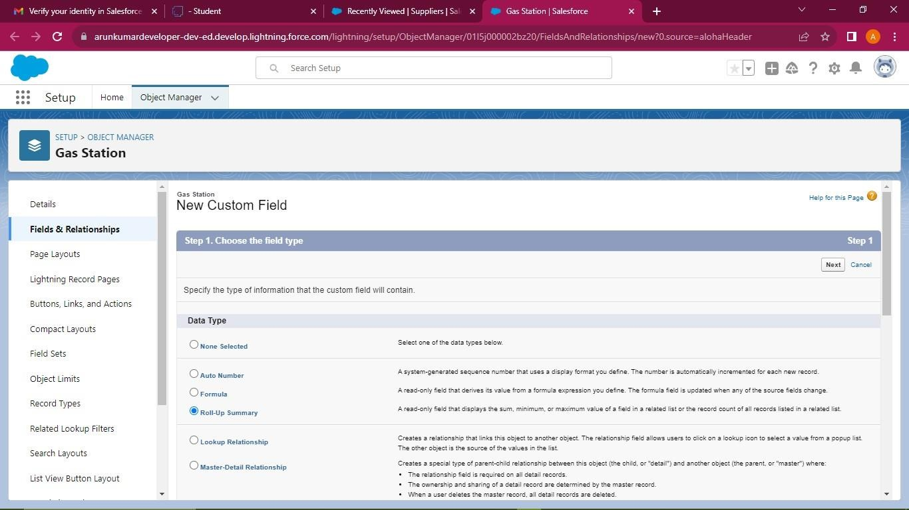

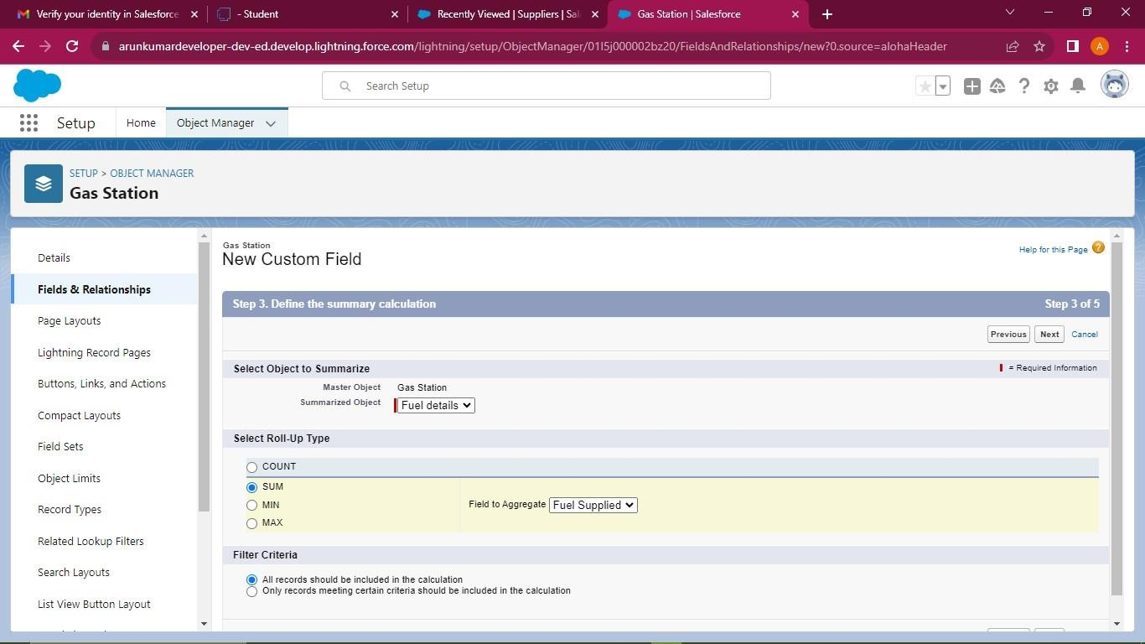

**Creating the formula field**

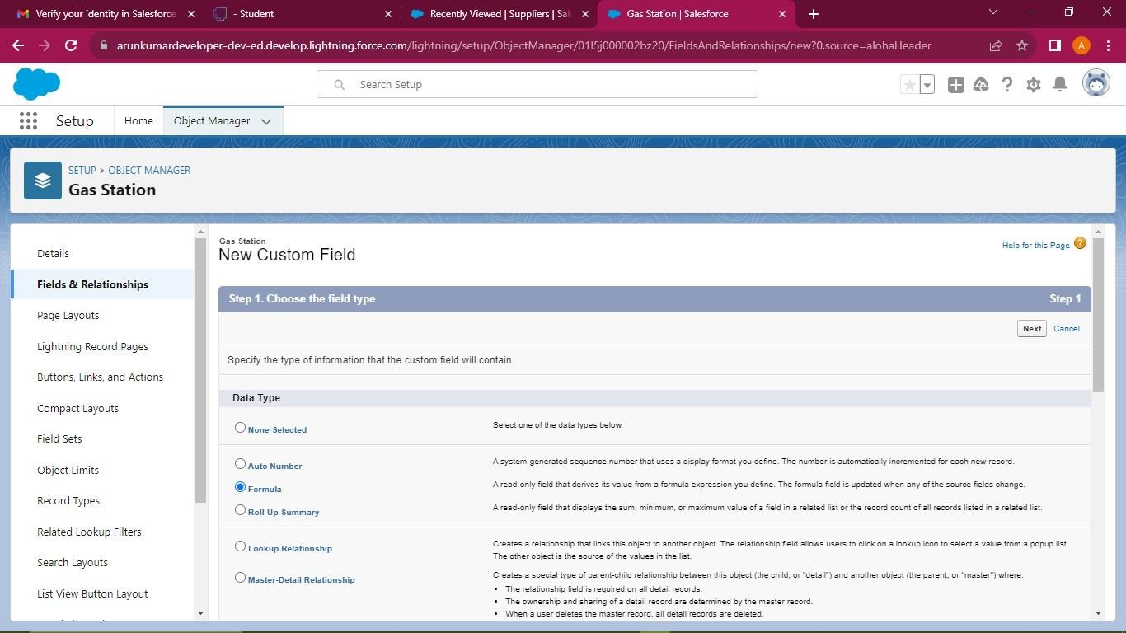

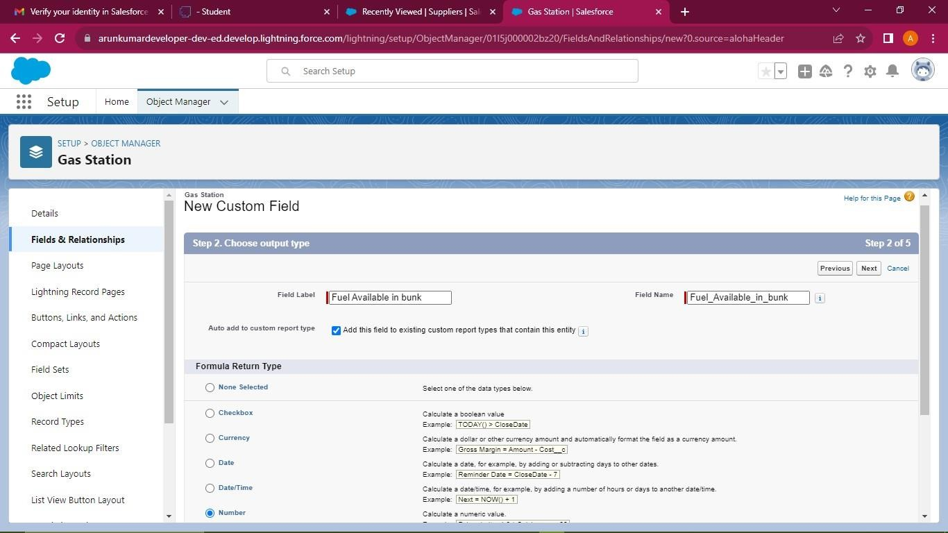

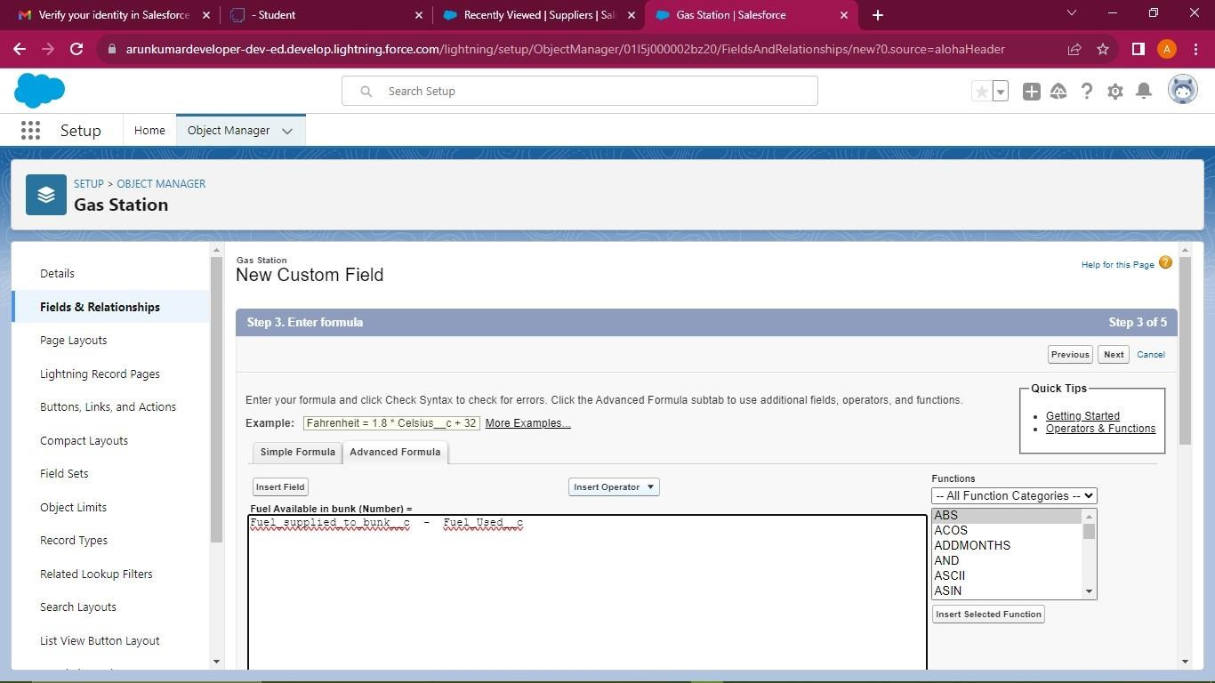

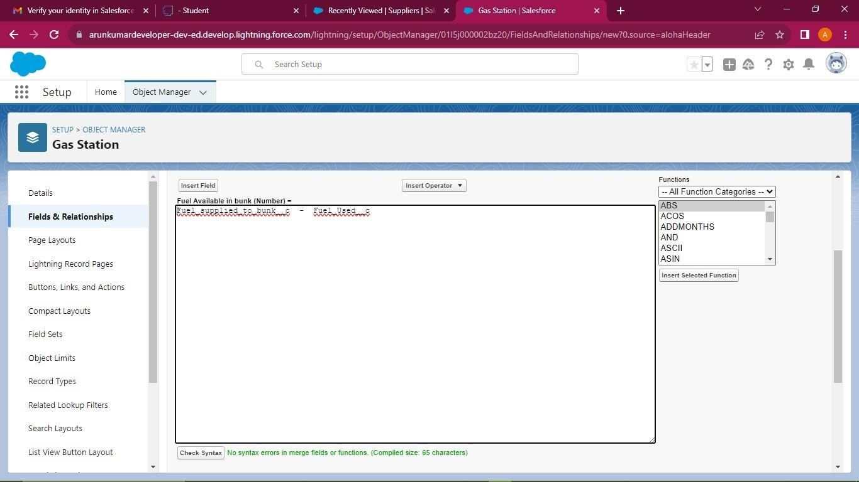

## Page Layouts

In Salesforce, page layouts define the organization and arrangement of fields, buttons, related lists, and other components on an object's detail and edit pages.

## Creating the Page Layout

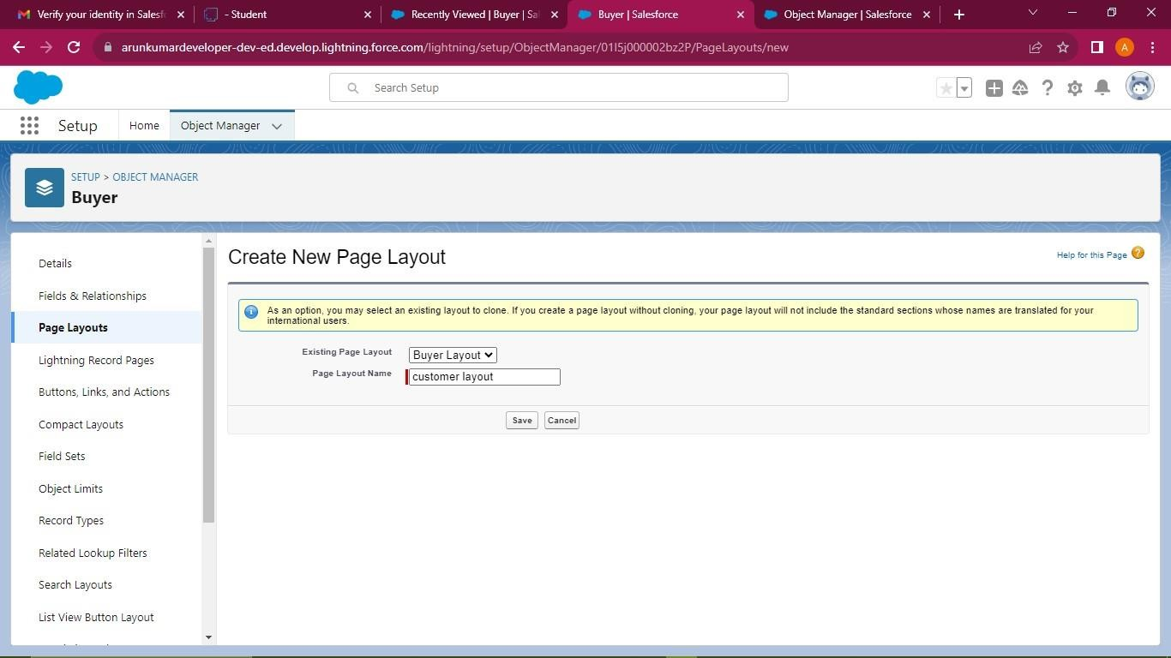

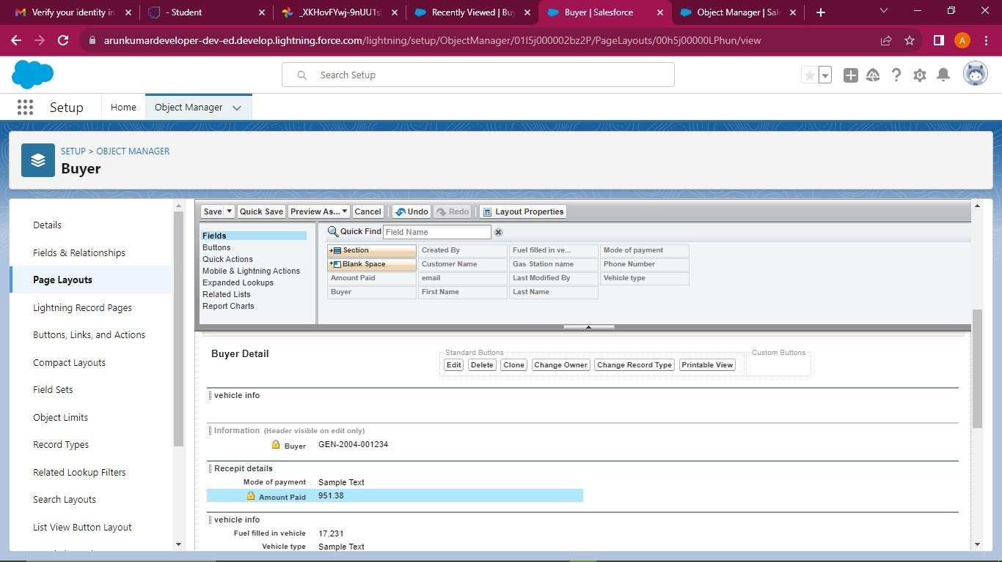

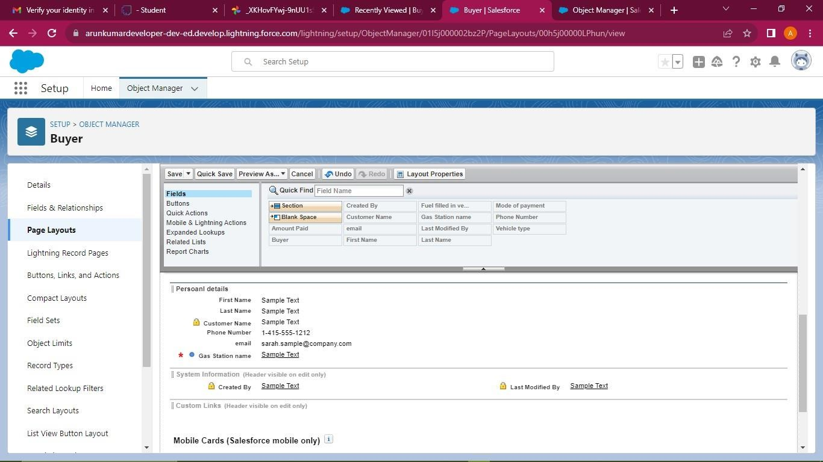

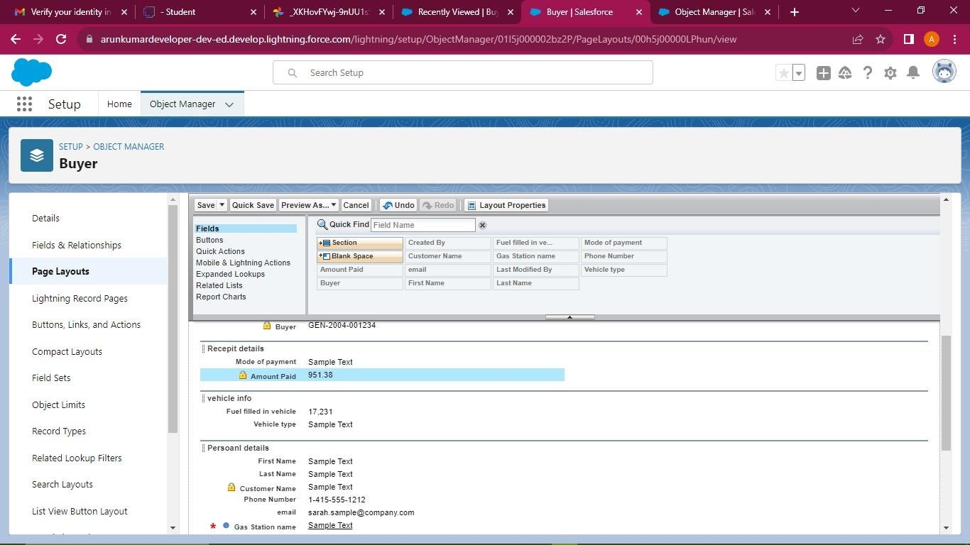

## Profile

# CHAPTER-3

**USERS & DATA SECURITY**

A profile is a group/collection of settings and permissions that define what a user can do in salesforce. A profile controls “Object permissions, Field permissions, User permissions, Tab settings, App settings, Apex class access, Visualforce page access, Page layouts, Record Types, Login hours & Login IP ranges.

## Creating a Profiles

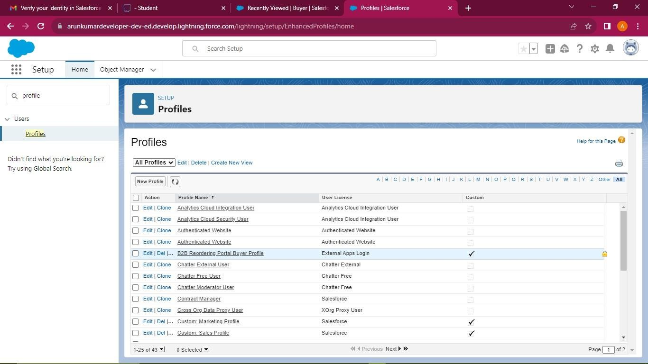

**To create a new profile (Manager)**

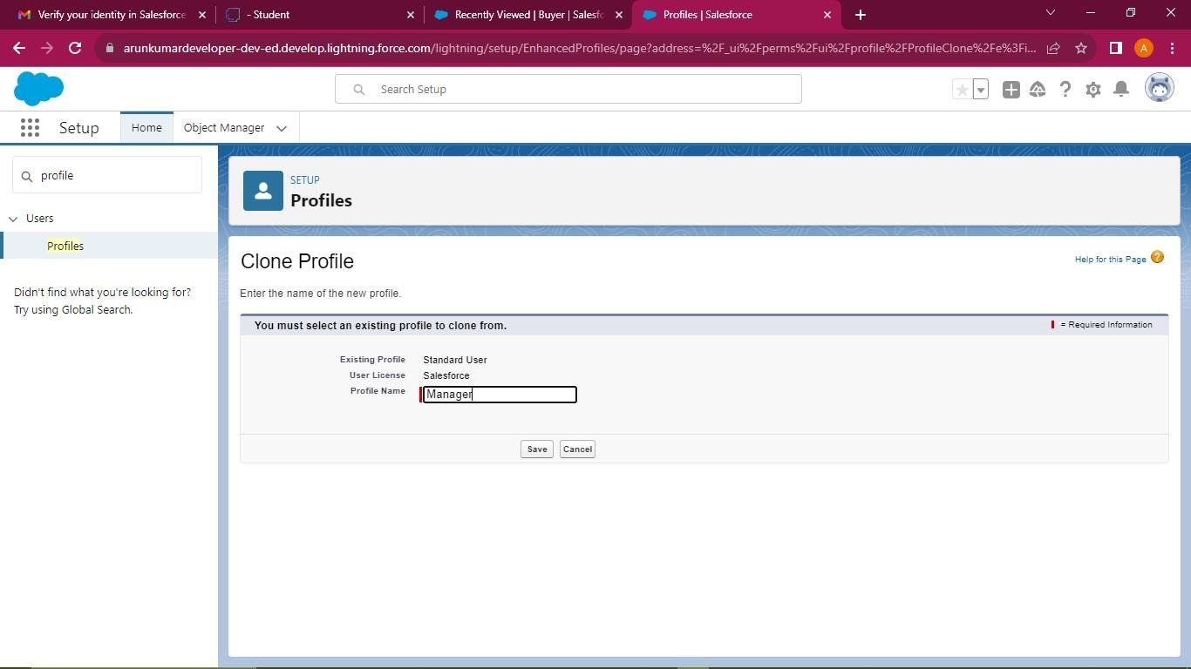

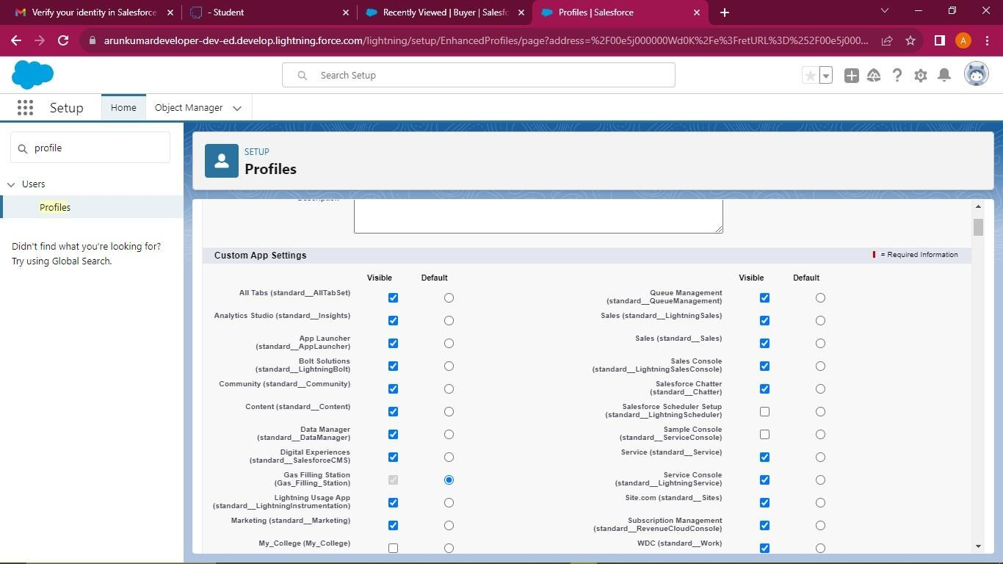

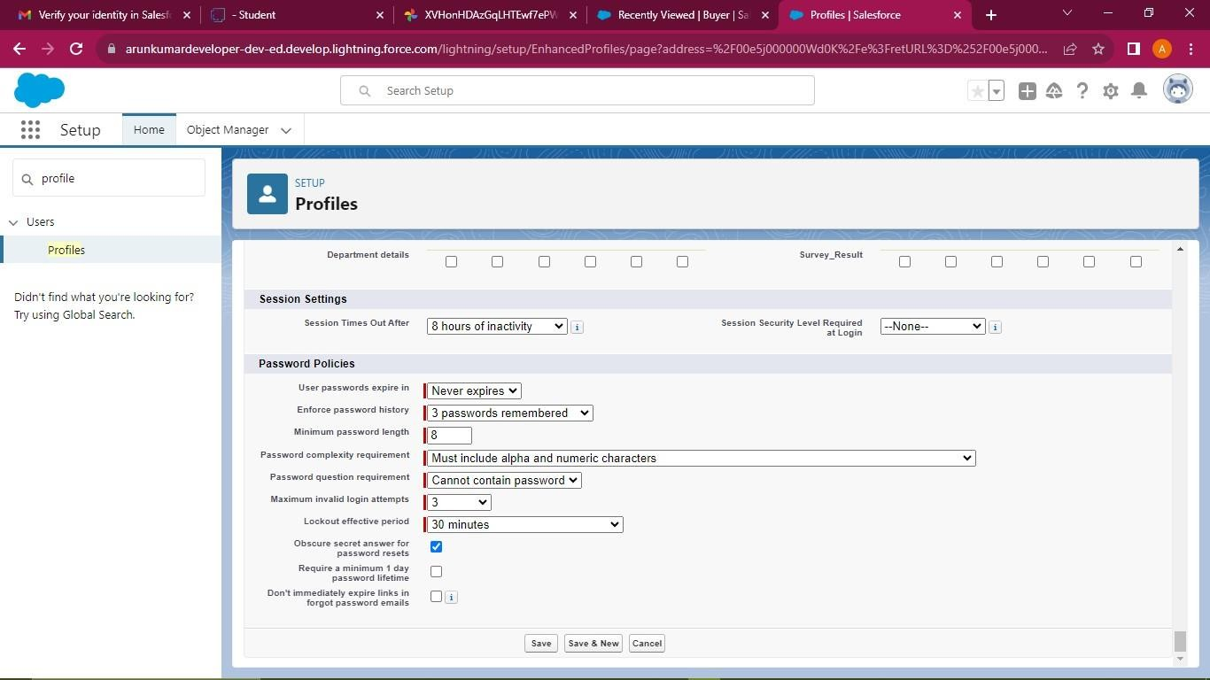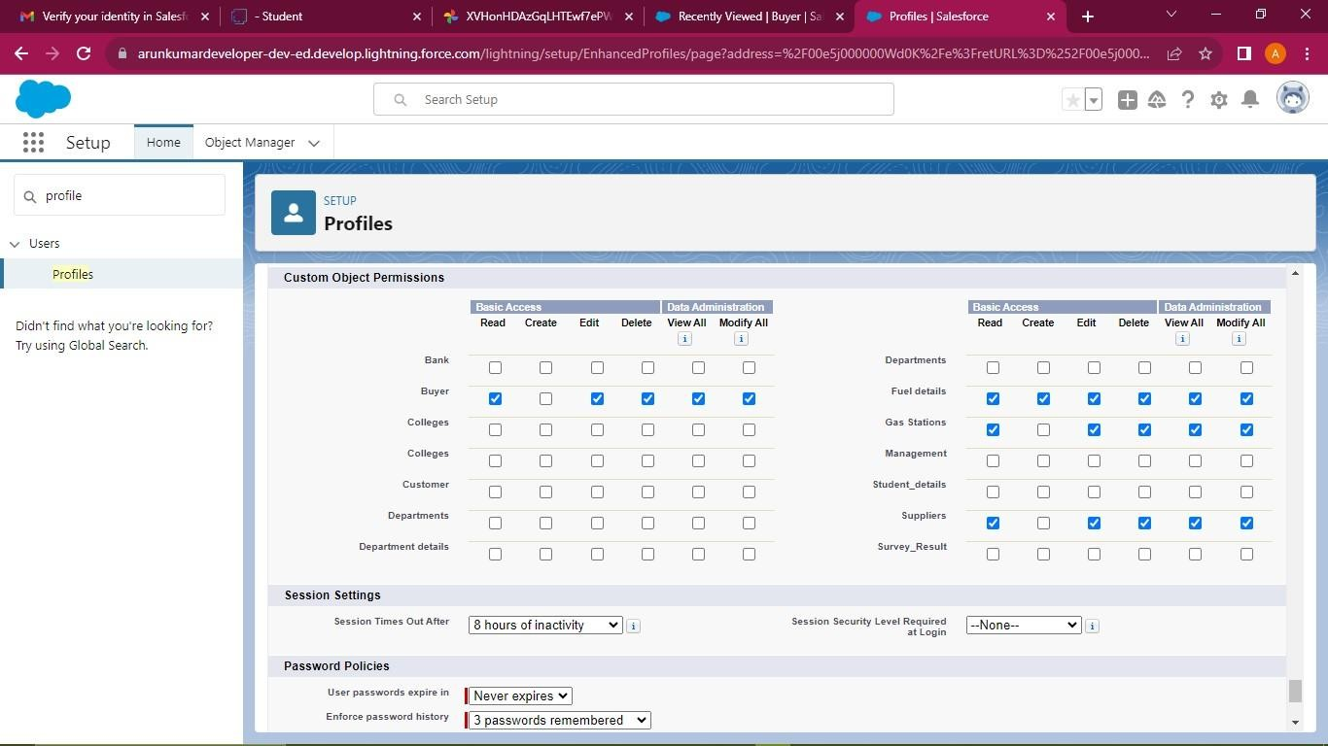

## To create a new profile (Sales Executive)

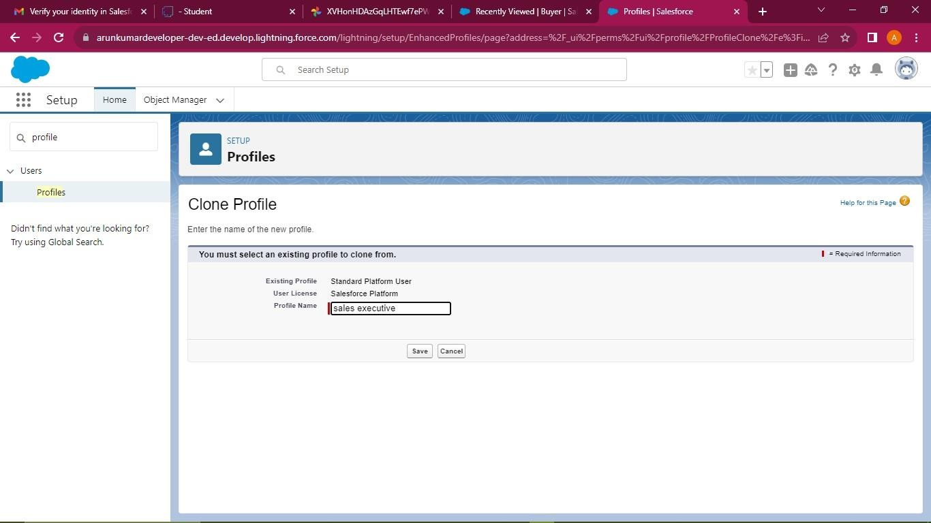

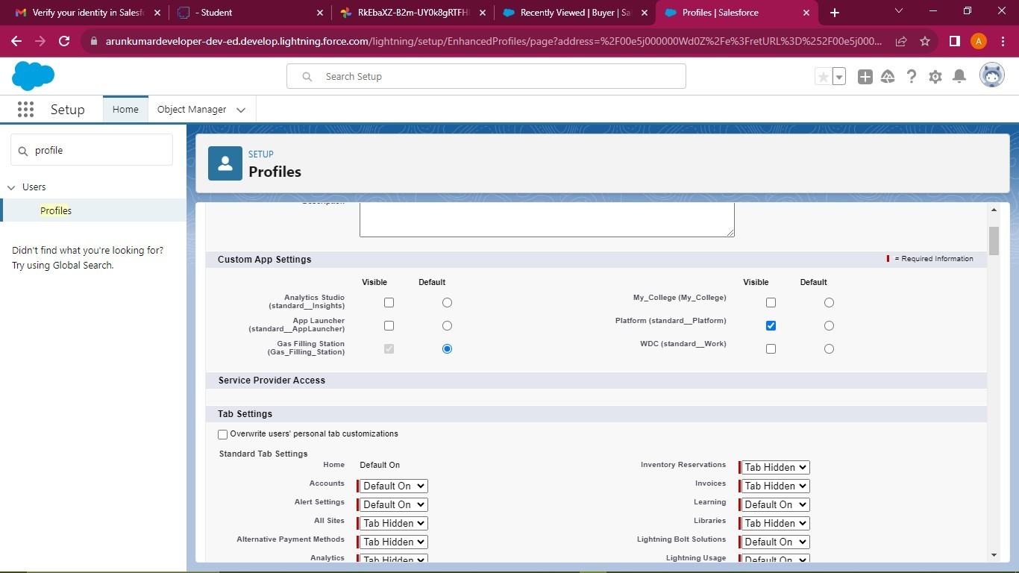

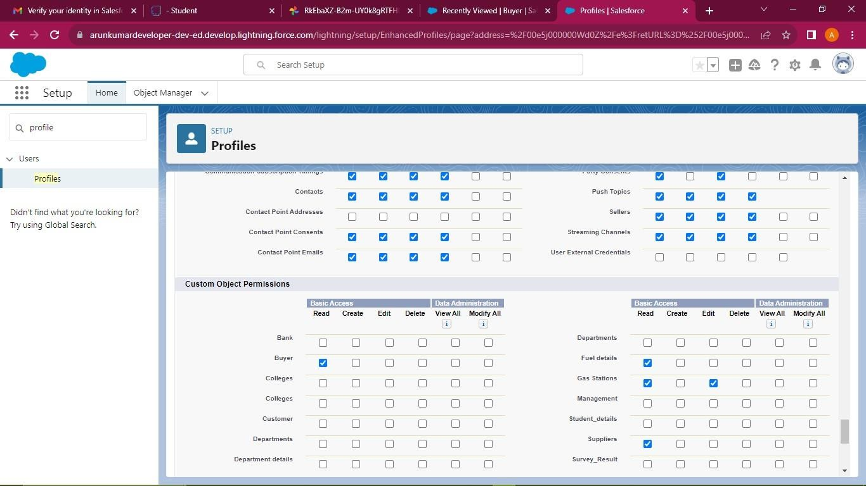

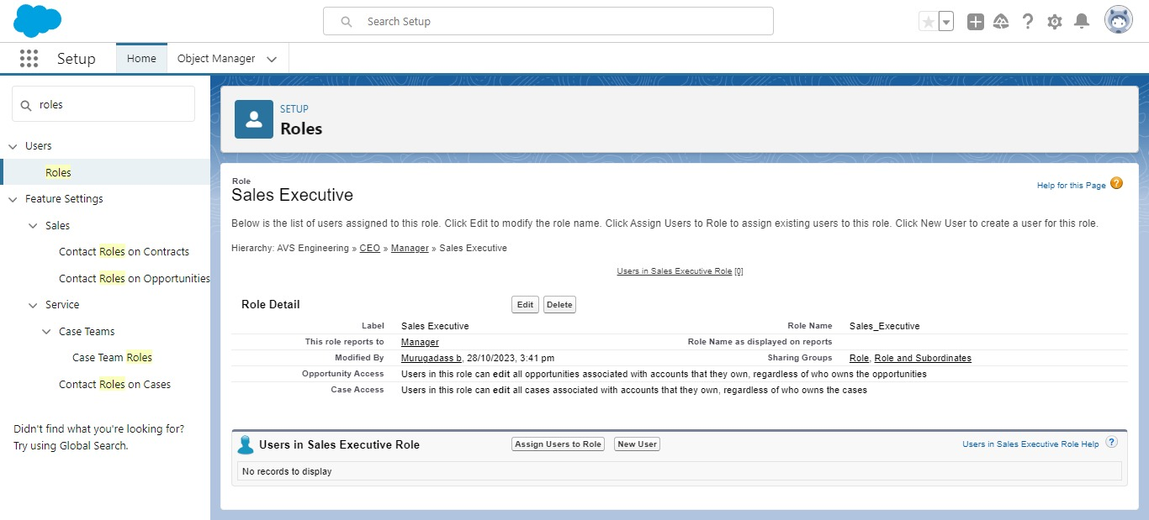

**To create a new profile (Sales Person)**

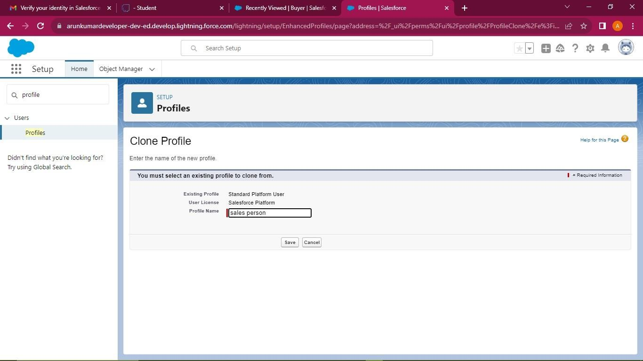

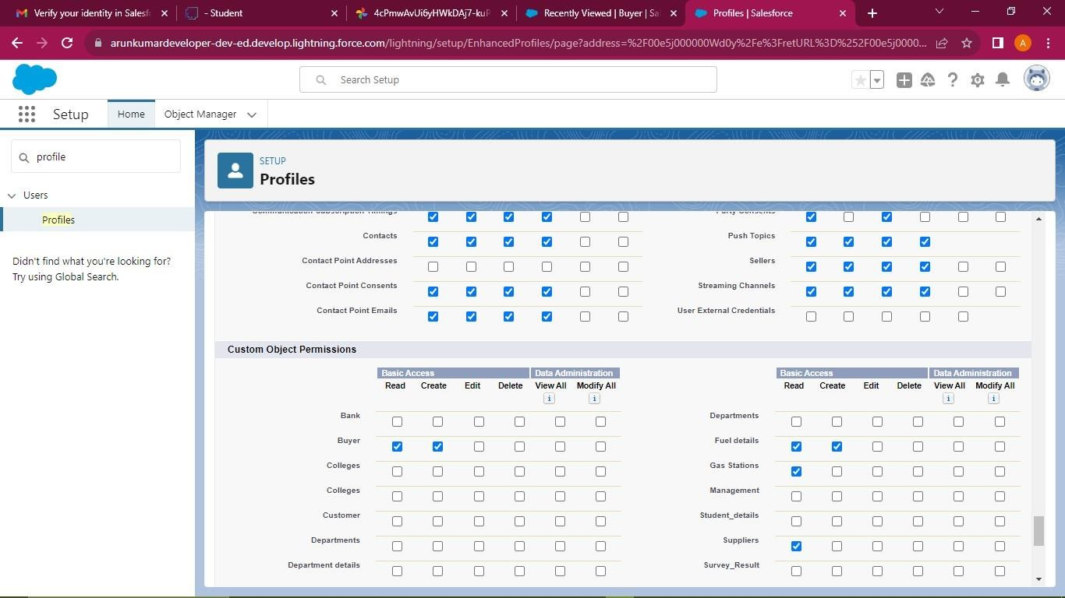

## Setup Roles

Salesforce roles are record-level access controls that define what data a user can see in Salesforce.

## Creating a Manager Role

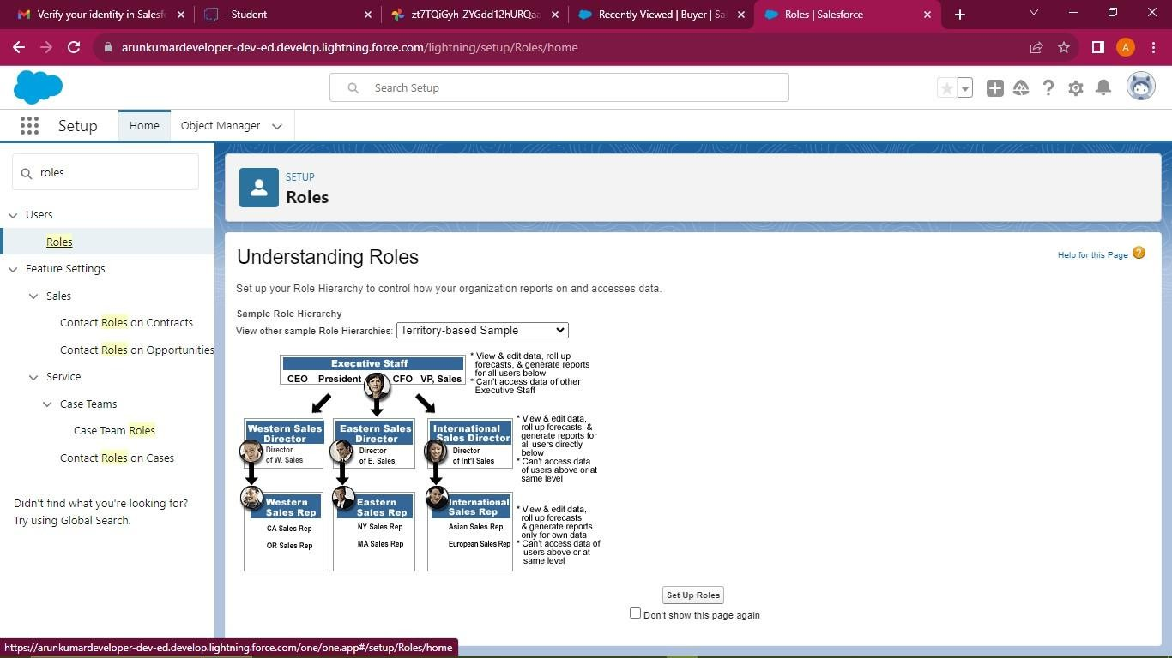

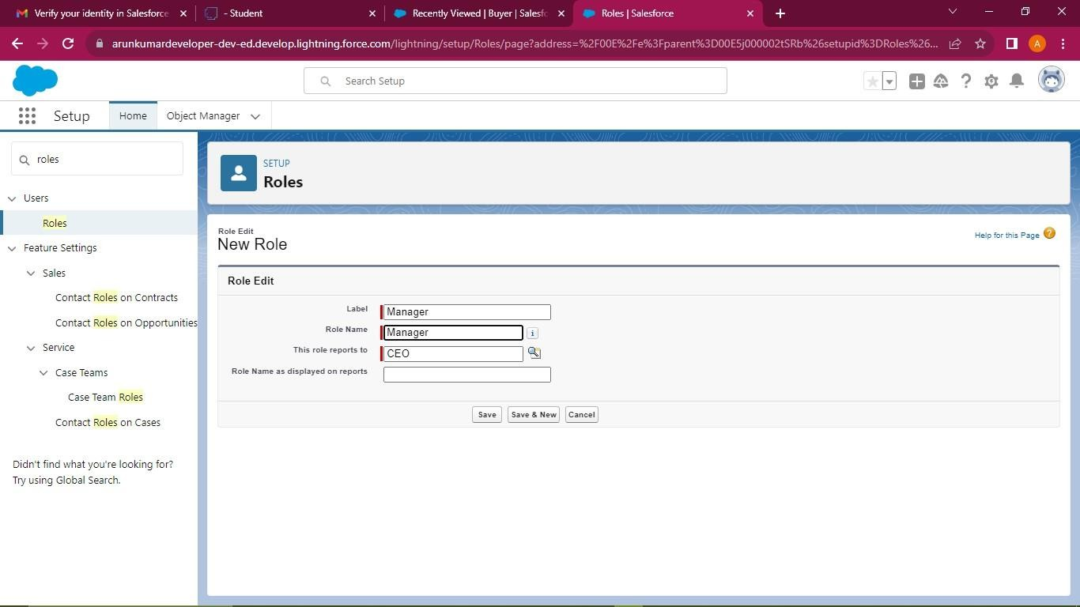

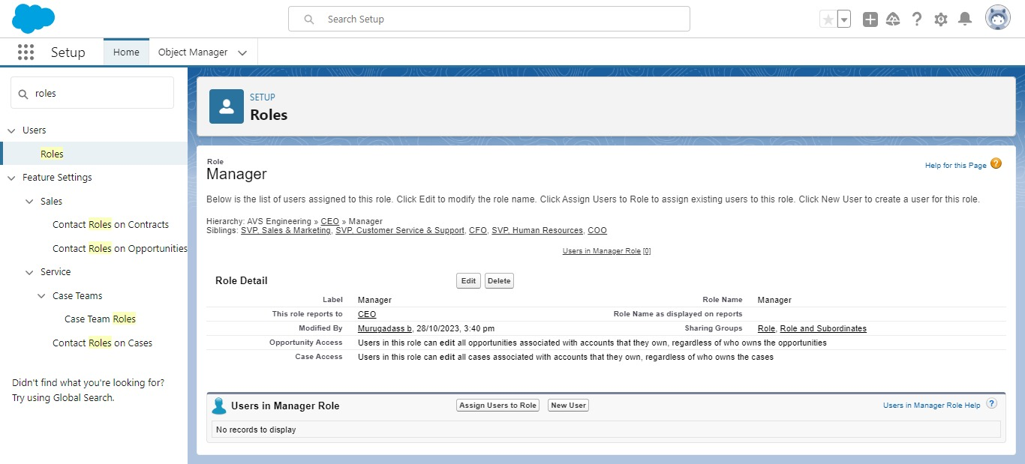

**Creating Another Roles**

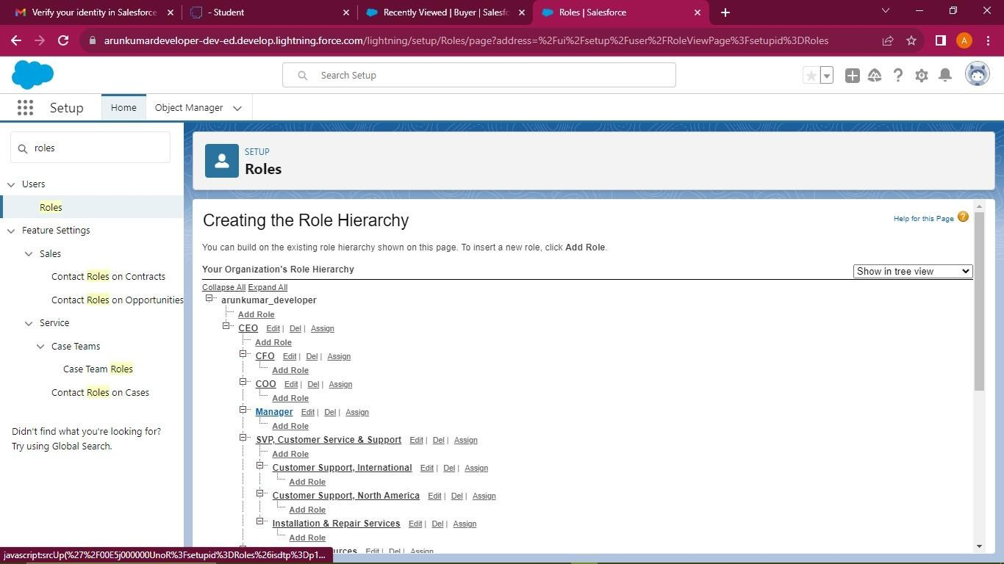

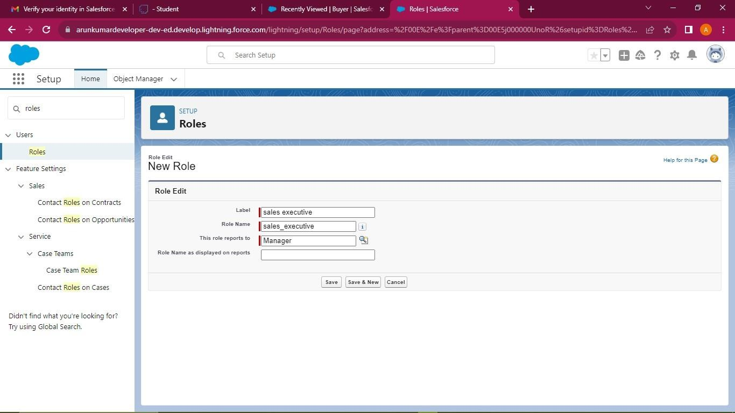

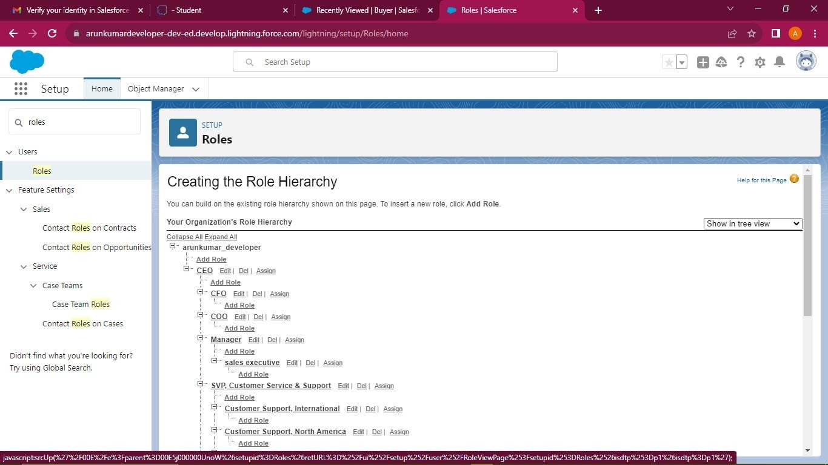

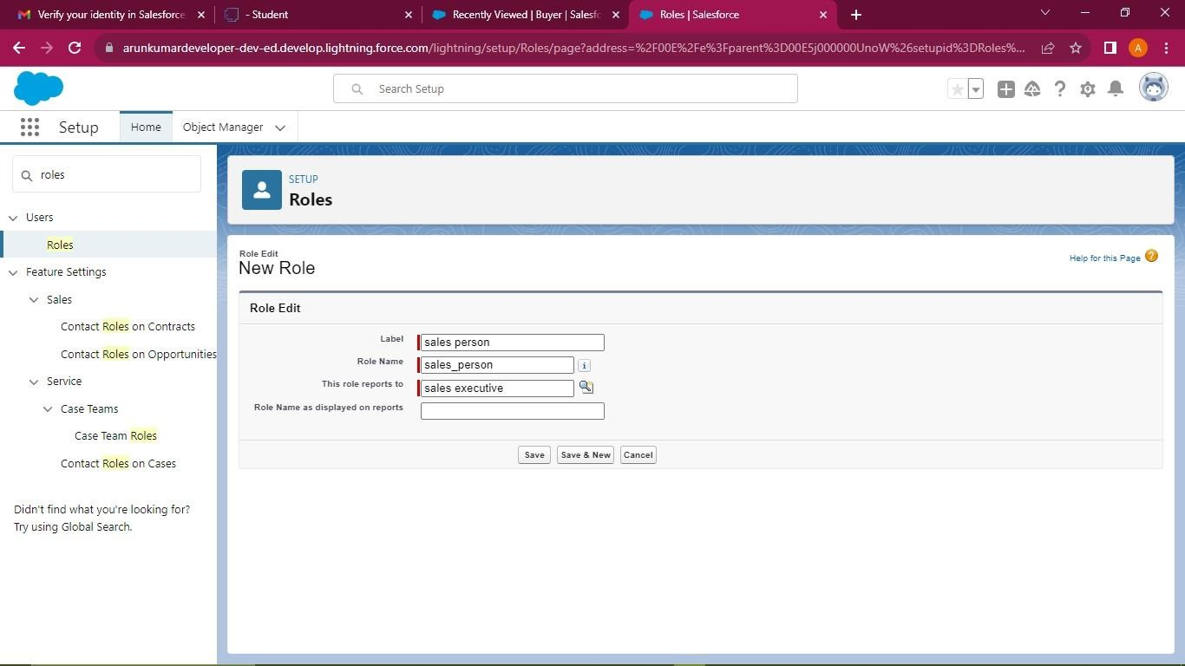

## Users

A user is anyone who logs in to Salesforce. Users are employees at your company, such as sales reps, managers, and IT specialists, who need access to the company's records. Every user in Salesforce has a user account.

## Create User

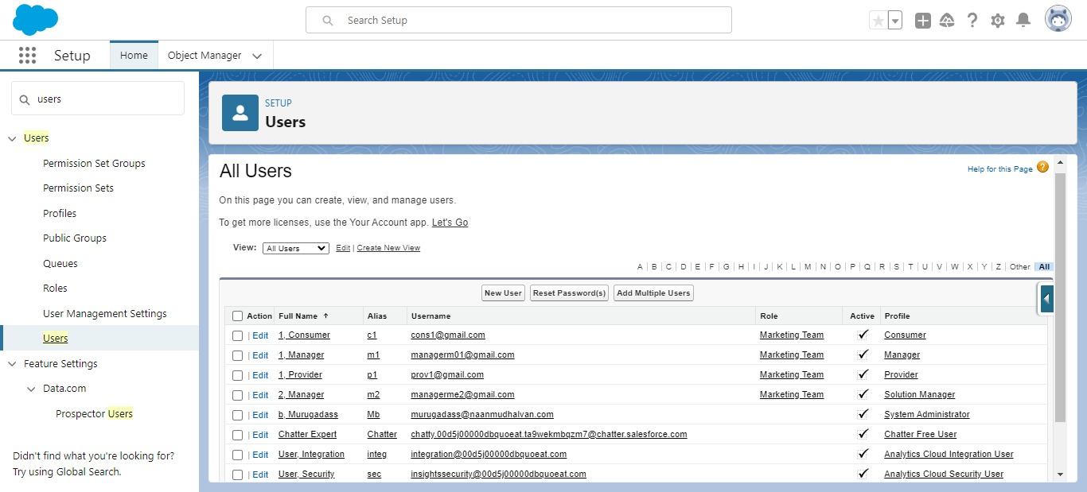

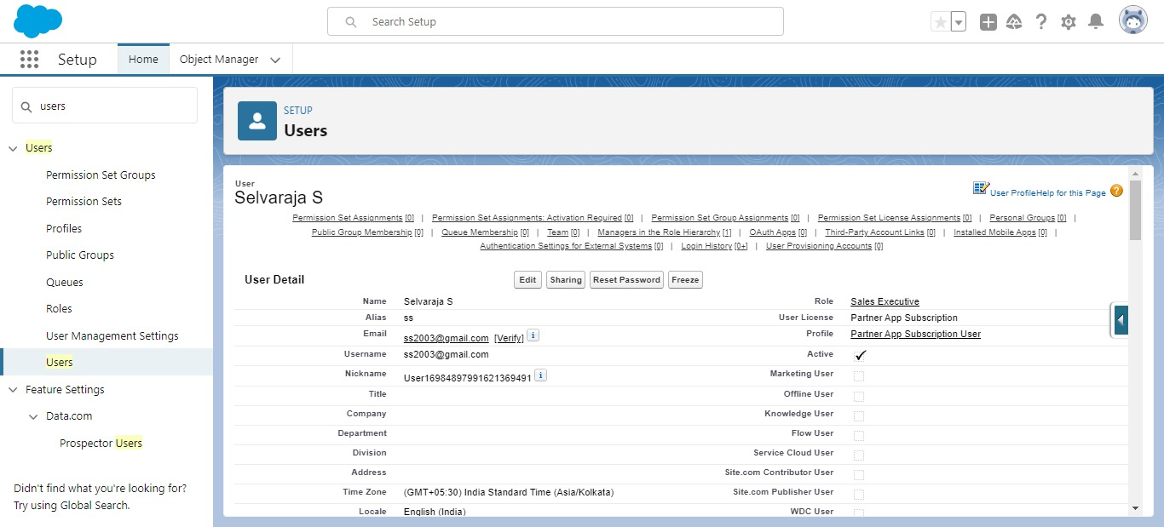

**Creating another Users**

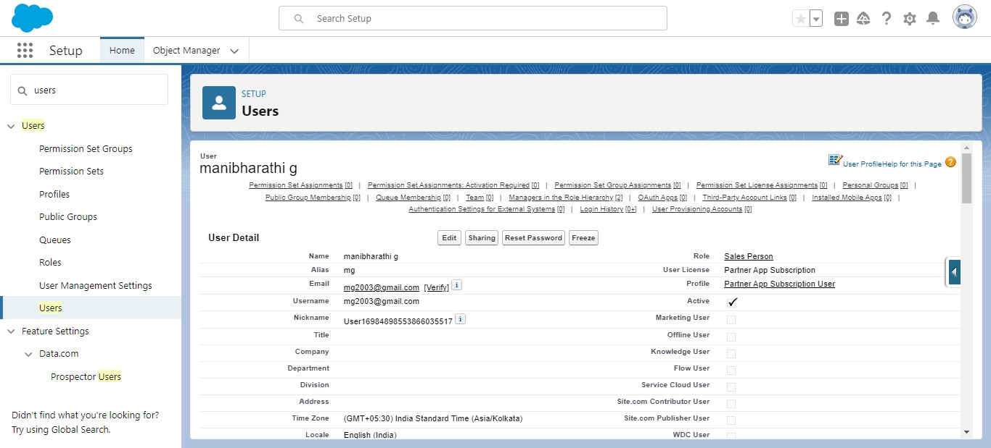

## Permission sets

A standard permission set consists of a group of common permissions for a particular feature associated with a permission set license. Using a standard permission set saves you time and facilitates administration because you don't need to create the custom permission set.

## Creating Permission Set

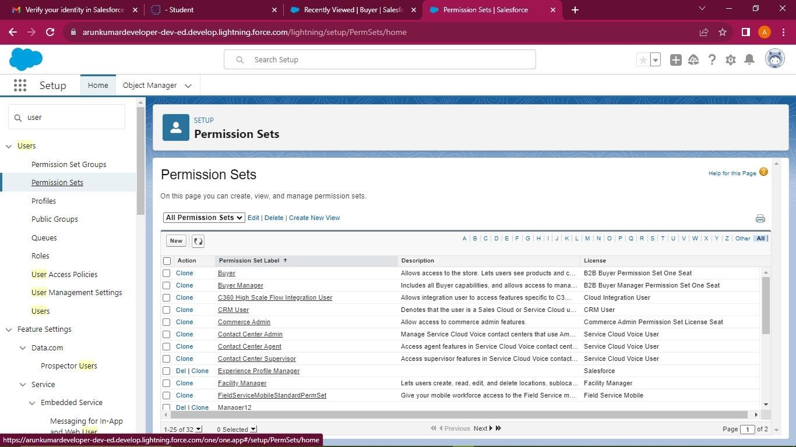

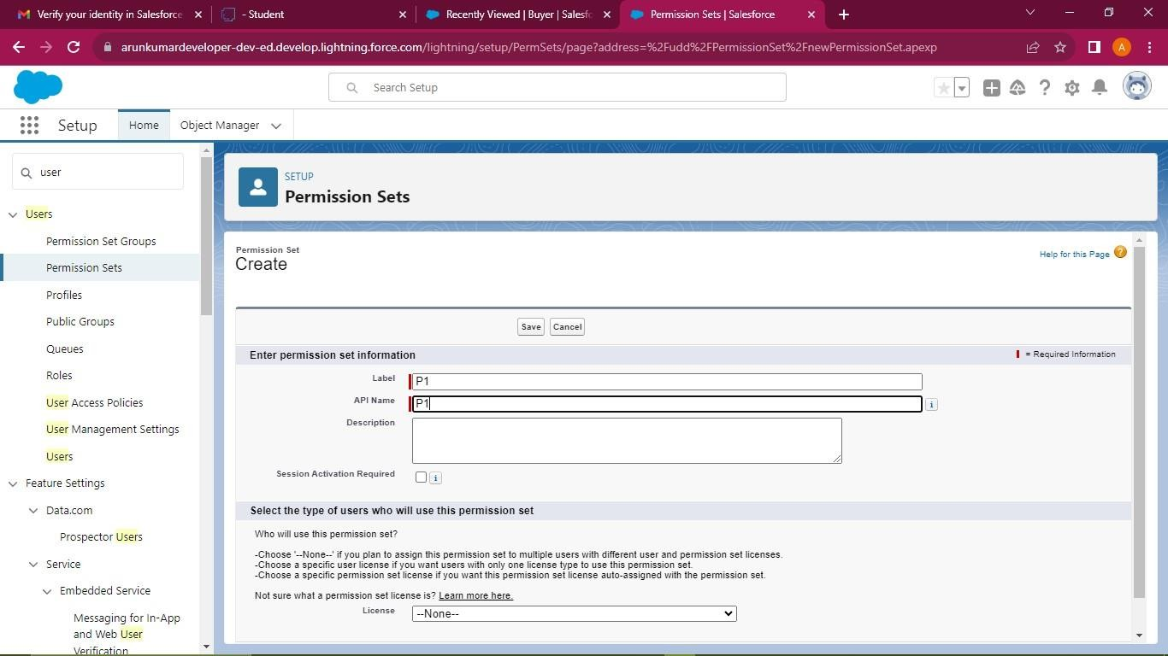

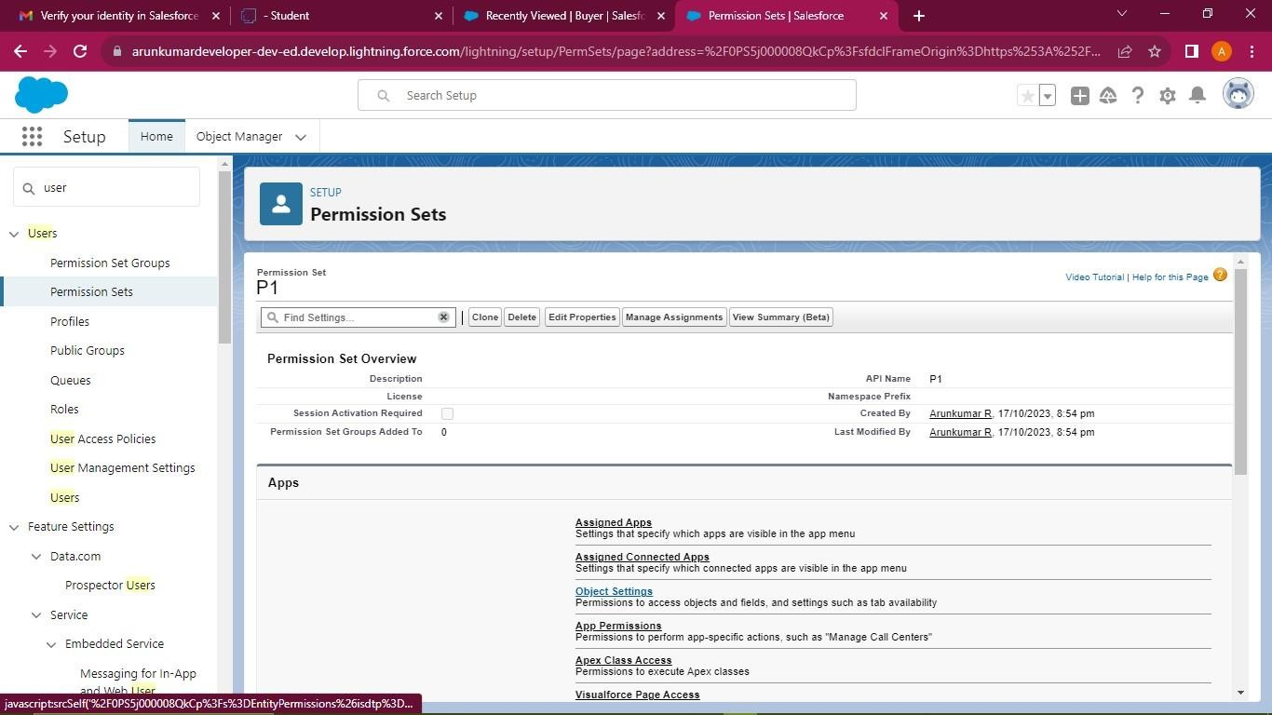

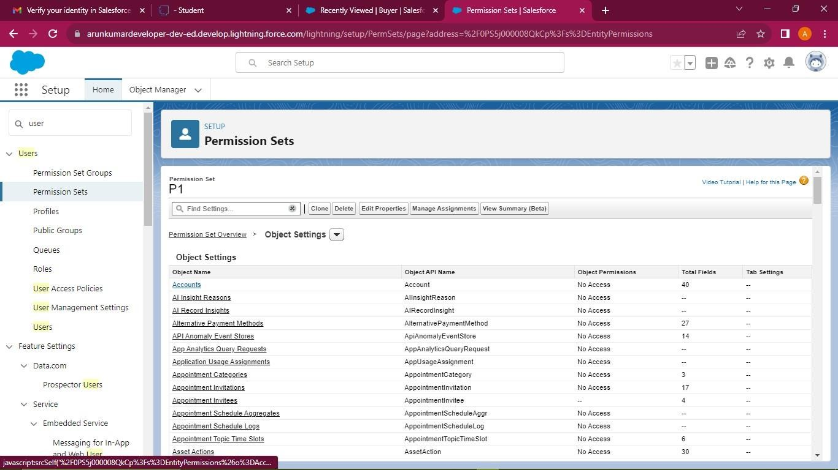

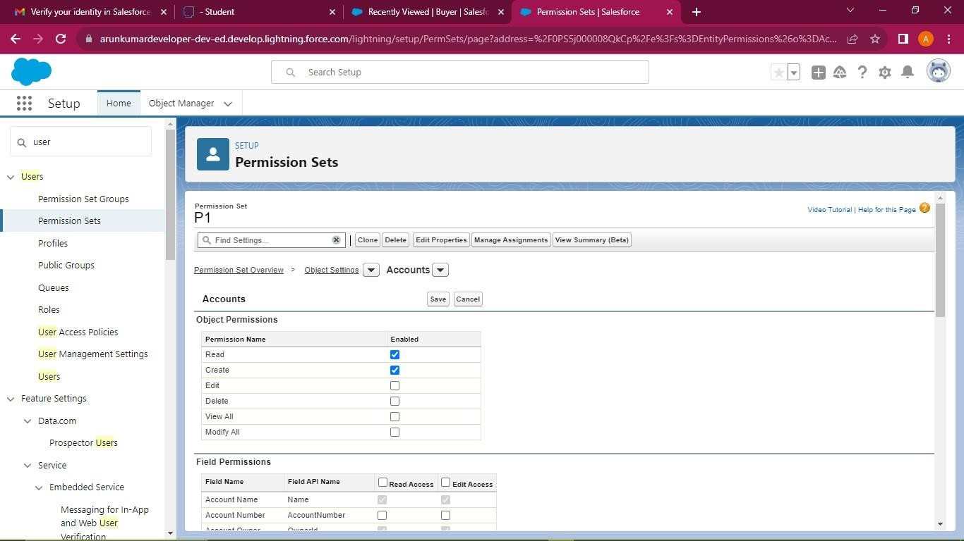

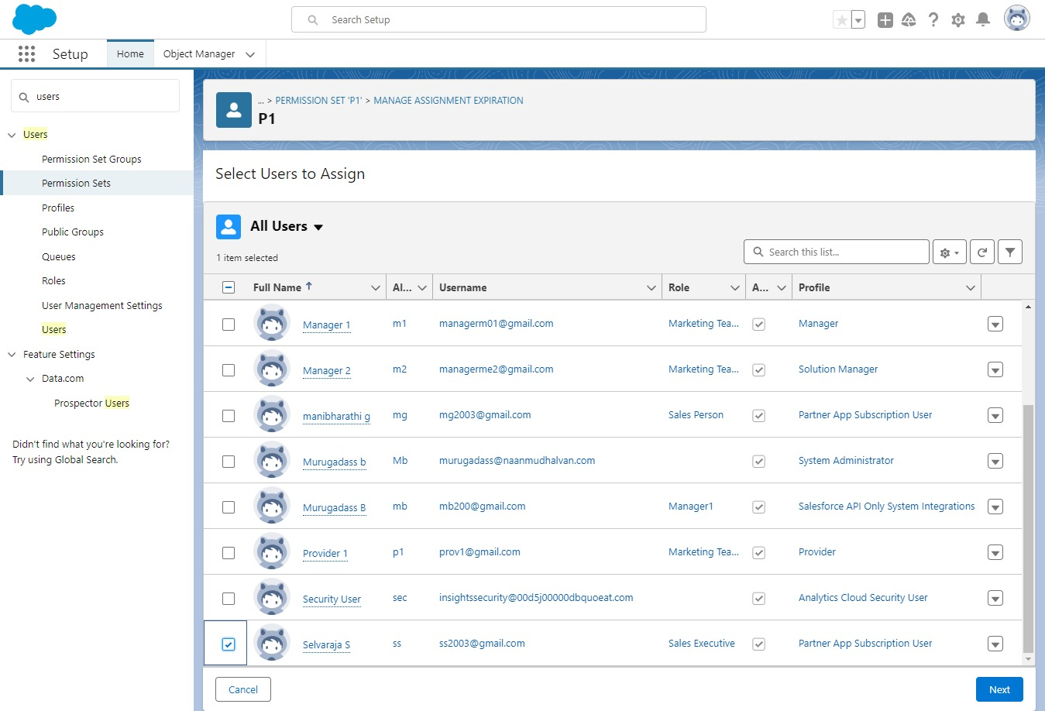

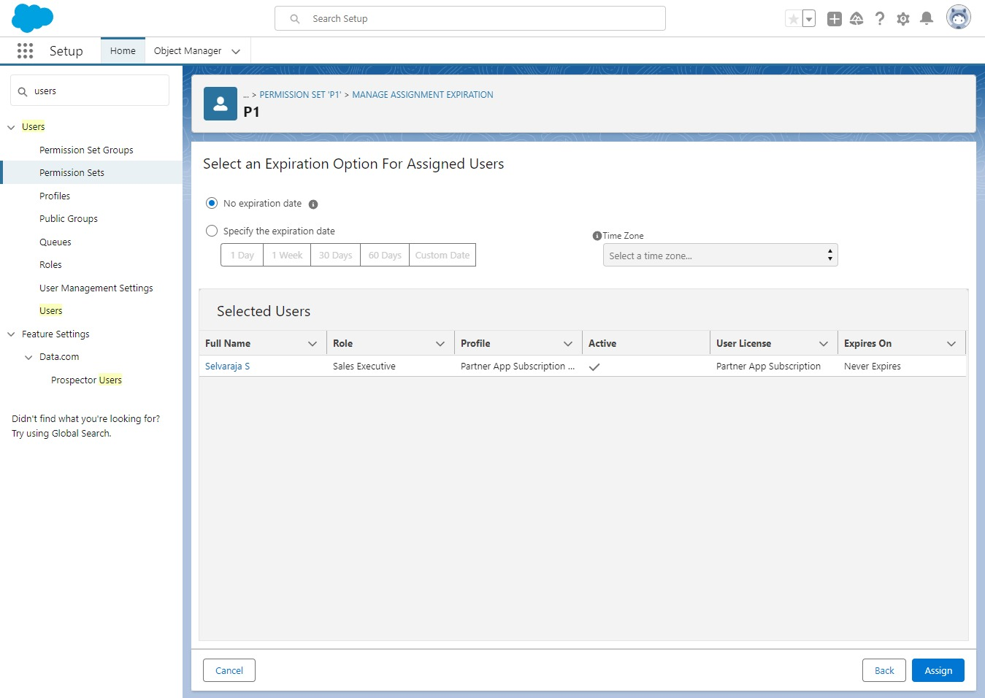

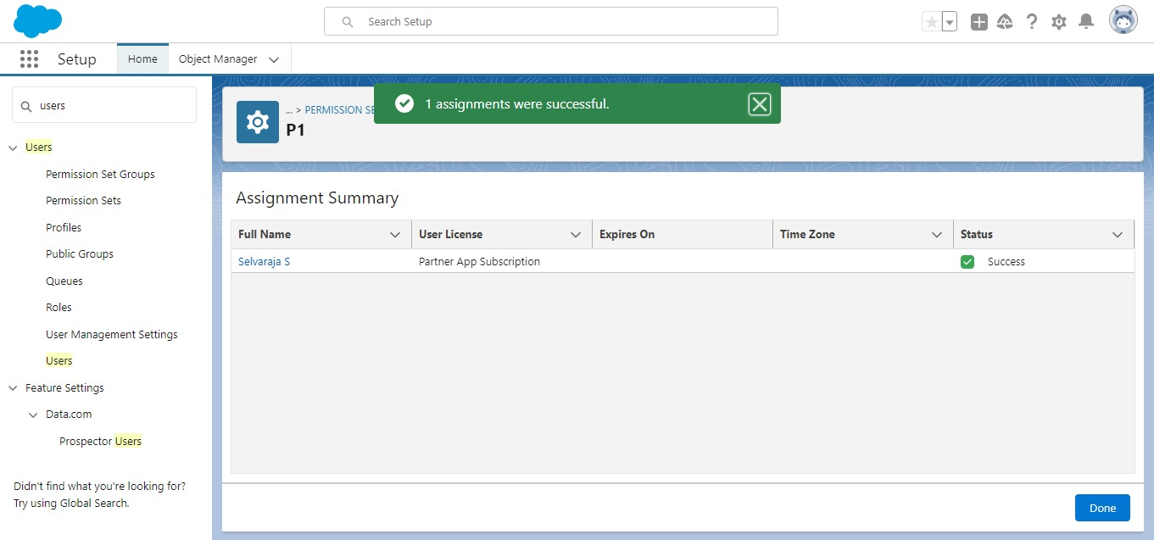

## Setup For OWD

Organization-Wide Defaults, or OWDs, are the pattern security rules that you can follow for your Salesforce instance. Organization Wide Defaults are utilized to confine who can access what information in your CRM. You can award access through different methods that we will discuss later (sharing principles, Role Hierarchy, Sales Teams, and Account groups, manual sharing, and so forth).

Primarily, there are four levels of access that can be set in Salesforce OWD and they are-

1. Public Read/Write/Transfer (only available of Enquiry and Cases)
2. Public Read/Write
3. Public Read/Only
4. Private

## Create a OWD Setting

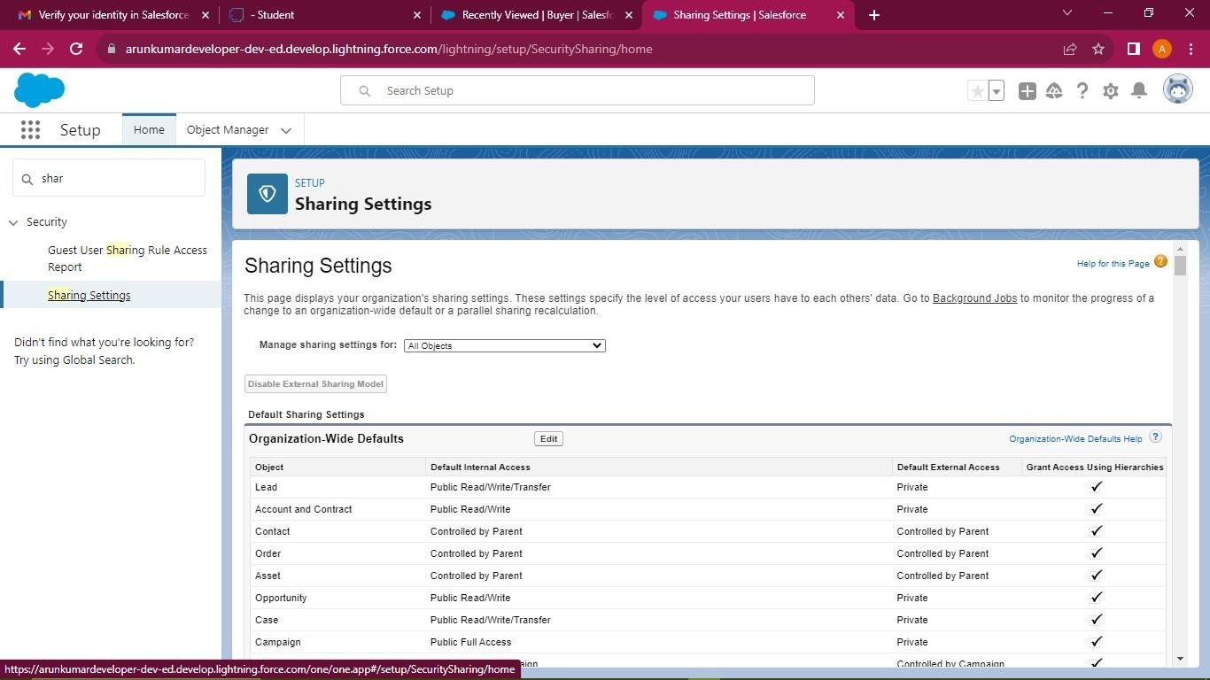

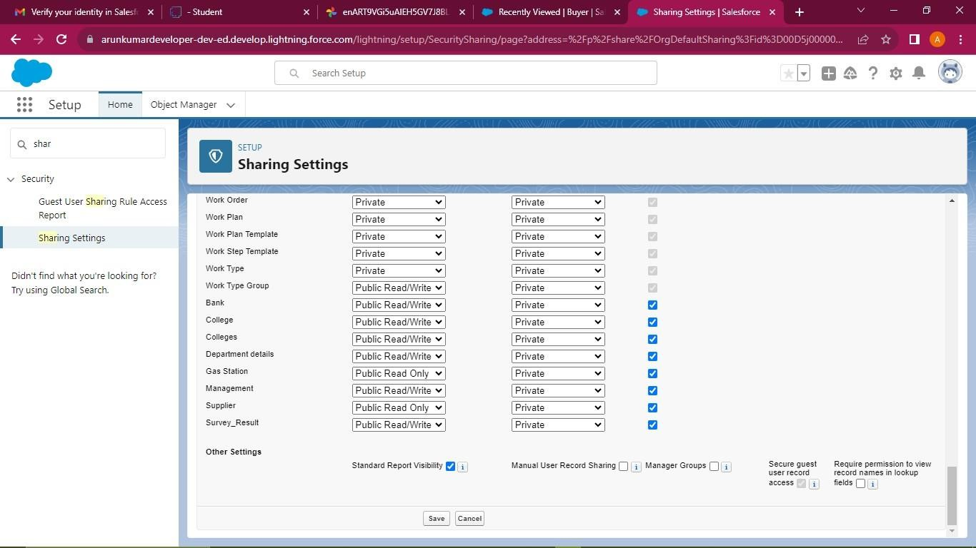

* 1. **User Adoption**

It is the interaction with database and their records.

## Create a Record

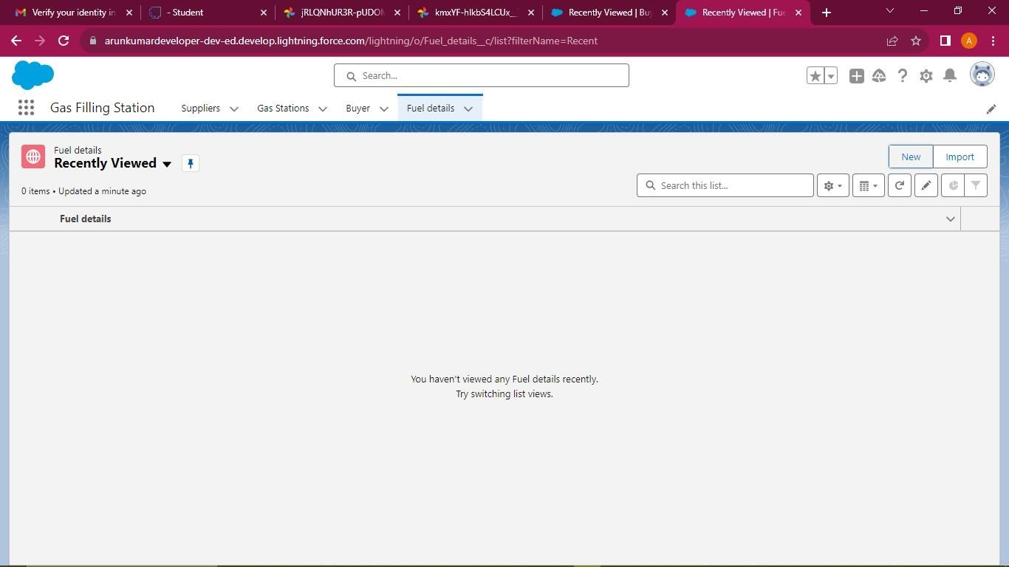

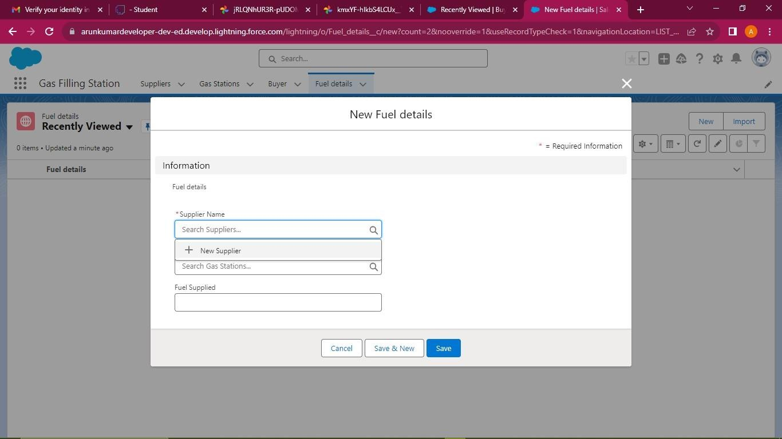

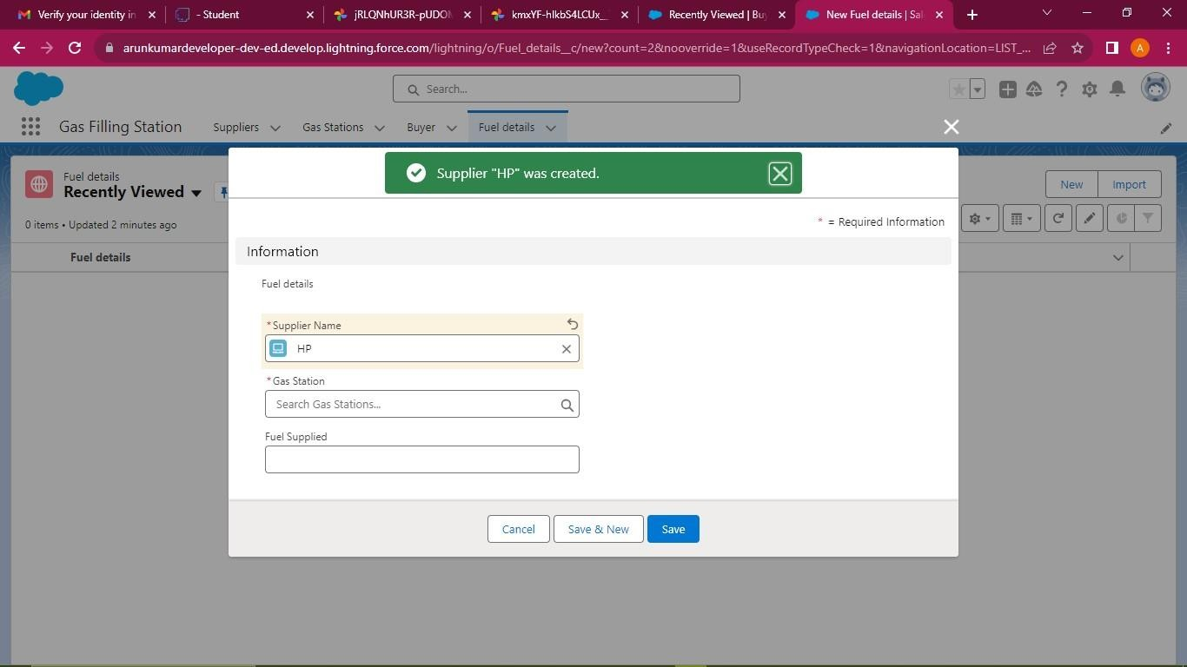

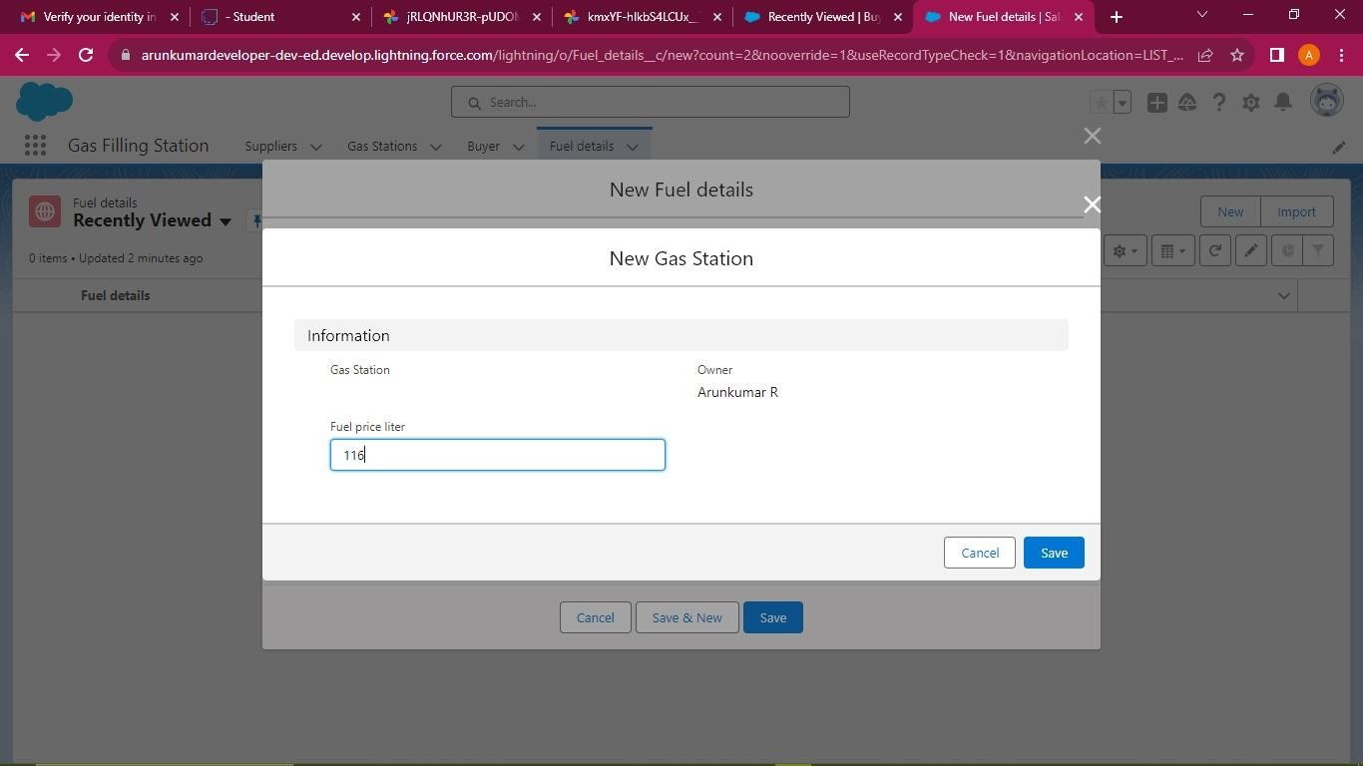

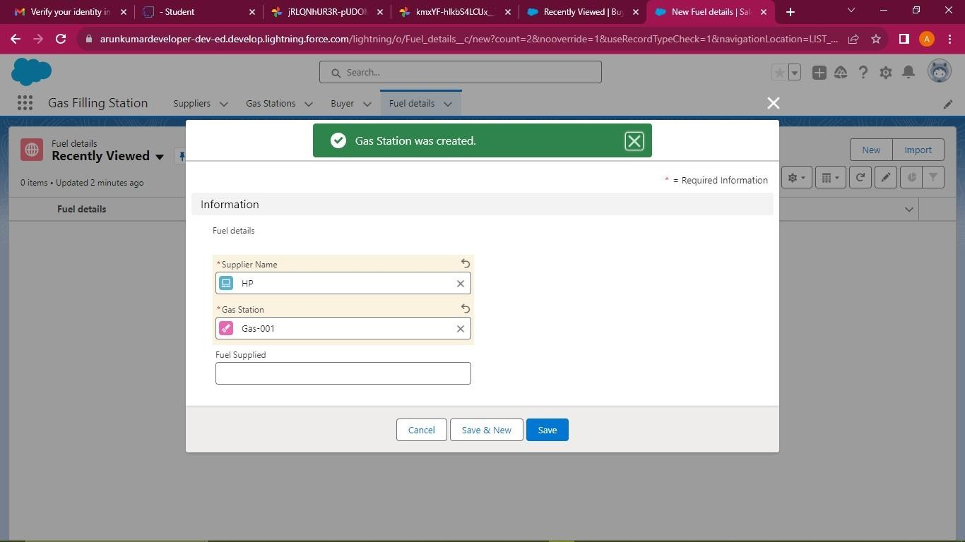

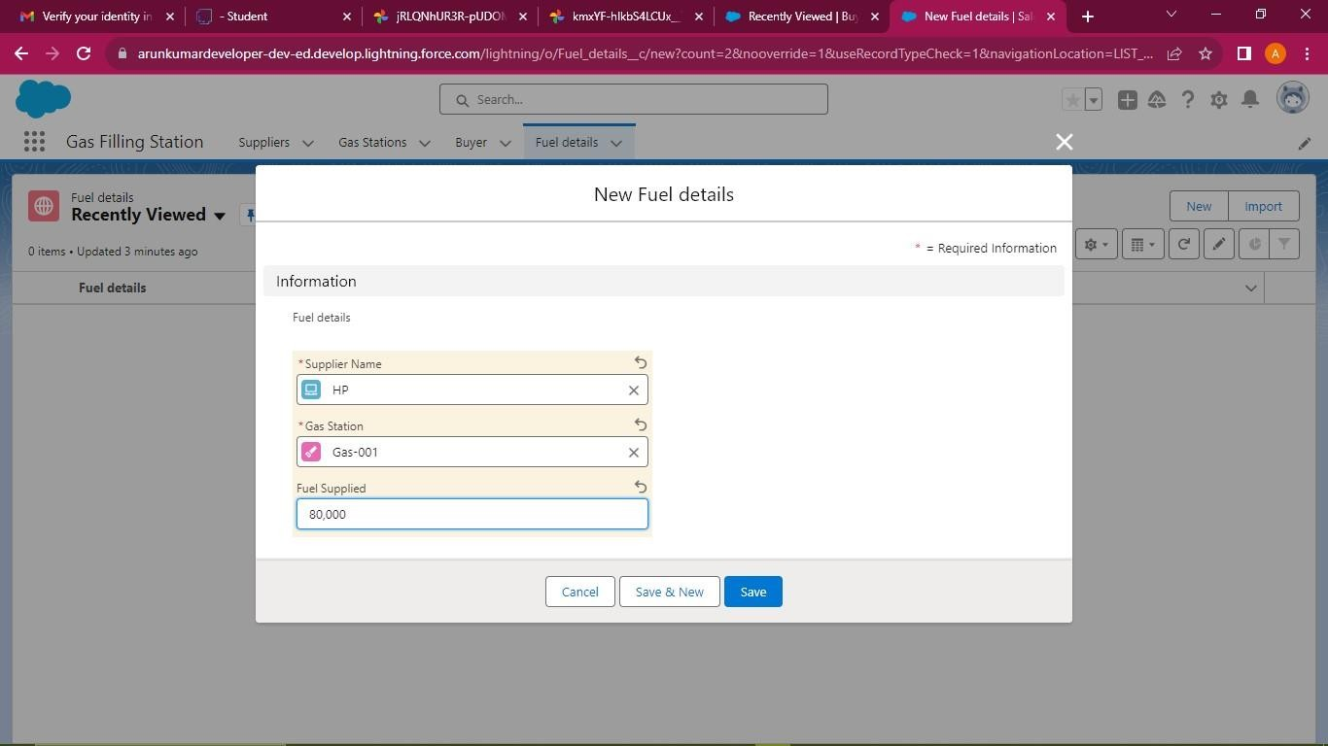

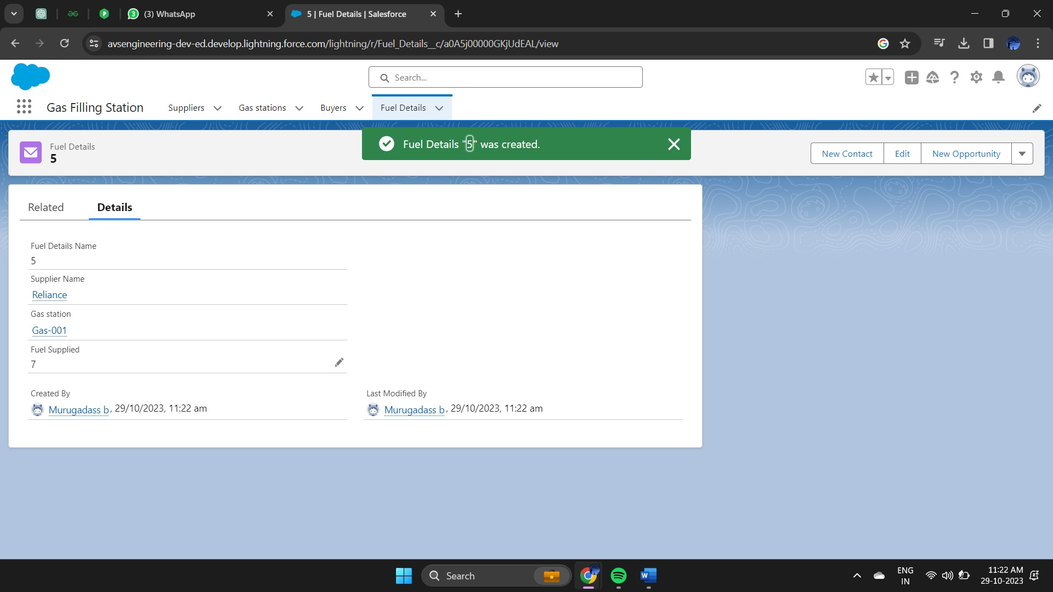

**View a Record**



## Delete Record (Our Customer)

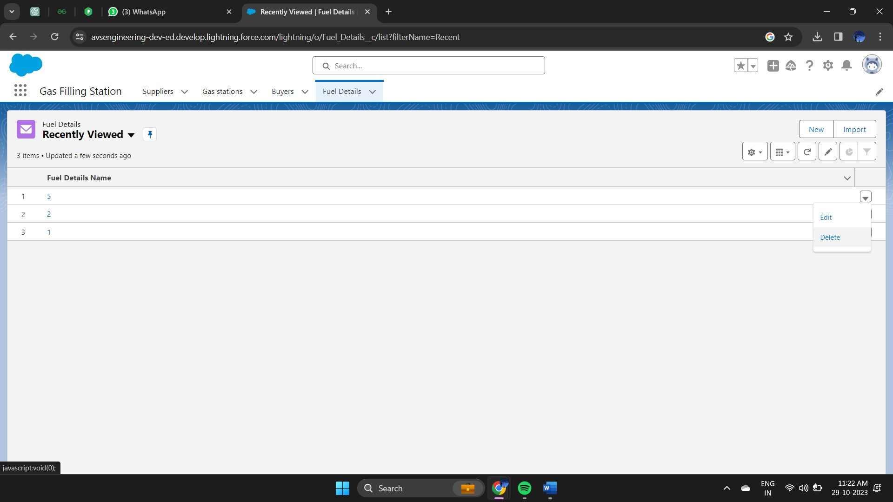

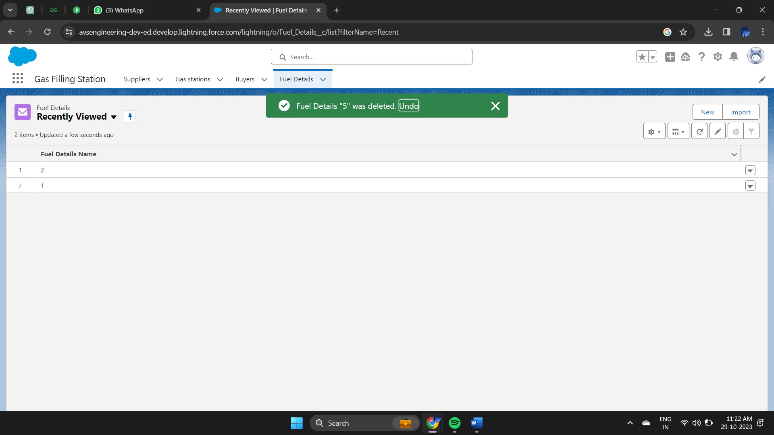

## Flow

# CHAPTER-4 AUTOMATION

The last business rule functionality to implement before testing your application is a rule to set the Out-of-State checkbox field on the Travel Approval object if out- of-state travel has been chosen. Salesforce offers workflow capabilities that provide a declarative, drag-and-drop design environment to build our business process logic.

## Create a flow

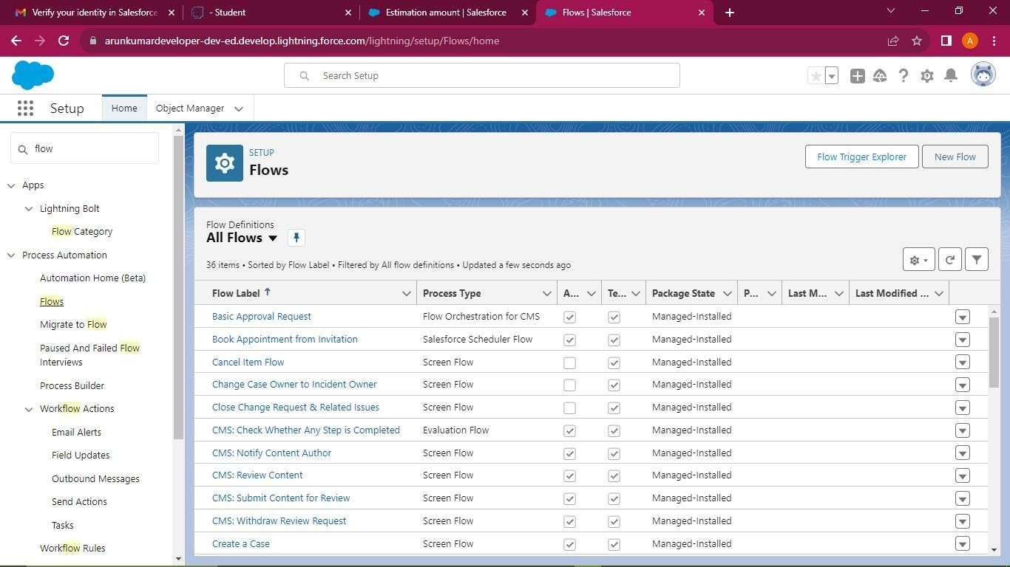

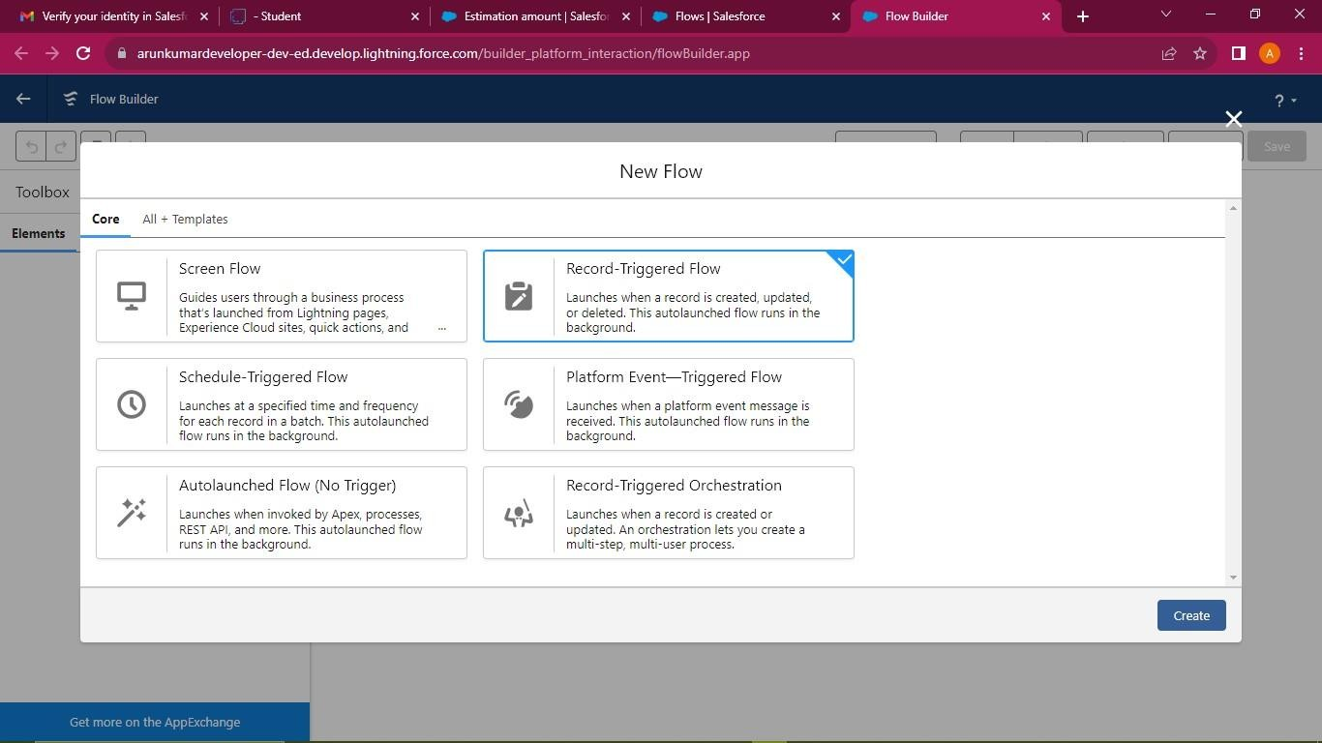

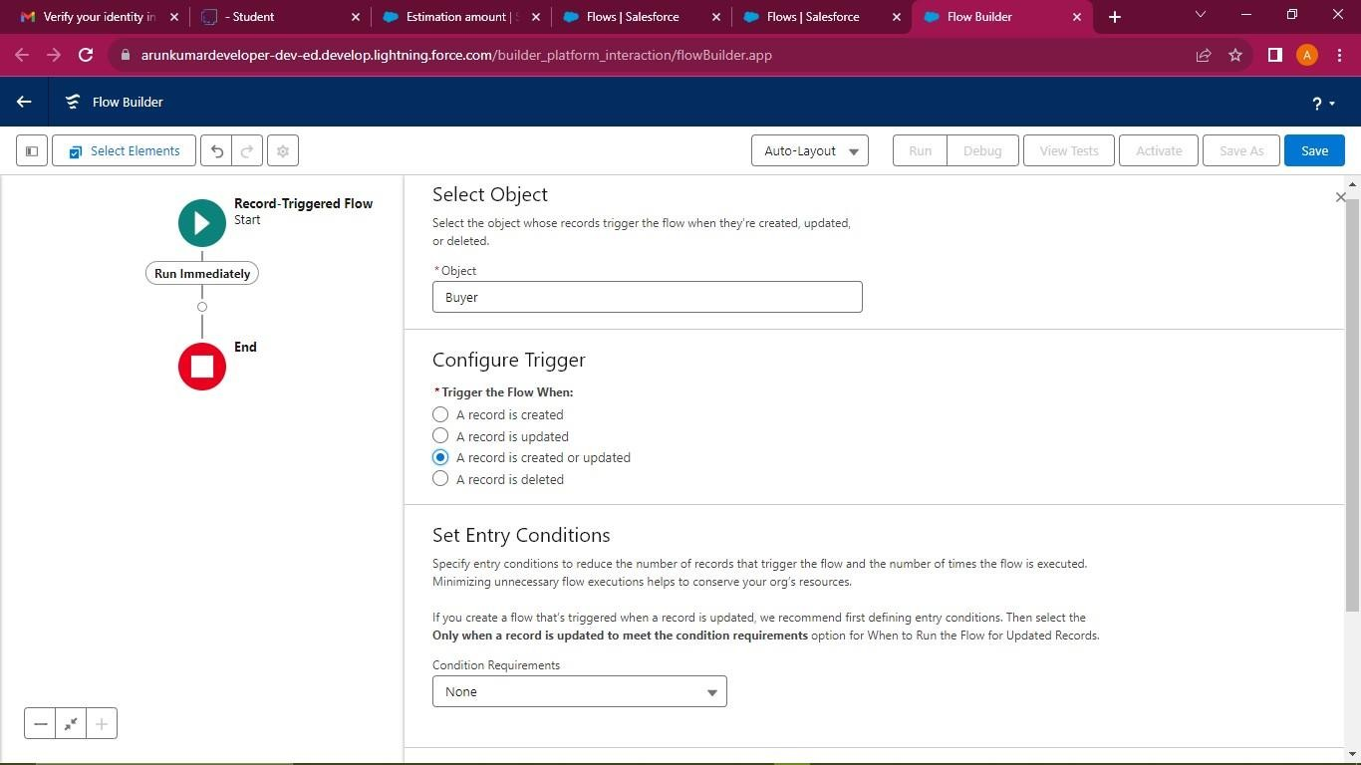

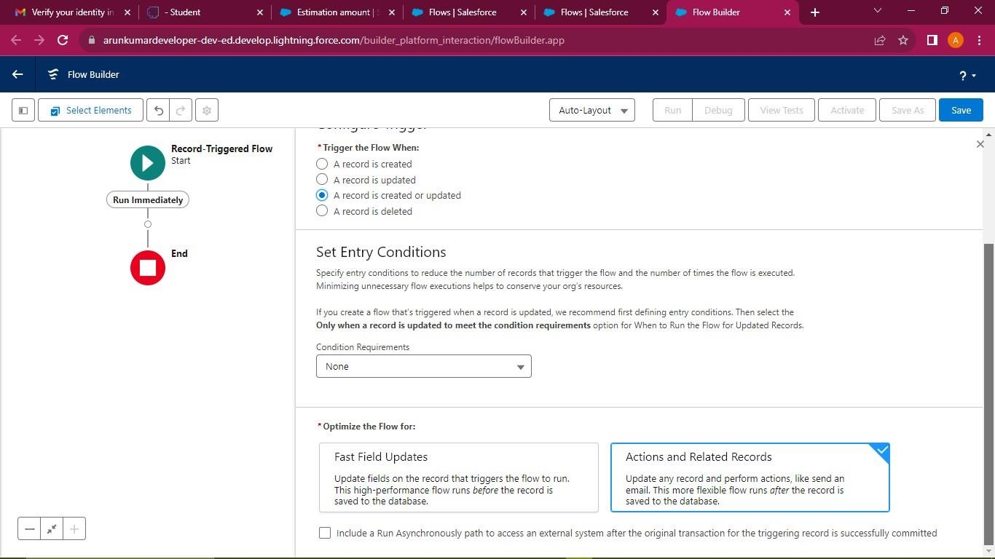

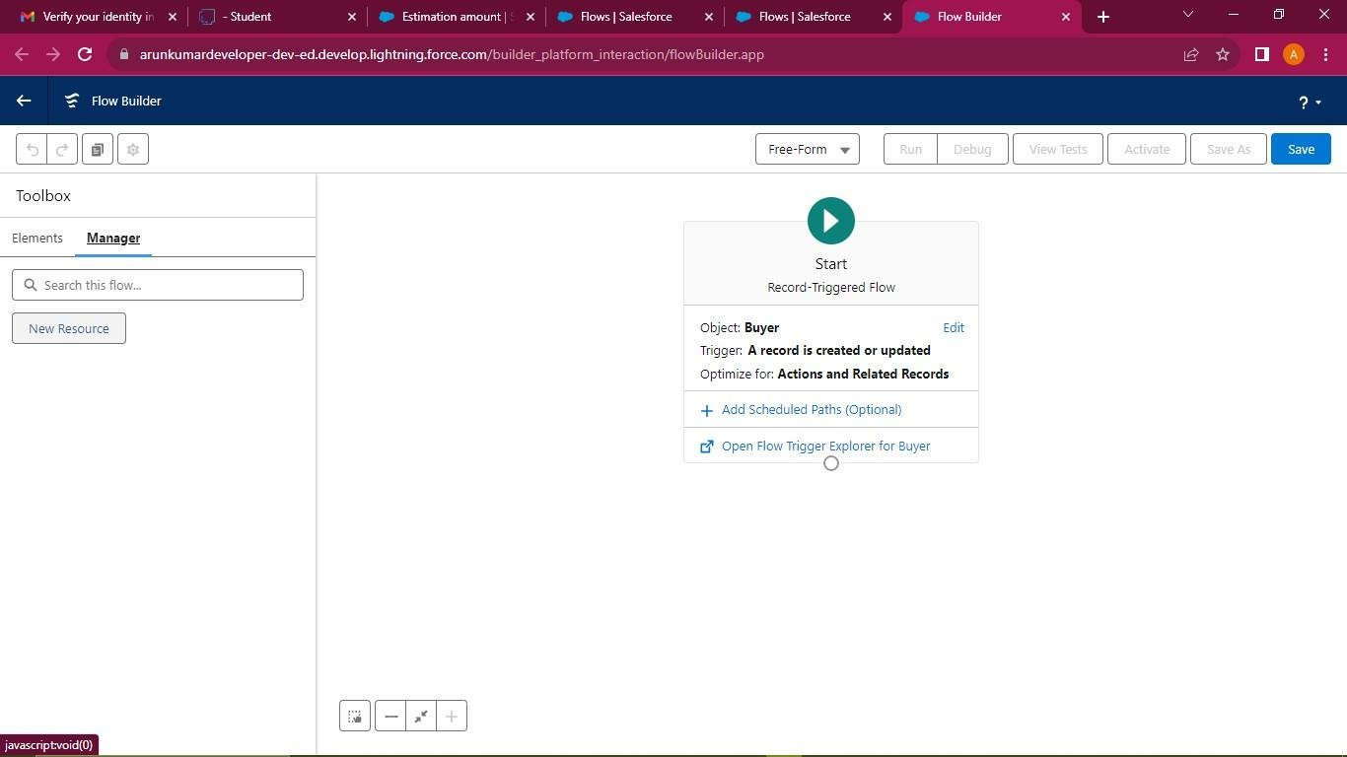

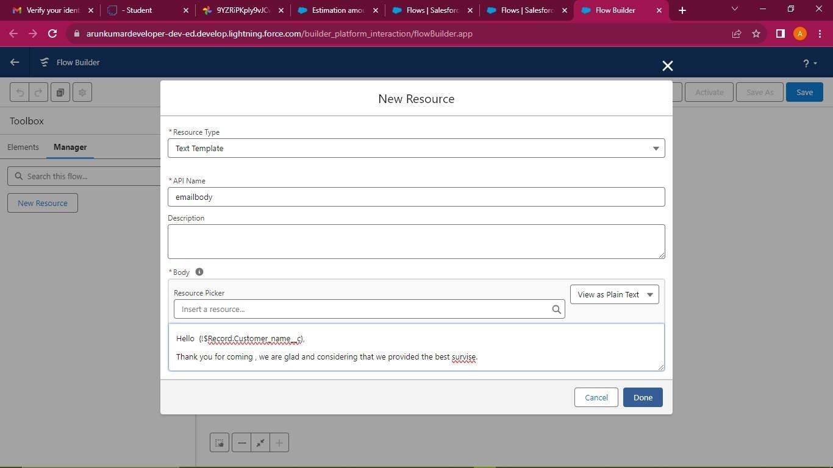

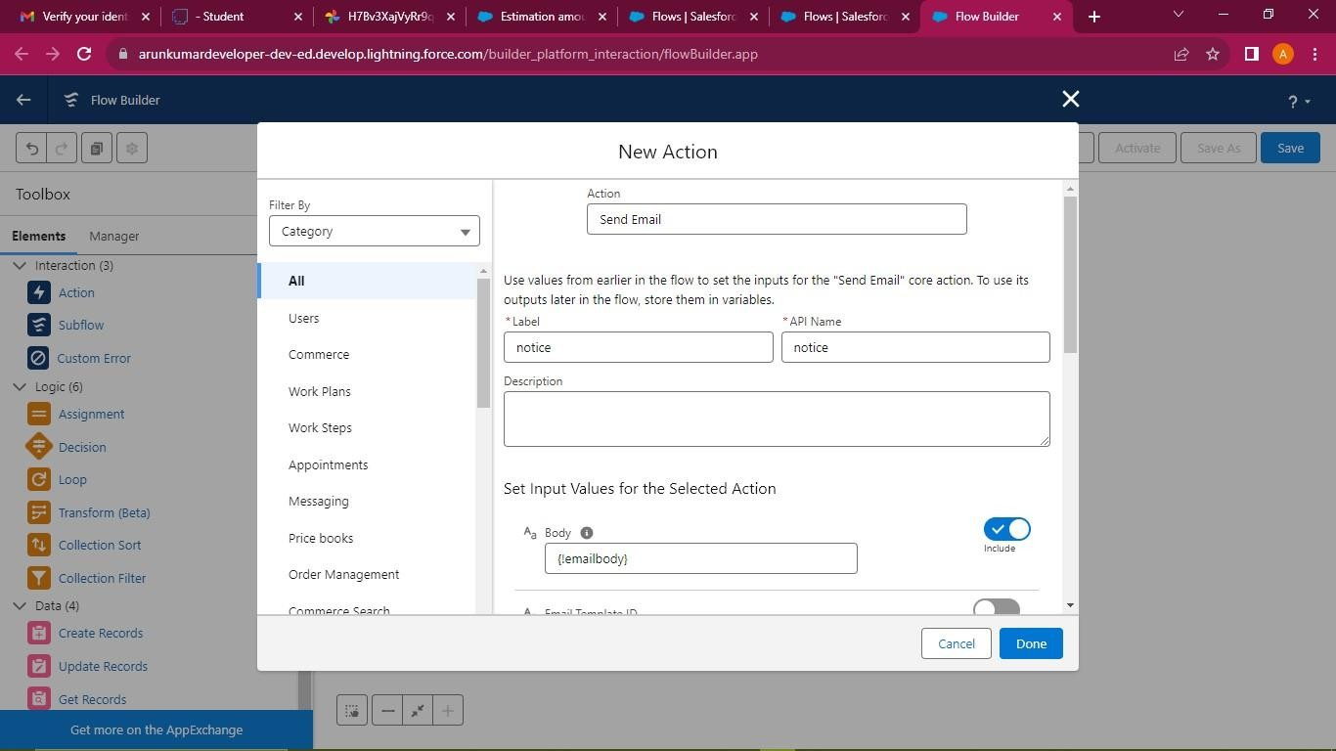

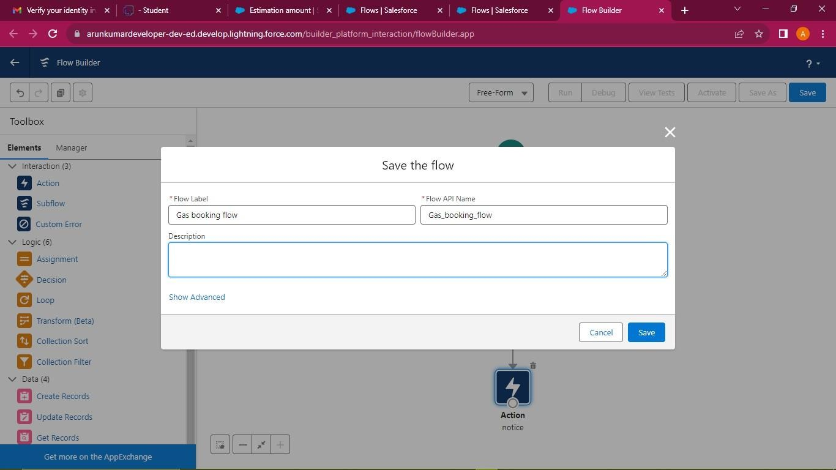

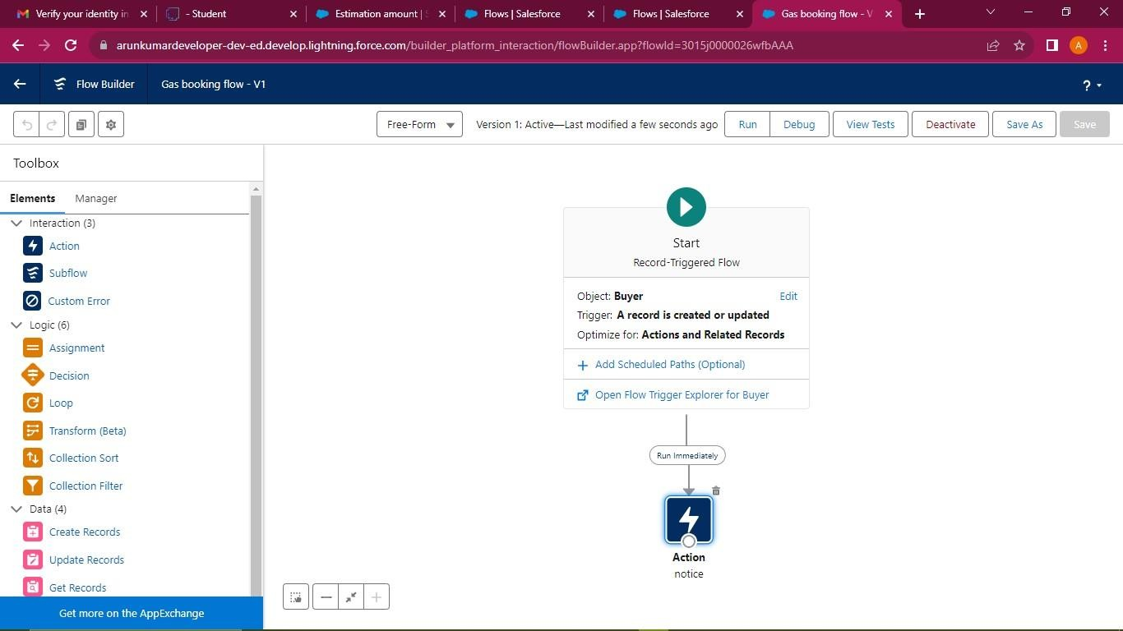

## Apex Trigger

Apex can be invoked by using triggers. Apex triggers enable you to perform custom actions.

before or after changes to Salesforce records, such as insertions, updates, or deletions.

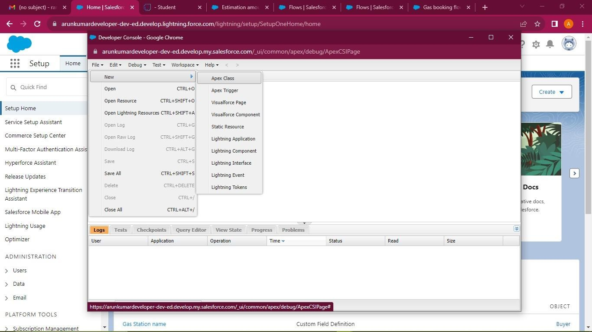

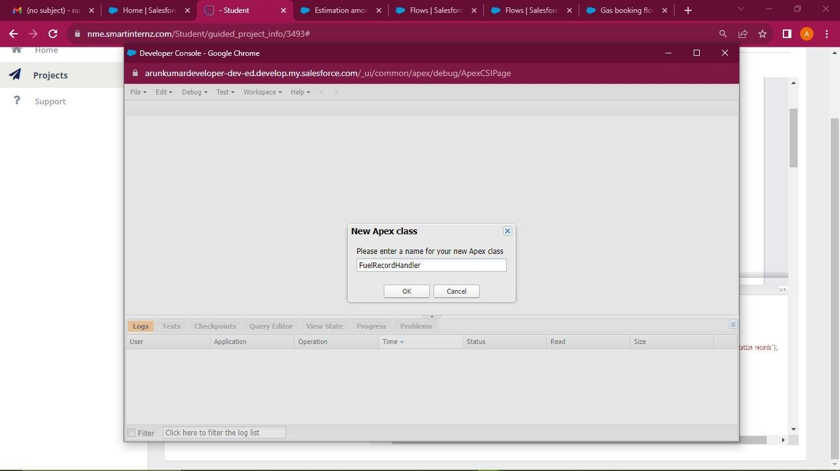

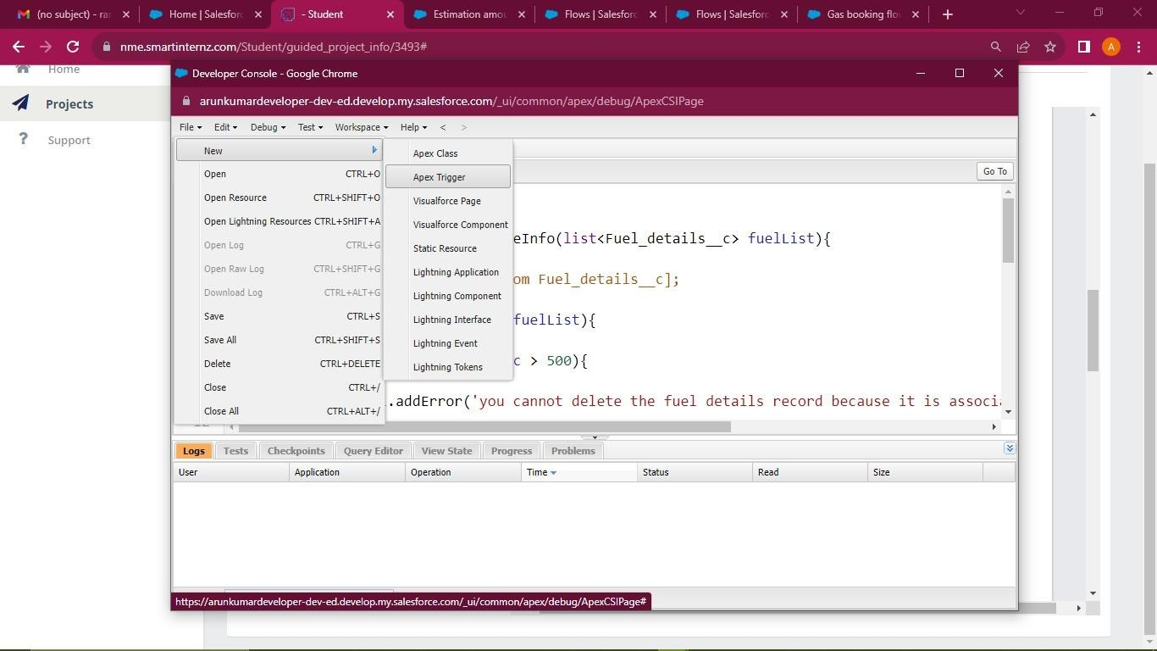

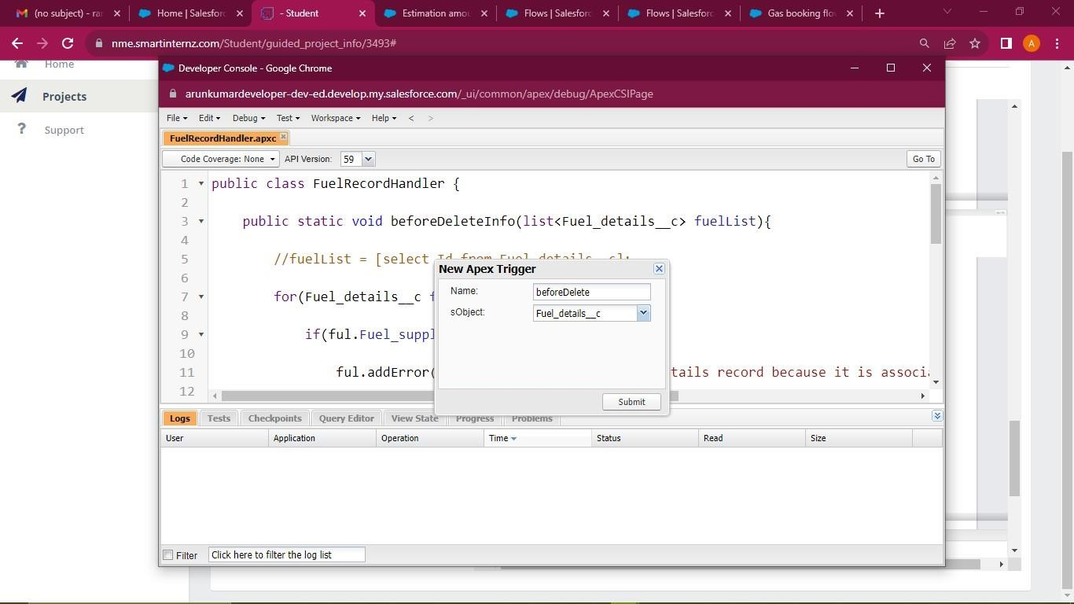

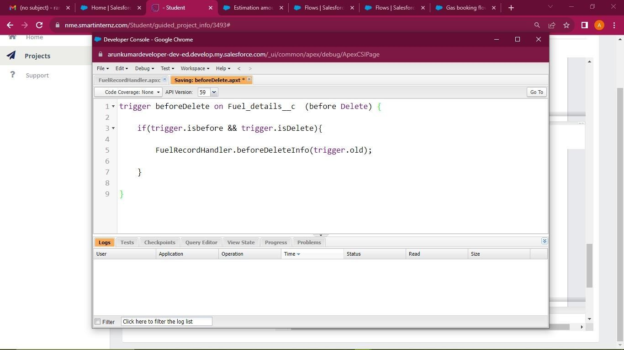

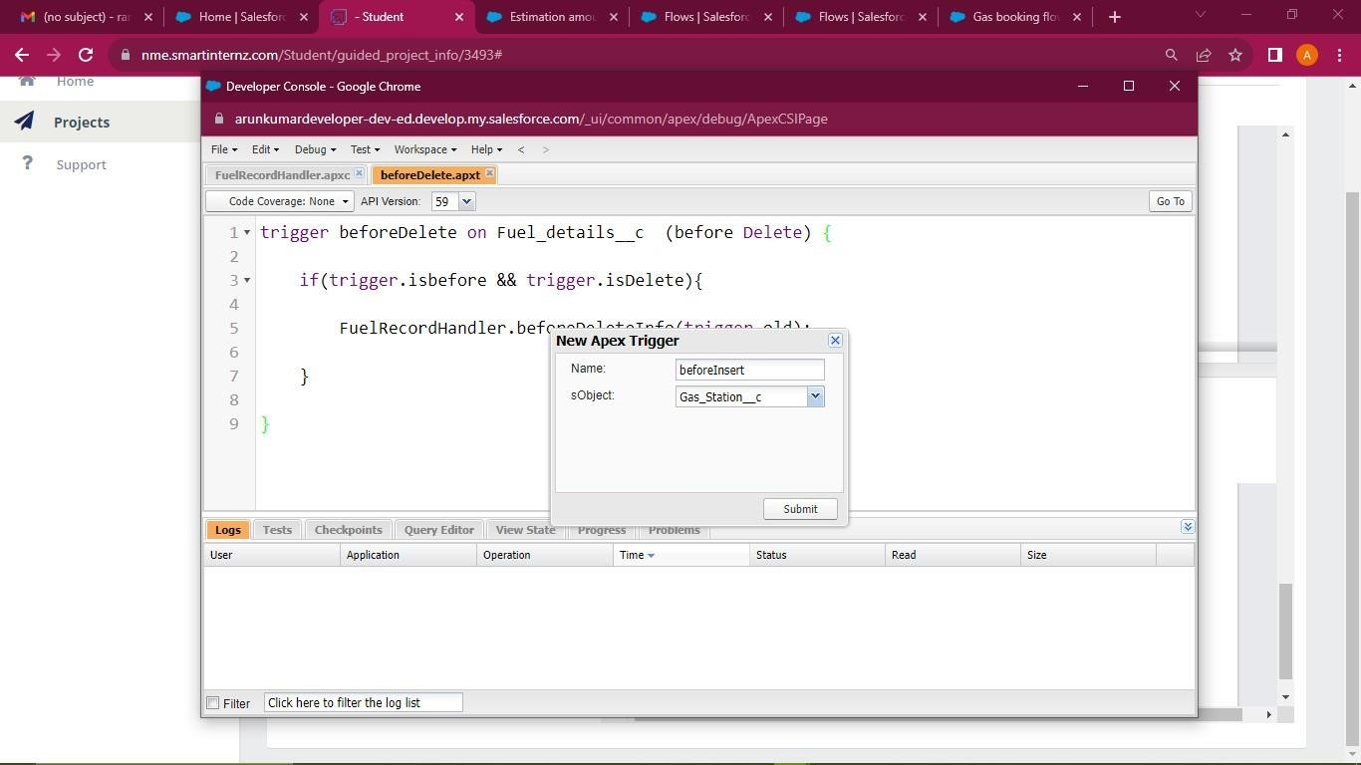

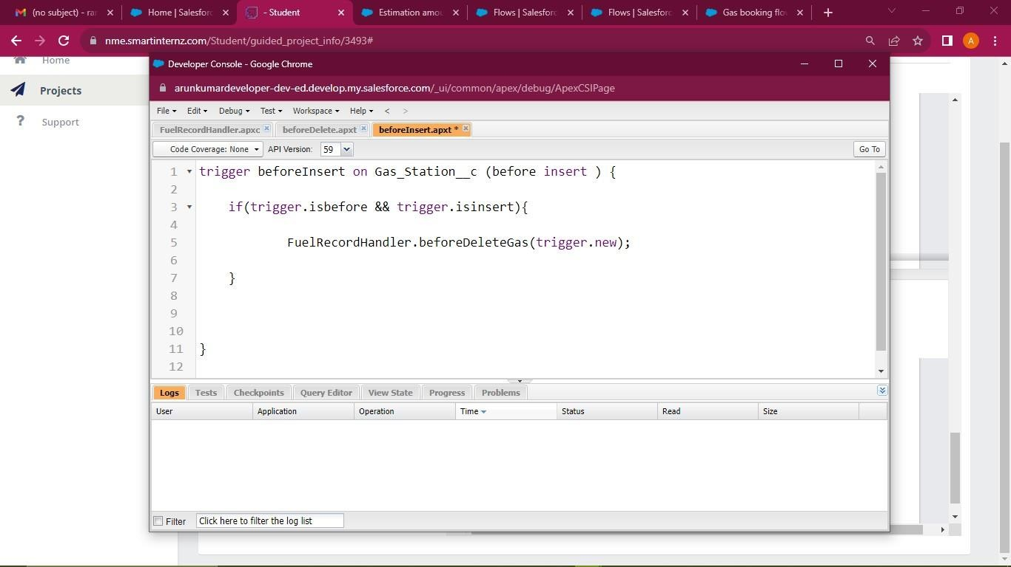

* 1. **Reports**

# CHAPTER-5 REPORTS & DASHBOARD

A Salesforce report is a list of data generated based on filter criteria. Salesforce Reports helped us predict trends and gives us the advantage to increase profits. The report builder provides a drag-and-drop interface to easily build and customize your reports.

## Create a Report Folder

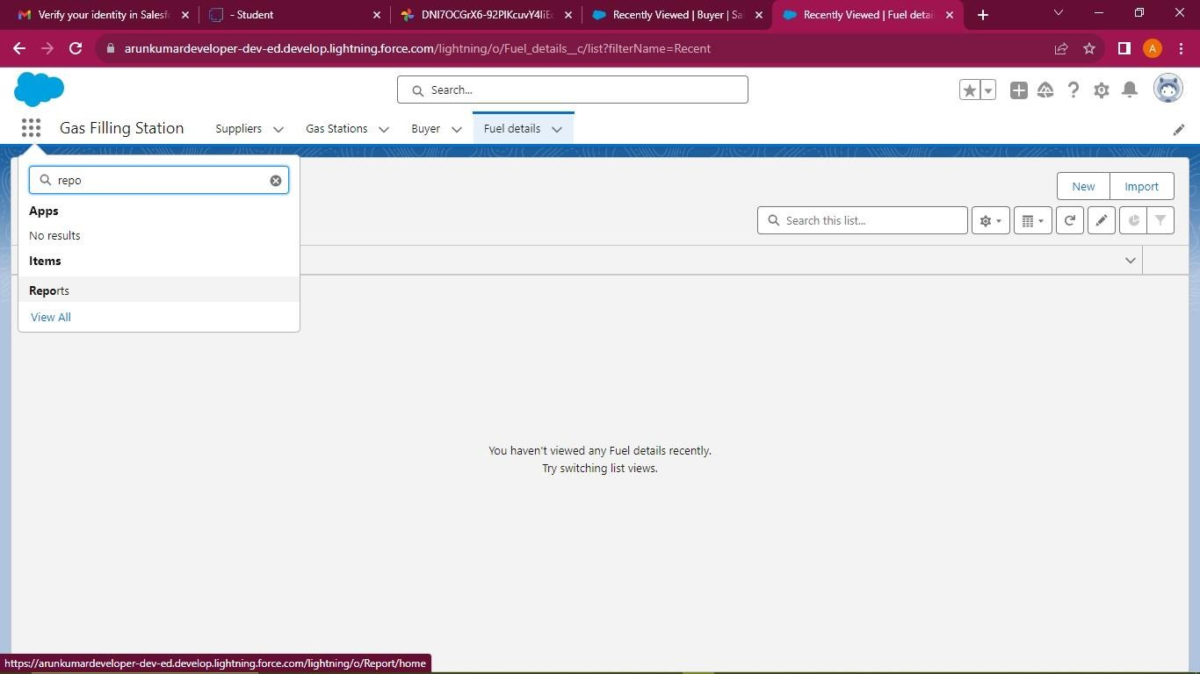

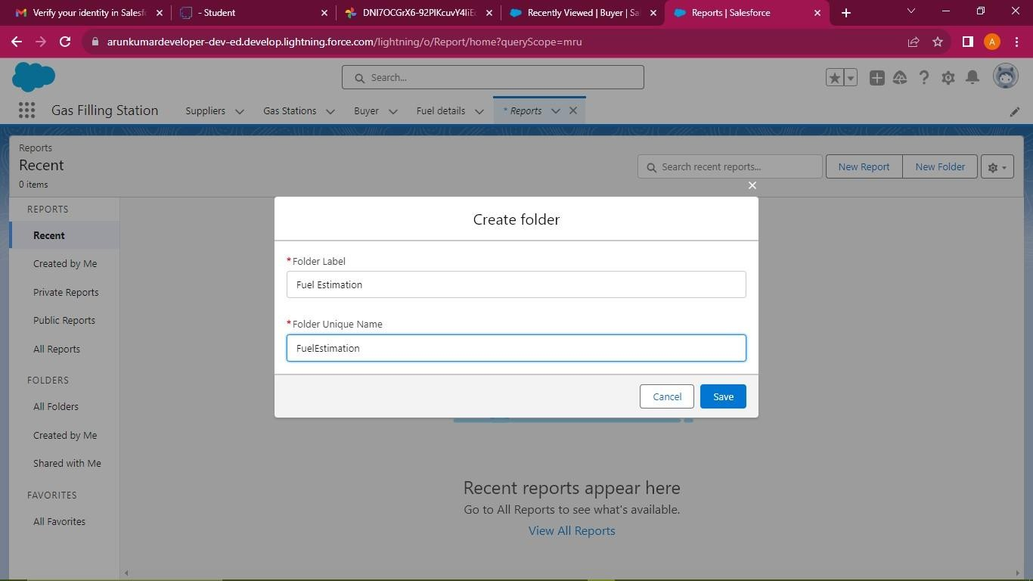

**Sharing a Report Folder**

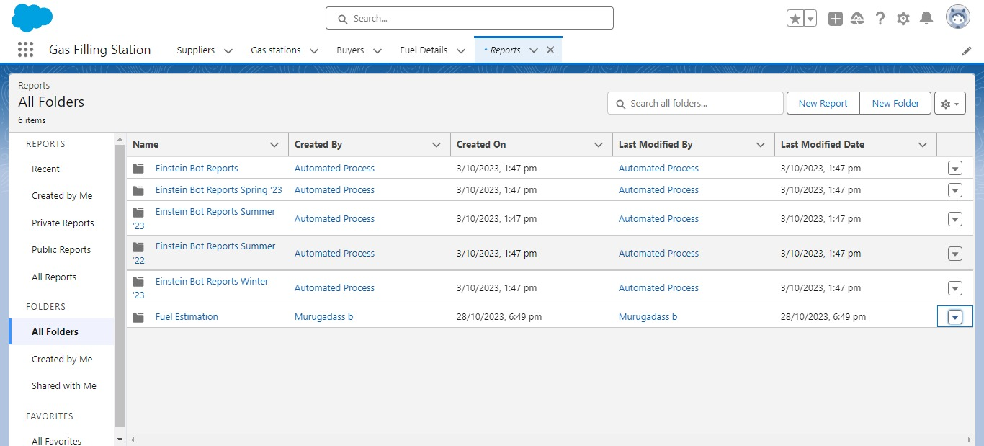

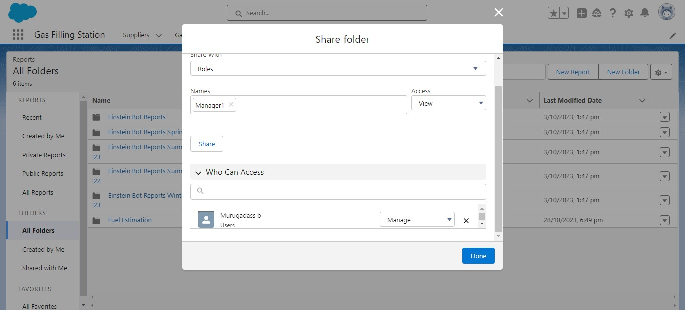

## Create a Report

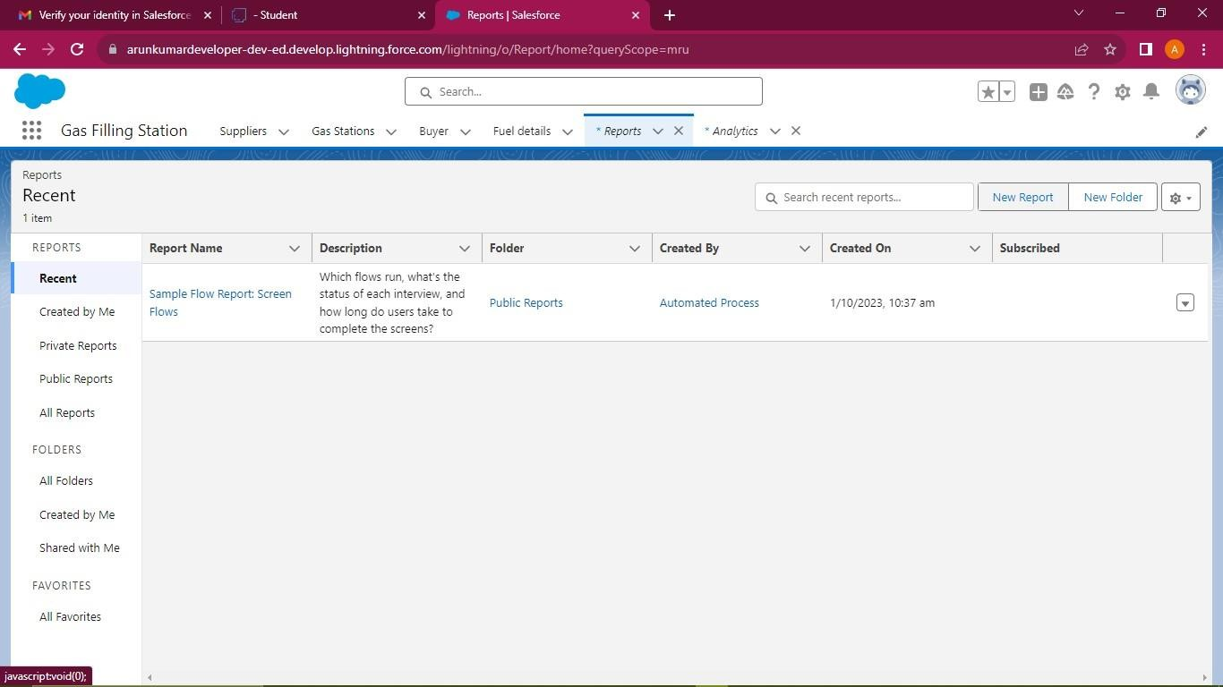

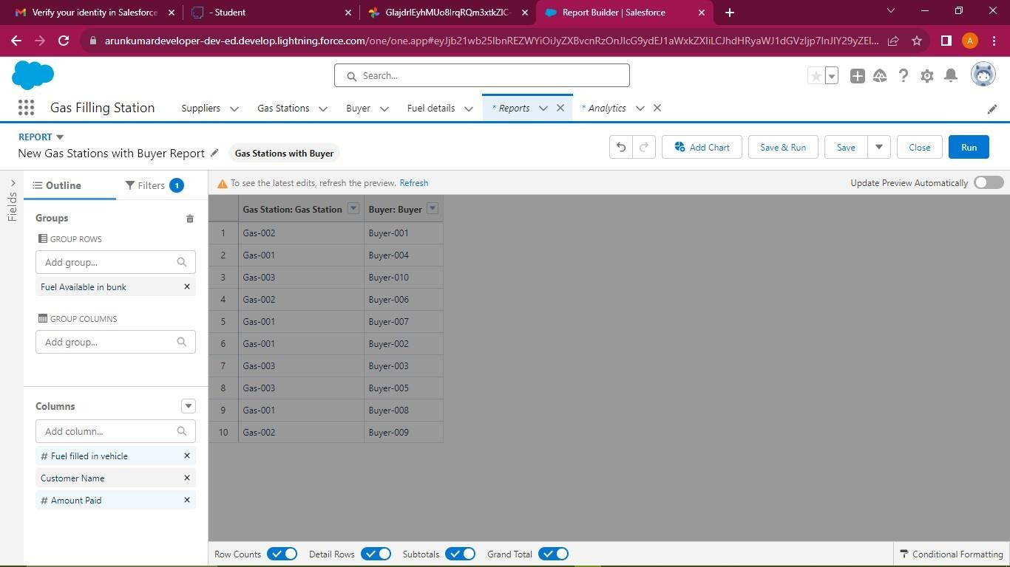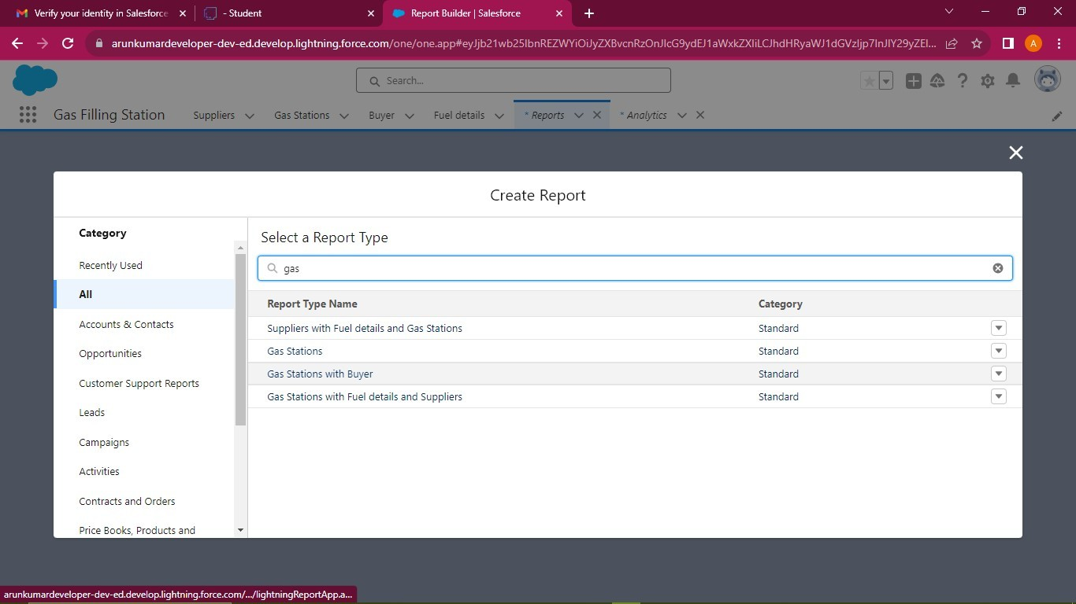

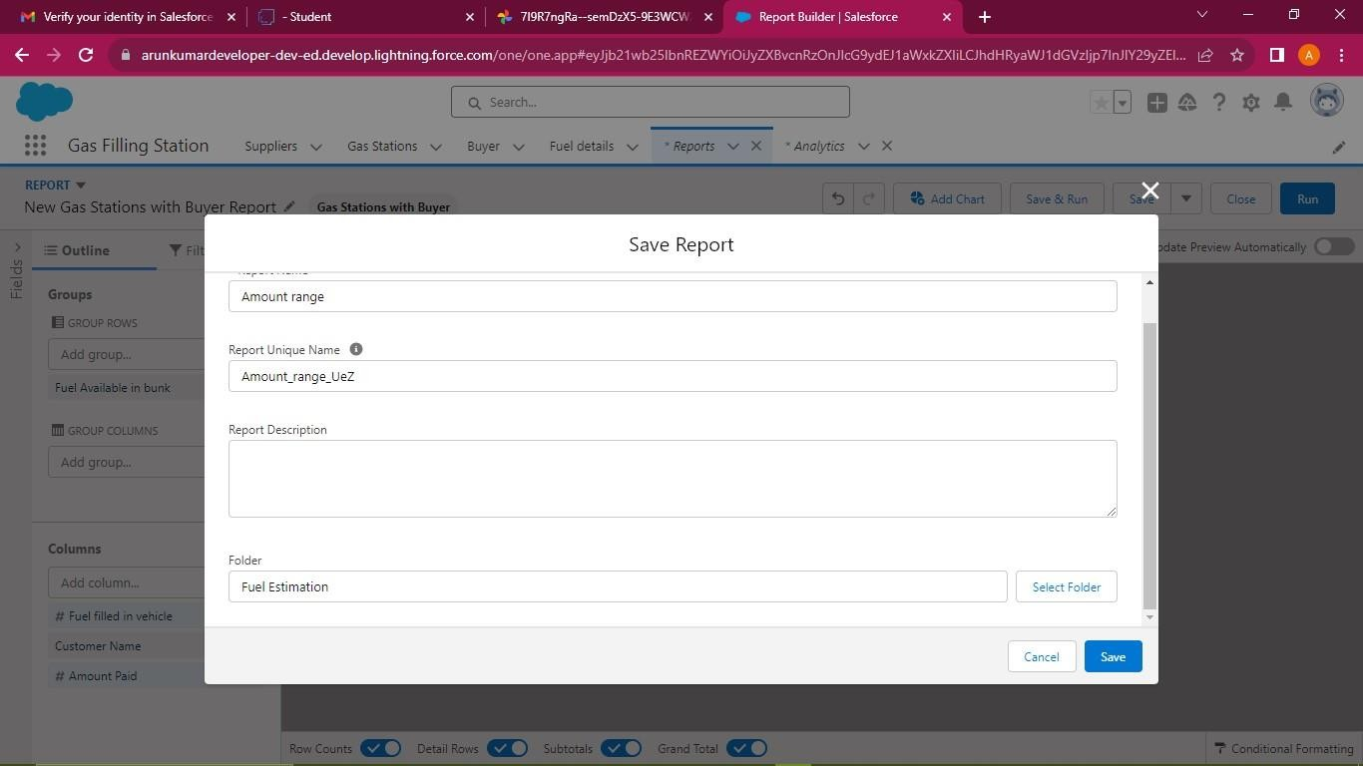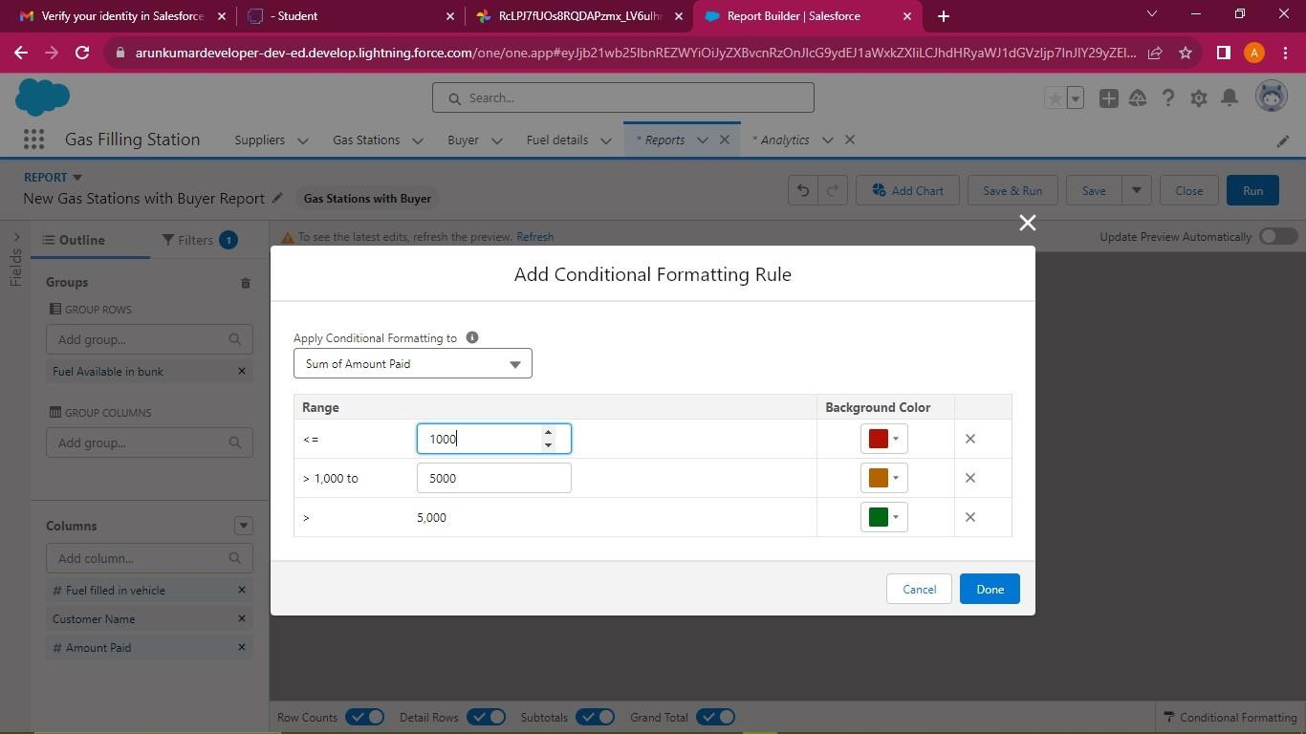

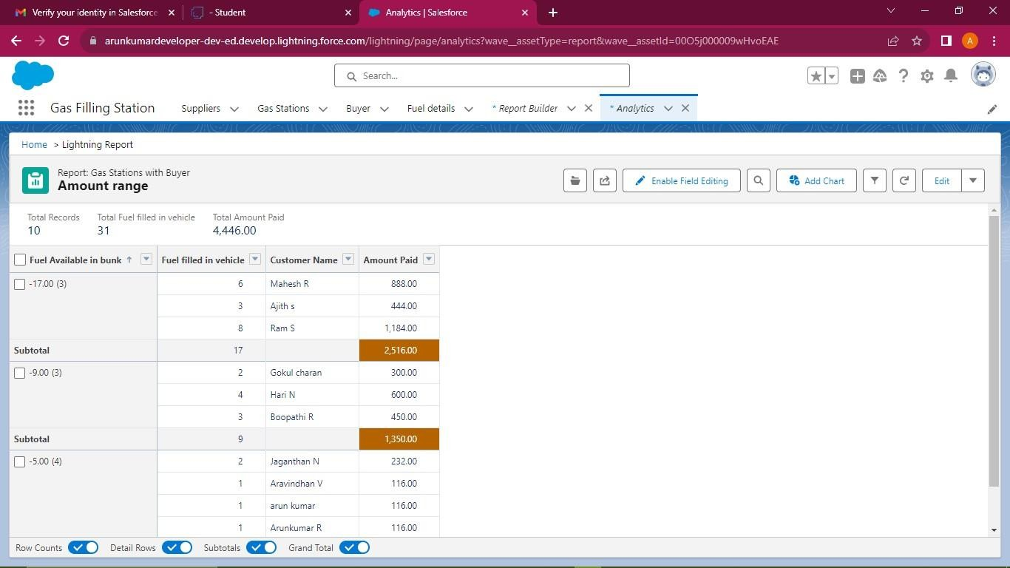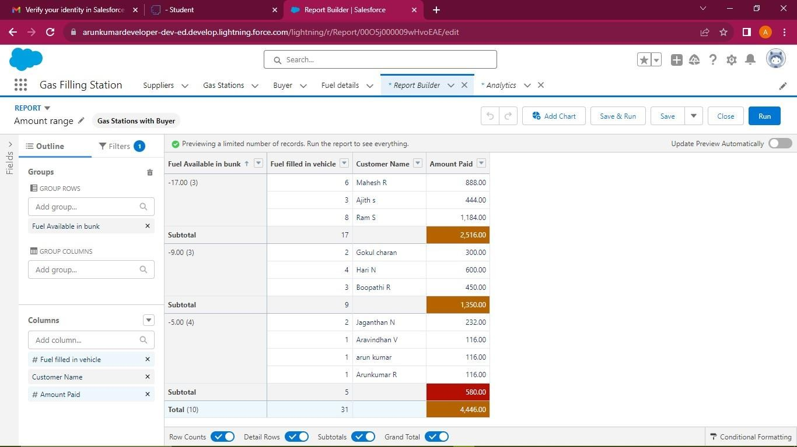

* 1. **Dashboard**

A dashboard provides an interactive visual display of key metrics and trends. Multiple dashboard components can be shown together on a single dashboard layout, creating rich visual displays of multiple reports that have a common theme. **Create a Dashboard Folder**

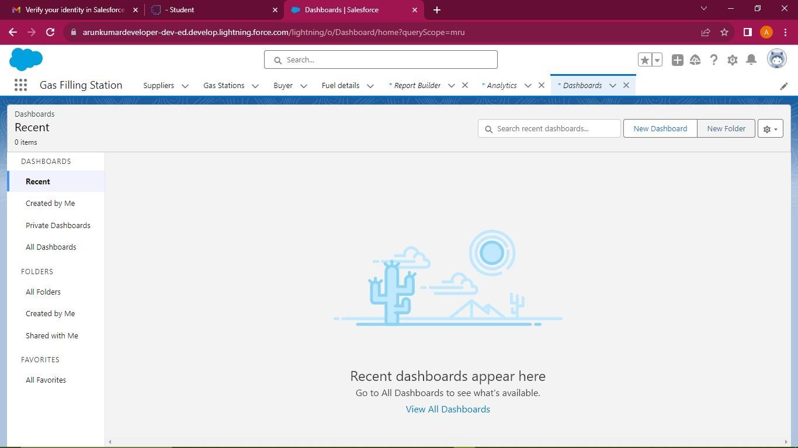

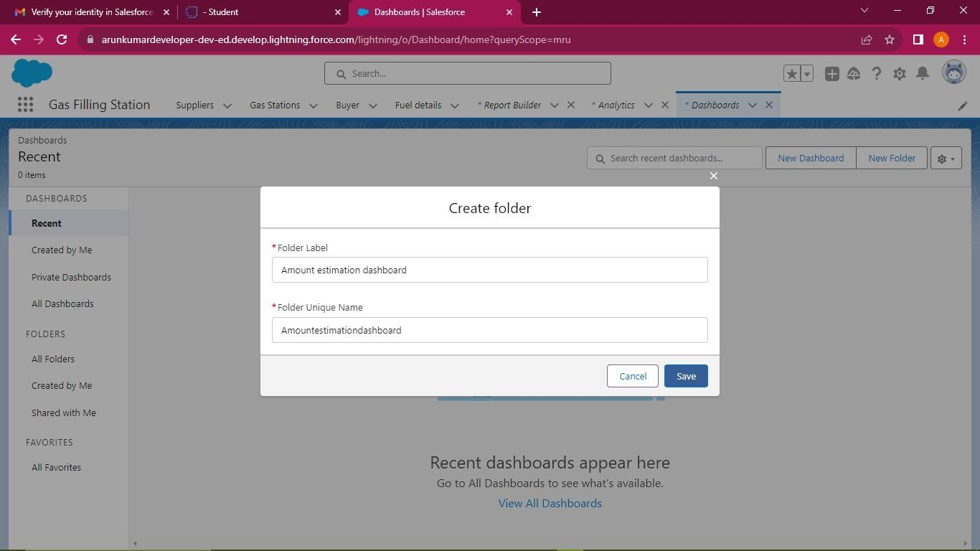

**Create Dashboard**

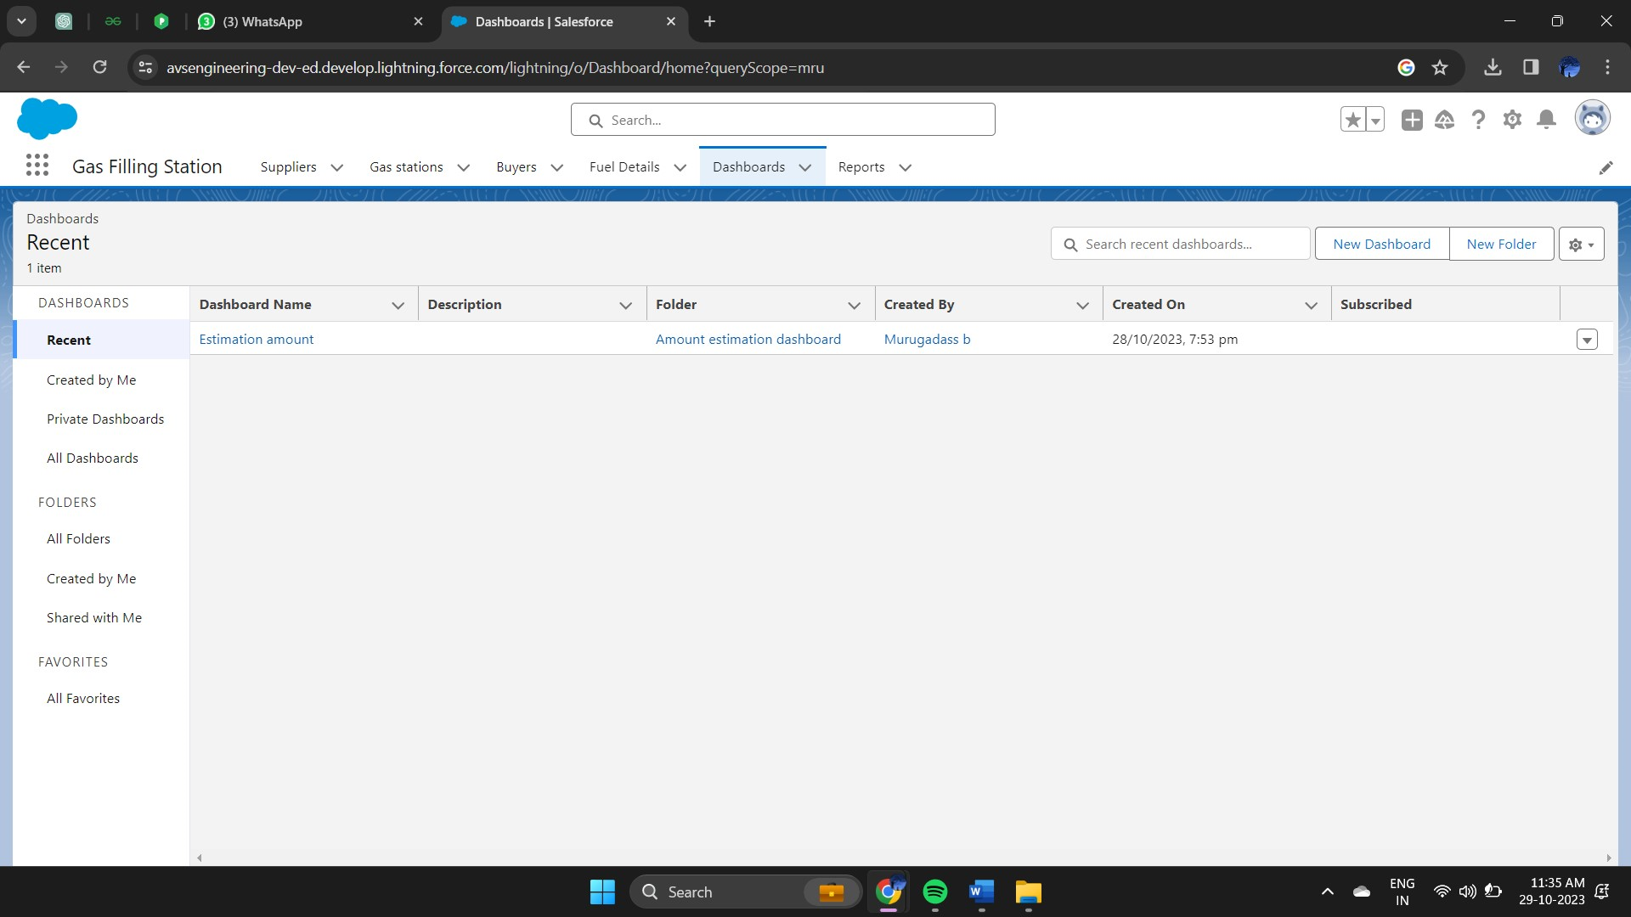

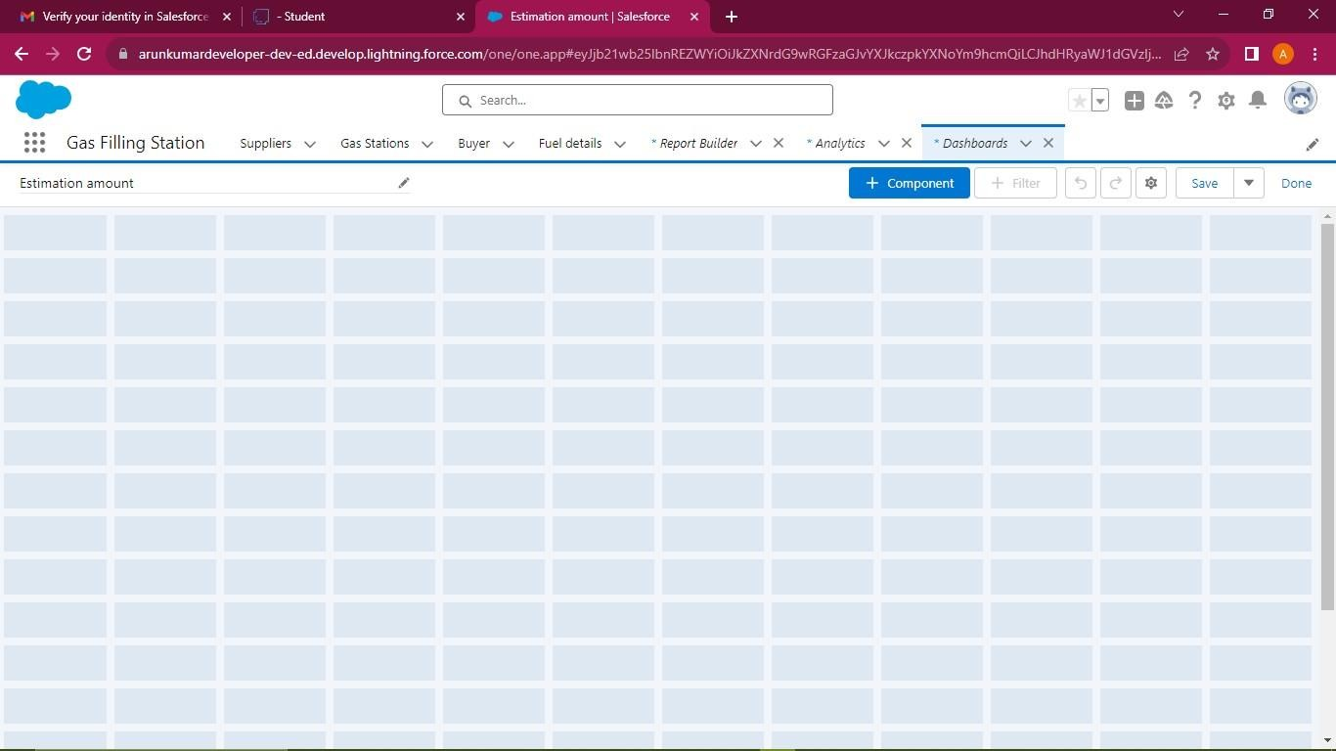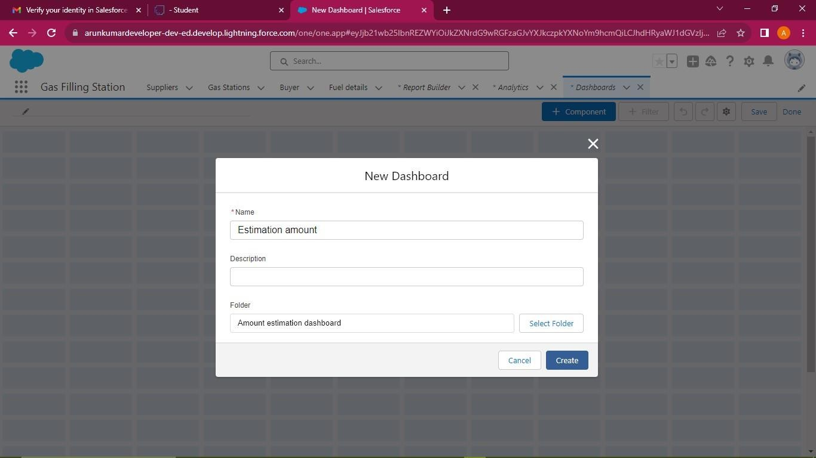

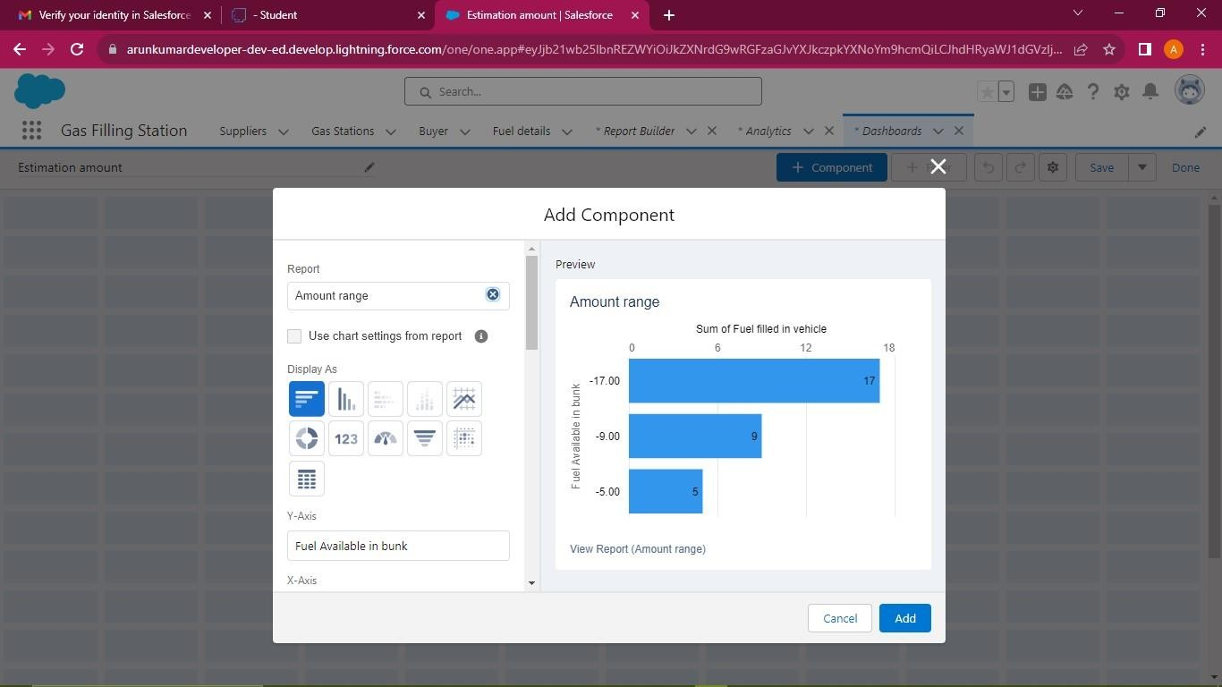

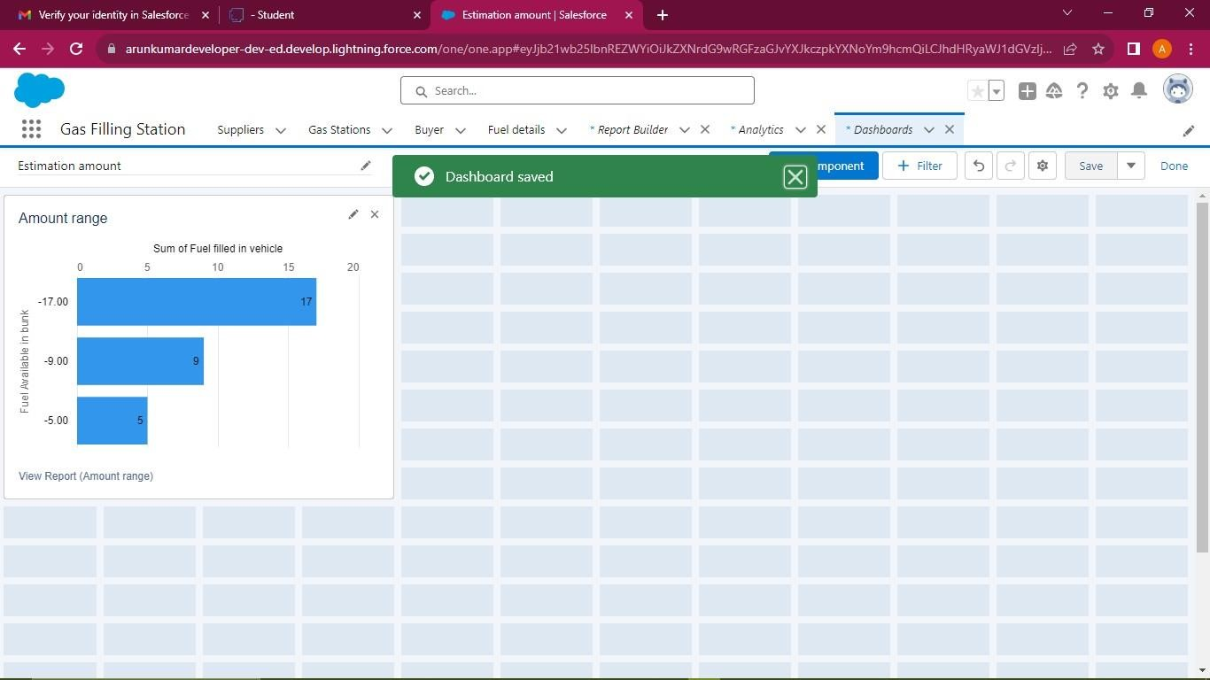

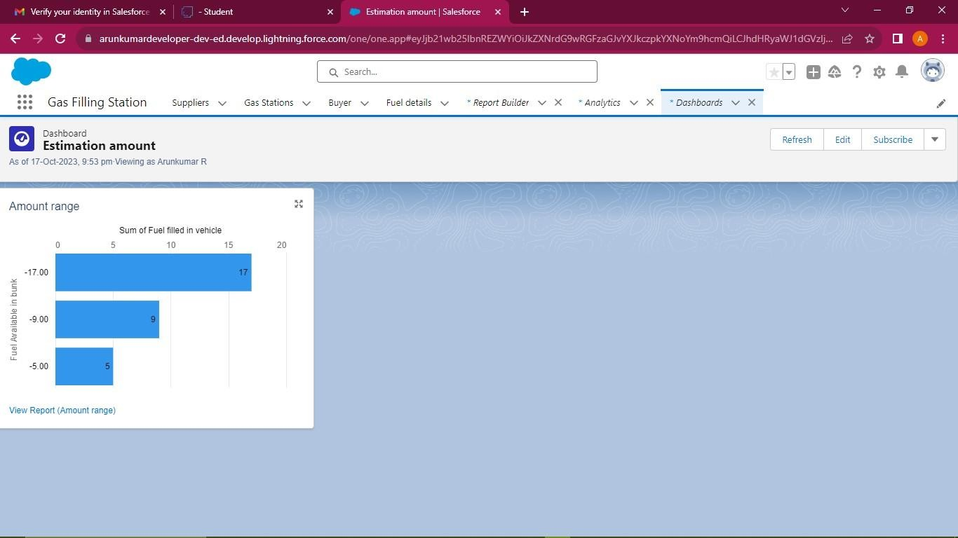

# CHAPTER-6 CONCLUSION

In conclusion, the Salesforce-based Customer Store Management project aims to address the significant challenges faced by employees in cosmetics stores when it comes to managing customer records, processing orders, and generating discount coupons. The project's primary goal is to create an efficient, automated system that enhances operational efficiency, reduces errors, and ultimately improves customer satisfaction.

Through the design and implementation of custom objects, user profiles, and automation tools, the project offers a unique and tailored solution for cosmetics stores. The use of Salesforce as the platform ensures a secure, scalable, and customizable environment to meet the specific needs of the business.

By streamlining data entry, order processing, and coupon generation, this project not only simplifies the daily tasks of employees but also contributes to the store's growth and success. It enables personalized customer engagement, data-driven decision-making, and efficient management of customer relationships.

The project emphasizes the social impact of enhancing the customer experience, potentially leading to increased customer loyalty and revenue. It also aligns with the digital transformation trend in the retail industry, where businesses are leveraging technology to stay competitive and meet customer expectations.

In summary, the Salesforce Customer Store Management project has the potential to revolutionize how cosmetics stores operate, providing a competitive advantage and customer-centric approach that can lead to long-term success in the industry.

**GitHub:**

<https://github.com/Murugadass-b/Salesforce-Developer-NM2023TMID04730-Murugadass-8040BEFFA6B19979A3E4D469F90A2849-/tree/main>

# CHAPTER-7 PROJECT DEMONSTRATION

**Demo Link:**

<https://youtu.be/R0v2GPj4mKM?si=OWu_mykdd6eytfuM>